10th Meeting of the SIOFA Compliance Committee (CC10) and 13th Meeting of the Parties to SIOFA (MoP13)
Savoy Seychelles Resort & Spa, Beau Vallon, Seychelles, 1–3 July and 6–10 July 2026

MoP-13-34

Potential Amendments to CMM 18 (2025) on Conservation and Management Measure for Benthic Fishery Closures
The Meeting of the Parties
Meeting | Compliance Committee ☐  Meeting of the Parties ✔
Document type | Administrative Paper ☐  Proposal or Working Paper ✔  Information Paper ☐
Distribution | Public ✔  Restricted ☐  Closed session document ☐
Abstract
At SC11, the Scientific Committee noted uncertainty regarding the interpretation of paragraph 6 of CMM 18 (2025) on Conservation and Management Measure for Benthic Fishery Closures and requested clarification from the Meeting of the Parties. Following the clarification provided by the Meeting of the Parties, the Secretariat has prepared this paper to reflect that advice and to identify the amendments required to give effect to it.

Recommendations
- Note these amendments proposed by the Meeting of the Parties to CMM 18 (2025) on Conservation and Management Measure for Benthic Fishery Closures and agree to adopt these changes to the CMM

CMM 18(2025)
Conservation and Management Measure for Benthic Fishery Closures
The Meeting of the Parties to the Southern Indian Ocean Fisheries Agreement;
RECALLING Article 4(a) of the Southern Indian Ocean Fisheries Agreement (the Agreement) which calls on the Contracting Parties, in giving effect to the duty to cooperate, to adopt measures on the basis of the best scientific evidence available to ensure the long-term conservation of fishery resources, taking into account the sustainable use of such resources and implementing an ecosystem approach to their management;
FURTHER RECOGNISING Articles 4(c), (d), (e) and (f) of the Agreement which call on the Contracting Parties to apply the precautionary approach and the principles that measures shall be taken to ensure that the level of fishing activity is commensurate with the sustainable use of the fishery resources, that fishing practices and management measures shall take due account of the need to minimise the harmful impact that fishing activities may have on the marine environment, and that biodiversity in the marine environment shall be protected;
FURTHER RECOGNISING Articles 6(1)(d) and (e) of the Agreement which provide that the Meeting of the Parties shall adopt conservation and management measures (CMMs) necessary for ensuring the long-term sustainability of fishery resources, taking into account the need to protect marine biodiversity, based on the best scientific evidence available and adopt generally recommended international minimum standards for the responsible conduct of fishing operations;
FURTHER RECOGNISING that the Mid-Indian Ridge Benthic Fishery Closure established under this CMM shall be implemented in accordance with SIOFA’s mandate and not prejudice any CCP’s rights and obligations under international law. This includes provisions under UNCLOS, International Seabed Authority (ISA) or other competent international organizations and shall not prejudice any rights exercised or activities undertaken subsequent to the claim for an extended continental shelf undertaken in accordance with international law.
MINDFUL of Article 16 of the Agreement that calls on Contracting Parties, acting jointly under the Agreement, to cooperate closely with other international fisheries and related organisations in matters of mutual interest;
COMMITTED to ensuring that bottom fishing undertaken in the SIOFA Area of Application (the Agreement Area) is consistent with the long-term sustainability of deep-sea fish stocks and the protection of the marine environment;
NOTING that the SC10 recommended the establishment of benthic protected areas in areas with sensitive physical and/or biological properties, and the SC has agreed on a set of criteria to evaluate protected area designation;
NOTING that since 2006, SIODFA members have voluntarily refrained from engaging in bottom fishing within the areas outlined in this CMM and now agree to formally designate these areas as Benthic Fishery Closures (BFCs) under SIOFA CMMs;
NOTING the requirements in CMM 01(2025) on the Management of Bottom Fishing in the Agreement Area which place a number of obligations on Contracting Parties, cooperating non-Contracting Parties and participating fishing entities who intend to authorise their flagged vessels to engage in any bottom fishing in the Agreement Area.

ADOPTS the following CMM in accordance with Articles 4 and 6 of the Agreement:
Objective
- The objective of this CMM is to provide benthic protection to sensitive areas through the implementation of Benthic Fishery Closures (BFCs) in the Agreement Area.

General provisions
- This CMM applies to all bottom fishing vessels flying the flag of Contracting Parties, cooperating non-Contracting Parties, participating fishing entities or cooperating non-participating fishing entities (collectively CCPs) to the Agreement currently engaging in, or intending to engage in, any existing, new or exploratory bottom fishing activities in the Agreement Area.

- CCPs shall ensure that their flagged vessels do not engage in bottom fishing within the BFCs outlined in Table 1.

- CCPs shall ensure that their flagged vessels do not engage in bottom fishing within the BFCs outlined in Table 2 unless the CCP has existing bottom longline footprint within those areas.

Definitions
- For the purpose of this CMM,
  - ‘bottom fishing’ means fishing using any gear type likely to come in contact with the seafloor or benthic organisms during the normal course of operations. This includes trawling; bottom longlining; drop lining and trap fishing or any method listed as bottom gear in CMM 01 or CMM 17 or bottom fisheries listed in any future amendments, or replacements, to these CMMs.
  - ‘BFC’ means Benthic Fishery Closure where bottom fishing is not permitted, unless specifically provided for in Table 2. The latitude and longitude coordinates of the BFCs are specified in Tables 1 and 2 and a map of the BFCs are included at Figure 1.
Reporting requirements
- For any vessel allowed to fish, and engaging in fishing within the BFCs listed in Tables 1 and 2, CCPs shall record all catch and effort occurring within these BFCs and shall report these data annually, for each BFC separately, to the SC in the CCP’s country report.
- The secretariat shall annually undertake an assessment of the VMS data for all vessels entering these BFCs noting the time spent and potential activity (fishing and transiting) by vessel type and flag in each BFC. In addition, the secretariat shall provide a summary of VMS reporting under paragraph 30 of CMM 16(2025).

- Until such time that CCPs' flagged vessels automatically report VMS position reports in accordance with CMM 16, the Master of any CCP's flagged vessel transiting through a BFC shall report to the Secretariat and its flag CCP 4 hours prior to entering and exiting a BFC.

- All reports under paragraph 8 shall contain the following information:
- Report type (ZENT for entry and ZEXT for exit)
- Vessel name
- Flag CCP
- IMO Number
- Trip start date i.e. date of departure from port
- Date and time on entry or exit (GMT)
- International Radio Call Sign (IRCS)
- Position of entry to, or exit from, the BFC by latitude/longitude (to one tenth of a minute of arc)
- Intended or completed activity while inside the BFC
- On exit from a FC, catch on board by weight (kilograms) and species for all catch caught within the BFC.

Research and Monitoring
- By 2028, the SC shall develop a research and monitoring plan for the BFCs listed in Tables 1 and 2 and provide advice to the Meeting of the Parties on the maintenance, modification or termination of these BFCs. The research and monitoring plan may include fisheries independent surveys, benthic monitoring data, remote sensing analyses or other relevant research.
Review
- This CMM shall be reviewed no later than at the 17th ordinary Meeting of the Parties in 2030 and periodically thereafter (e.g. every 5 years). The review shall take into account, inter alia, the most recent advice from the Scientific Committee including the results of the research and monitoring plan, international best practices and analyses of fisheries impacts on benthic areas.

Table 1: SIOFA Benthic Fishery Closures, closed to all bottom fishing with the coordinates and closure type. Note these can be downloaded as shapefiles from the SIOFA website.

Area Name | Coordinates |  |  |  |  | Closure type
Area Name | Position 1 | Position 2 | Position 3 |  | Position 4 | Closure type
Gulden Draak | 28° 00'S  98° 00E | 29° 00’S  98° 00’E | 28° 00'S  99° 00’E |  | 29° 00'S  99° 00’E | Closed to all bottom fishing activities
Rusky | 31° 20'S  94° 55'E | 31° 30'S  94° 55'E | 31 ° 20'S  95° 00'E |  | 31° 30'S  95° 00'E | Closed to all bottom fishing activities
Fools-Flat | 31° 30'S  94° 40'E | 31 ° 40'S  94° 40'E | 31° 30'S  95° 00'E |  | 31° 40'S  95° 00'E | Closed to all bottom fishing activities
East Broken Ridge | 32° 50'S  100° 50'E | 33 ° 25'S  100° 50'E | 32° 50'S  101° 40'E |  | 33 ° 25'S  101° 40'E | Closed to all bottom fishing activities
Mid-Indian Ridge | 13° 00'S  64° 00'E | 15° 50'S  64° 00'E | 3a | 3b | 15° 50'S  68° 00'E | Closed to all bottom fishing activities
Mid-Indian Ridge | 13° 00'S  64° 00'E | 15° 50'S  64° 00'E | 15° 50'S  66° 48'E | 15° 02'S  68°00'E | 15° 50'S  68° 00'E | Closed to all bottom fishing activities
Atlantis Bank | 32° 00'S  57° 00'E | 32° 50'S  57° 00'E | 32° 00'S  58° 00'E |  | 32° 50'S  58° 00'E | Closed to all bottom fishing activities
Bridle | 38° 03'S  49° 00'E | 38° 45 'S  49° 00'E | 38° 03'S  50° 00'E |  | 38° 45'S  50° 00'E | Closed to all bottom fishing activities
Banana | 30° 20'S  45° 40'E | 30° 30'S  45° 40'E | 30° 20'S  46° 00'E |  | 30° 30'S  46° 00'E | Closed to all bottom fishing activities
Middle of What | 37° 54'S  50° 23'E | 37° 56.5’S  50° 23'E | 37° 54'S  50° 27'E |  | 37° 56.5’S  50° 27'E | Closed to all bottom fishing activities

Table 2: SIOFA Benthic Fishery Closures, closed to all bottom fishing, but where bottom longlining is permitted, with the coordinates and closure type. Note these can be downloaded as shapefiles from the SIOFA website.

Area Name | Coordinates |  |  |  | Closure type
Area Name | Position 1 | Position 2 | Position 3 | Position 4 | Closure type
Walters Shoal | 33° 00'S  43° 10'E | 33° 20'S  43° 10'E | 33° 00'S  44° 10'E | 33° 20'S  44° 10'E | Closed to bottom fishing, with bottom longlining permitted
Coral | 41° 00'S  42° 00'E | 41° 40'S  42° 00'E | 41° 00'S  44° 00'E | 41° 40'S  44° 00'E | Closed to bottom fishing, with bottom longlining permitted
Magneto (formally South Indian Ridge) | 44° 00'S  40° 52’40.8”E | 45 ° 00'S  42° 07’26.4”E | 44° 00'S  46° 32’38.4”E | 45° 00'S  45° 42’39.6”E | Closed to bottom fishing, with bottom longlining permitted

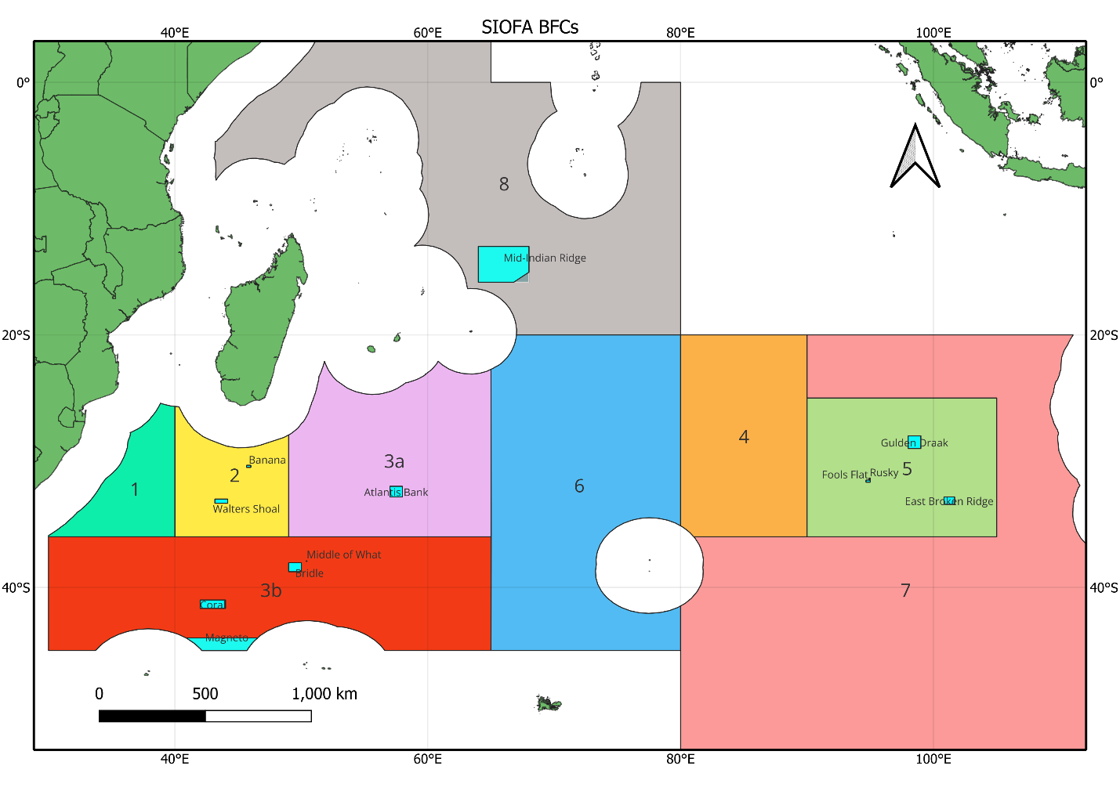
Figure 1: Map showing the location of all the SIOFA BFCs.

Restricted documents may contain confidential information. Please do not distribute restricted documents in any form without the explicit permission of the SIOFA Secretariat and the data owner(s)/provider(s).
Documents available only to members invited to closed sessions.
The reporting requirements required in paragraph 6 apply to all fishing vessels.
Or its replacement.
The Mid-Indian Ridge BFC established under this CMM shall not prejudice any rights of coastal States in respect of extended continental shelf claims submitted in accordance with international law.

