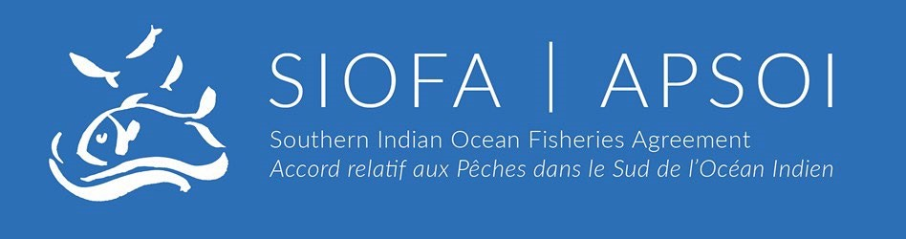

9th Meeting of the Compliance Committee (CC9) and 12th Meeting of the Parties (MoP12)

Ebene, Mauritius, 25–27 June 2025 and 30 June – 04 July 2025

MOP-12-52
Conservation and Management Measure for Exploratory Hapuka Fishery in the SIOFA Convention Area

The MoP Chairperson upon request of the MoP

Meeting | Compliance Committee ☐  Meeting of the Parties ✔
Document type | General Document (Secretariat) ☐  Proposal or Working Paper ✔  Information Paper ☐
Distribution | Public ✔  Restricted ☐  Closed session document ² ☐
Abstract
This document presents a proposal for a new Conservation and Management Measure for Exploratory Hapuka Fishery in the SIOFA Convention Area, presented by the MoP Chair as requested by the MoP.

Recommendations
• Consider the proposal for a new Conservation and Management Measure for Exploratory Hapuka Fishery in the SIOFA Convention Area

CMM-XX

Conservation and Management Measure for Exploratory Hapuka Fishery in the
SIOFA Convention Area

Southern Indian Ocean Fisheries Agreement
RECALLING Article 2 of the Southern Indian Ocean Fisheries Agreement (the Agreement) which states its objectives are to ensure the long-term conservation and sustainable use of the fishery resources in the Area through cooperation among the Contracting Parties, and to promote the sustainable development of fisheries in the Area, taking into account the needs of developing States bordering the Area that are Contracting Parties to this Agreement, and in particular the least- developed among them and small island developing States.
RECALLING Article 4(a) of the Agreement which calls on the Contracting Parties, in giving effect to the duty to cooperate, to adopt measures on the basis of the best scientific evidence available to ensure the long-term conservation of fishery resources, taking into account the sustainable use of such resources and implementing an ecosystem approach to their management;
FURTHER RECOGNISING Articles 4(c), (d), (e) and (f) of the Agreement which call on the Contracting Parties to apply the precautionary approach and the principles that measures shall be taken to ensure that the level of fishing activity is commensurate with the sustainable use of the fishery resources, that fishing practices and management measures shall take due account of the need to minimise the harmful impact that fishing activities may have on the marine environment, and that biodiversity in the marine environment shall be protected;
FURTHER RECOGNISING Articles 6(1)(d) and (e) of the Agreement which provide that the Meeting of the Parties shall adopt conservation and management measures (CMMs) necessary for ensuring the long- term sustainability of fishery resources, taking into account the need to protect marine biodiversity, based on the best scientific evidence available and adopt generally recommended international minimum standards for the responsible conduct of fishing operations;
COMMITTED to ensuring that bottom fishing undertaken in the SIOFA Area of Application (the Agreement Area) is consistent with the long-term sustainability of deep-sea fish stocks and the protection of the marine environment;
NOTING the requirements in CMM 01(2024) on the Management of Bottom Fishing in the Agreement Area which place a number of obligations on Contracting Parties, cooperating non-Contracting Parties and participating fishing entities who intend to authorise their flagged vessels to engage in any bottom fishing in the Agreement Area;
AGREEING that new and exploratory fisheries should not be permitted to expand faster than the acquisition of information necessary to ensure that the fishery can and will be developed in accordance with the principles set out in Article 4 of the Agreement;
ADOPTS the following CMM in accordance with Articles 2, 4 and 6 of the Agreement:

Objectives

1. To provide for exploratory dropline fishing for Polyprion oxygeneios, or hapuka (common name), to allow the evaluation of the long-term fishery potential for this species in the Convention Area. In addition, for the purpose of obtaining scientific data: to evaluate the possible impacts on the target stocks, associated or dependent species, and marine ecosystems; to evaluate the effectiveness of mitigation measures; and to ensure that the dropline exploratory fishery for hapuka is developed on a precautionary and gradual basis according to the best available science.

Definitions

2. For the purpose of this measure:
- “Hapuka” means Polyprion oxygeneios; Polyprion spp.; Polyprion americanus;
- “Dropline fishing” means deployment of droplines in the vicinity of sea mountains to a depth of 1000 meters that are dedicated to capturing Polyprion oxygeneios; Polyprion spp.; Polyprion americanus while having minimal adverse impact on the environment as described in the Fisheries Operational Plan noted by the 10th Annual Meeting of the SIOFA Scientific Committee (SC10);
- “Fishing Year” means a year of 12 months, from July 1 to June 30;
- “FOP” means the relevant Fisheries Operation Plan;
- “TAC” means Total Allowable Catch;
- “Trip” means any period commencing with the departure of the vessel from port for the purpose of beginning a fishing trip to such time as any or all fish on board the vessel are unloaded from the fishing vessel, either ashore or to a transshipment carried in port.

Application

- None of the obligations in this measure exempt a member or CNCP from complying with any Convention obligation or any other CMMs adopted by the Commission. Details and Specification of Exploratory Fishing Activities

- Fishing for Polyprion oxygeneios; Polyprion spp.; Polyprion americanus using dropline may be conducted on seamounts or other features within SIOFA subareas 2, 3a, 3b and to a much lesser extend in the eastern side, in subarea 4. (Figure 1). The vessel is targeting the following sea mountains:
- 35.54S 53.13E
- 38.28S 46.46E
- 36.40S 52.06E
- 38.30S 47.41E
- 37.02S 51.56E
- 34.53S 54.16E

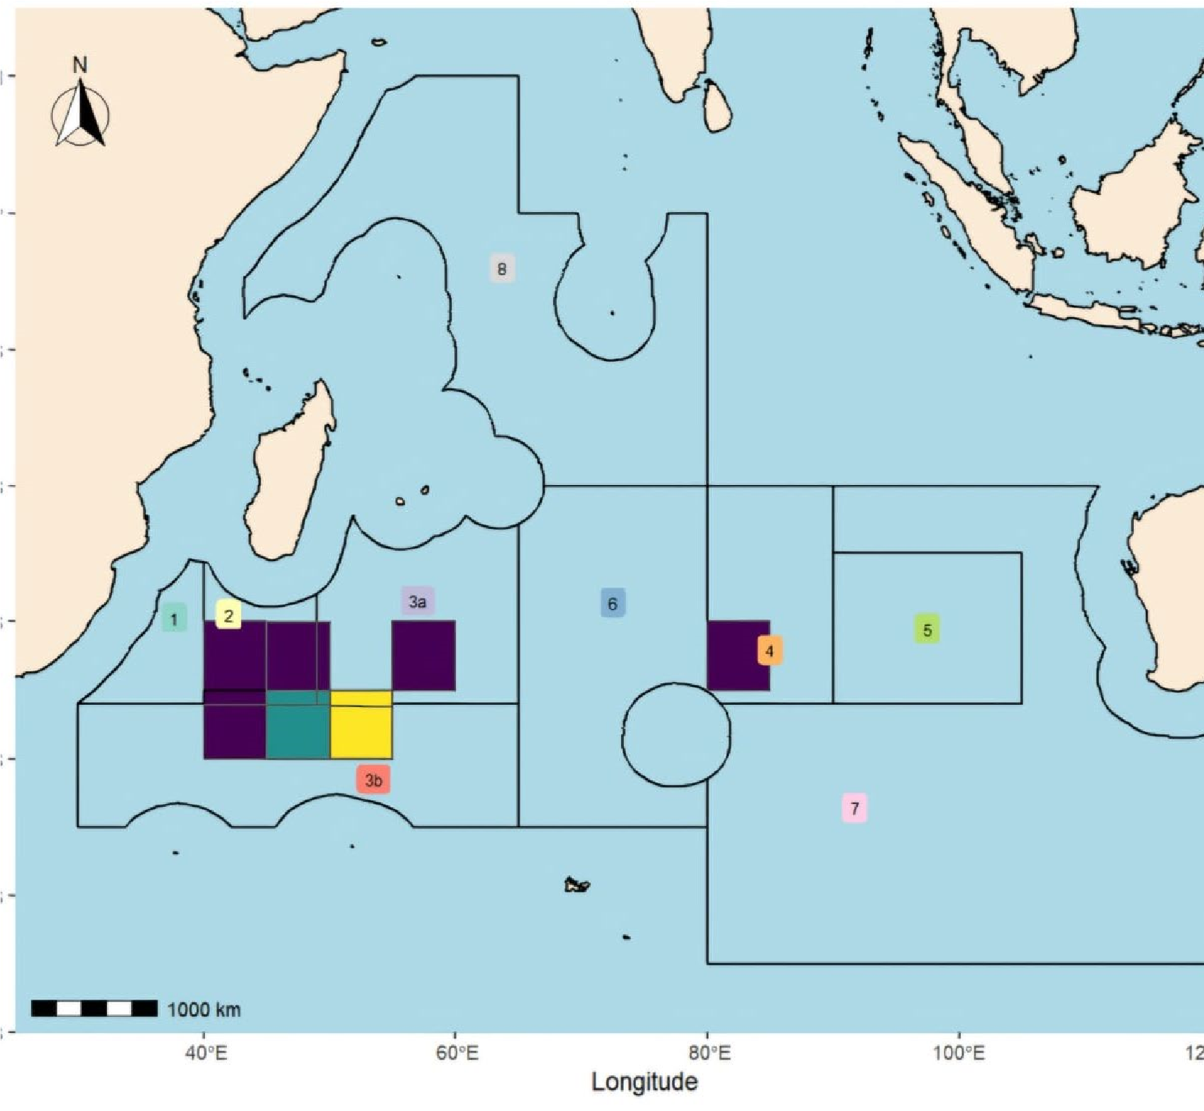

Figure 1

- The fishery will be conducted in such a way, so measures recommended by the 10th
Annual meeting of the Scientific Committee (SC 10) in relation to the Benthic Protected Areas (BPAs) closed for bottom fishing are respected.
- The exploratory fishing conducted pursuant to this CMM shall commerce after the MoP meeting in 2025 beginning July 11, 2025. It is proposed to initially run this exploratory fishery for three fishing years with annual reviews by the SC and the MoP meetings. Therefore ending on July 10, 2028.
- The proposed annual total allowable catch (TAC) is 500 tonnes (t) for Polyprion oxygeneios; Polyprion spp.; Polyprion americanus combined.
- The TAC will not be allowed to be taken from a single seamount and, to spread the catch and effort, therefore a 14 days fishing per seamount per trip shall apply.
- The proposed annual total allowable effort (TAE) is 270 days
- Dropline fishing will be restricted to a maximum 10 lines deployed at any time with a maximum of 100 hooks per line.
- The vessel is authorised to test alternative dropline configurations to evaluate gear selectivity.
- The Union of Comoros shall ensure that any vessel authorised to conduct the exploratory fishing shall provide reports on its fishing activity at the end of each trip to the secretariat.
- Any results will be used to develop proposals for consideration of the Scientific Committee on the design of any subsequent fishing.
- Catch and Effort shall be monitored on a set-by-set basis and fishing operation shall cease in that year once the catch limit or the TAE, specified in paragraphs 7 and 9 are reached. Once the seamount specific limit reached that seamount will be closed for fishing for that trip.
a) As the stock and stock status is unknown, if at any time during the exploratory fishing the stock indicators at a specific sea mountain show sustainability concern, the Union of Comoros shall issue a directive to the authorised vessel for exploratory fishing to cease at that sea mountain and advice the MoP promptly thereafter.
- The Union of Comoros shall ensure that any vessel authorised to undertake this exploratory fishing shall have experience working within catch limits and use intensive monitoring of all catch. It is proposed that the fishing vessel Rinascente 9 will be conducting the exploratory fishery for hapuka in the convention area. Details of the vessel are listed in Annex 1
- Fishing activity undertaken pursuant to this measure shall not be considered a precedent for future allocation decisions.

Authorised vessels

- Any Comorian vessel authorized to undertake fishing shall do so pursuant to this measure. If the authorized vessel becomes unavailable, an alternate fishing vessel of similar capability and capacity may be authorized to undertake fishing pursuant to this measure only after the replacement fishing vessel has been notified by the Union of Comoros to the Executive Secretary who will notify all Members and CNCPs.
- In determining the suitability of an alternate fishing vessel, the Union of Comoros shall consider, inter alia:
  - the vessel’s ability to conduct the exploratory fishing set out in the approved
Fisheries Operation Plan;
  - the master and crew’s history and experience in comparable research or exploratory fishing;
  - the ability of the fishing vessel to provide suitable accommodation, facilities, and operating support for a scientific observer;
  - the ability of the fishing vessel to maintain rigorous monitoring of the potential for Significant Adverse Impacts on Vulnerable Marine Ecosystems (VMEs);
  - any history of Illegal, Unreported or Unregulated (IUU) fishing by the vessel. A vessel on the SIOFA IUU list or the IUU list of another competent regional fisheries management organization shall not be accepted as an alternate vessel.

Management measures

- Fishing pursuant to this measure shall take place in accordance with this measure or any amendment to the measure adopted by the regular meeting of the MoP.
- Target and limit reference points will be developed in future based on the outcomes of the research efforts associated with this fishery. An interim target reference point of 50%B 0and an interim limit reference point of 30%B 0as initial reference points unless that data analysis undertaken as part of this exploratory fishery suggests alternative reference points may be more appropriate.
- Initially, standardized CPUE analysis will be used and a percent change in CPUE (change from CPUE init which will equate with B0) as the initial means to monitor changes in biomass, and as the data becomes more informative other metrics may be more appropriate. (As the fishers will need some time to learn the fishery, CPUE init will be calculated as the mean CPUE t1-t2 determined by the Scientific Committee as a stable period of the CPUE series.)

Monitoring and Data Collection

- In undertaking fishing pursuant to this measure, any authorized fishing vessel shall collect all the data required by current CMMs and as set out in the Fisheries Operation Plan reviewed by the SIOFA MoP, and to the extent possible any further data requested by the Scientific Committee (SC) for its annual evaluation and assessment.
- The vessel shall be fully capable of complying with SIOFA data standards and reporting.
Marine Mammals, Seabirds, Turtles and other Species of Concern
- A vessel fishing pursuant to this measure shall use the following mitigation methods:
  - there shall be no dumping of offal while lines are being set or hauled.
  - any offal or discards shall be macerated by machine prior to discarding;
  - discarding shall take place only at the end of a dropline retrieval or while steaming; and no biological material shall be discarded for at least 30 minutes before the start of any dropline set or during any set;
  - discarding may only take place from the opposite side of the vessel from the hauling position.
  - The Union
of Comoros is required all Elasmobranchs to be released from the vessels while conducting this exploratory fishery.
  - In the event of persistent depredation with marine turtles, dolphins or whales, the vessel will be required to remove the gear from the water and move to another seamount.
  - if pods of, toothed or baleen whales approach the vessel droplines will not be deployed from the water until they have moved out of sight of the vessel.
- The following information shall be collected by observers for marine mammals, seabirds, turtles, and other species of concern:
    - standardized seabird and marine mammal abundance counts shall be made at the rear of the vessel at the start, middle, end of each event (from set to haul);
    - the observer shall have a target of observing 10% of droplines hauled for marine mammal, seabird and turtle captures, and for comparison with a sample of recorded video observations;
    - all marine mammals, seabirds, turtles, and other species of concern captured shall be identified, and photographs will be taken of as many seabird interactions as possible and all birds released alive;
    - all dead birds must be retained for formal identification and necropsy;
    - opportunistic observations, photography and identification of marine mammals may be undertaken in collaboration with the crew.
- All information specified in CMM 01 (2024) (Interim Management for Bottom Fishing) and all data necessary to assess encounters with VMEs shall be collected to enable assessment and monitoring of the distribution of vulnerable marine ecosystems in the areas fished.
a) the Union of Comoros will be limiting the number of droplines to 10 to be set at a time and has a VME encounter threshold. The VME indicator taxa threshold is 1 kg/ line. If VME indicator taxa are found attached to the line more than the threshold, then the vessel will be required to move on to the next fishing site and will record the location as a potential VME area.

- A vessel undertaking fishing pursuant to this measure shall carry at least one, and preferably two, observers appointed by the Union of Comoros. Observer data shall be collected in accordance with the SIOFA Observer data standard and shall include gear deployment and retrieval data, catch and effort information, biological data collection, and information on marine mammals, seabirds, reptiles and other species of concern.
- In addition to carrying an observer, a vessel undertaking fishing pursuant to this measure shall be equipped with a video monitoring and recording system to be located over the hauling position to ensure that all hauled droplines are observed or recorded on video.
- The vessel shall also be equipped with operational Automatic Location
Communicators for VMS reporting and can respond to polling at any rate if required consistent with requirements under CMM 10 (2023) Monitoring.

Review

- The preliminary biomass modelling approaches should be reviewed by the SC in 2026 or 2027.
- This CMM shall expire on July 10, 2028.

Annex 1
Details of the vessel to be authorised to conduct the exploratory fishery for Hapuka in the convention area.
Vessel name | Rinascente 9
Registration Number | 1600050
Vessel length: | 45.70 meters
Breadth | 8.50 meters
Depth | 3.65 meters
Gross tonnage | 498 tons
Port of registry | Moroni, Union of Comoros
Vessel owner/operator | Ebi Fishing Co., Ltd /  Comores Anglers SARL
IMO Number | 8947412
Radio Call Sign | D6HD3
Vessel Type | Fishing Vessel
Fishing Gear Type | - Traps/Pots for lobster fishery  - Dropline for hapuka fishery
Power of Main Engine | 870 KW
Material of Hull | Steel
Year Build | 1998
Main Engine Maker | Hanshin Iron Works Co., Ltd.
Fishhold capacity | 503,5 m3
Model of Engine | LH26RR
Place of build | Fong Kuo Shipbuilding, Taiwan
Equipment Used for Determining Position | VMS ; AIS

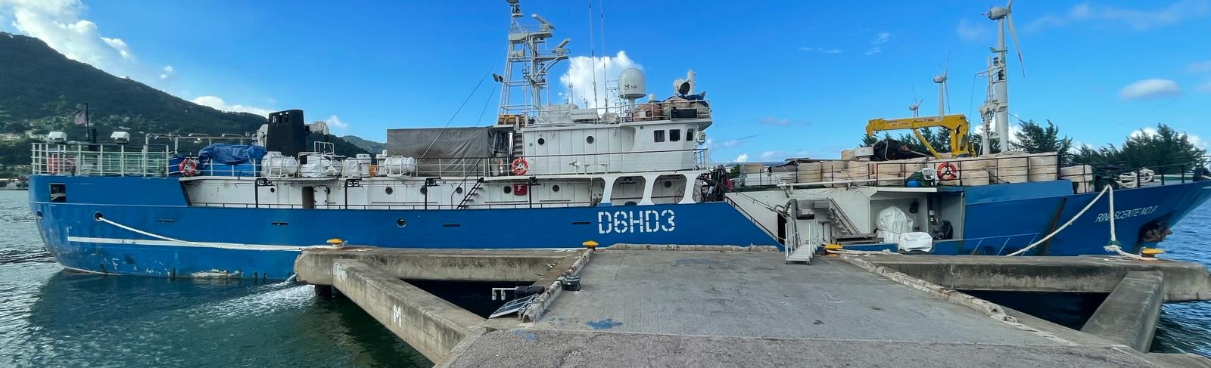

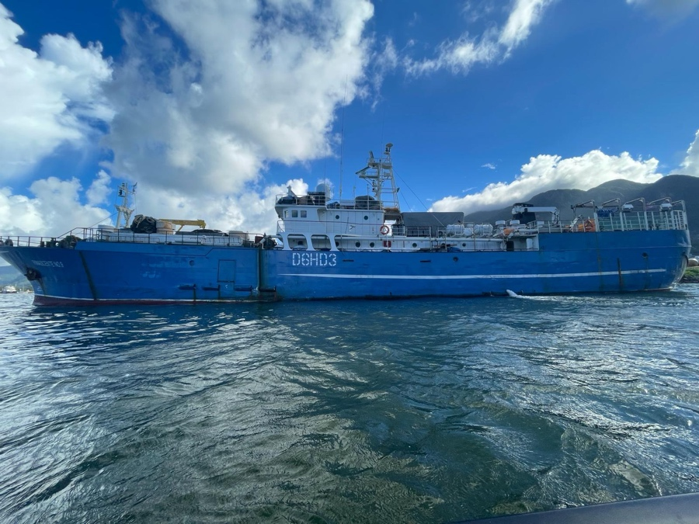
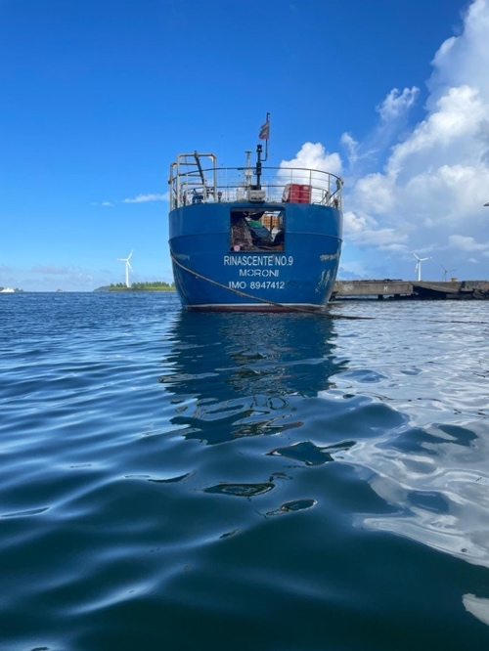

Restricted documents may contain confidential information. Please do not distribute restricted documents in any form without the explicit permission of the SIOFA Secretariat and the data owner(s)/provider(s). ² Documents available only to members invited to closed sessions. Southern Indian Ocean fisheries Agreement – SIOFA www.siofa.org

