9th Meeting of the Compliance Committee (CC9) and 12th Meeting of the Parties (MoP12)
Ebene, Mauritius, 25–27 June 2025 and 30 June – 04 July 2025

MoP-12-37 rev5

Proposal Amendment to CMM 13(2022) Mitigation of Seabirds Bycatch

Proposed by the delegations of Cook Islands and France Overseas Territories and SIODFA

Meeting | Compliance Committee ✔  Meeting of the Parties ✔
Document type | working paper ✔  information paper ☐
Distribution | Public ✔  Restricted ☐  Closed session document ☐
Abstract
Given the global concerns about seabird population declines and our requirements to mitigate any seabird mortality effectively, the SC10 made recommendations (paragraph 419) to improve CMM 13 to achieve more effective seabird bycatch mitigation in SIOFA fisheries. This requires an amendment to the current Seabird Bycatch CMM.
This proposal is to enact these recommendations and to update CMM 13(2022) in alignment with the recent science advice. The amendment includes the addition of mitigation requirements for trawl vessels and removes redundant text from the CMM.

- Changes in this revision are highlighted in the text due to multiple track changes in the document.
- There is additional preambular text.
- We have removed some elements from the general vessel provisions back into longline as they were originally.
- Some of the trawl elements are now non-obligatory.

Rev 3 Changes:
- Changes in Rev 3 are highlighted in cyan.
- This includes some editorial changes.
- A proposed new paragraph for the general provisions.
- Two options for paragraphs 8 and 9.
  - The first option is for the removal of trawl elements
  - The second option is for an exception for one flag.
- Some optional text still needs to be agreed these are highlighted in green.

REV 4 Changes:
- Some minor editorial changes
- Moving the trawl section to a annex as a set of guidelines.
- Removing the directive language from the guideline.

CMM 13(2025)
Conservation and Management Measure on mitigation of seabird bycatch in fishing gear within the SIOFA Agreement Area (Mitigation of Seabirds Bycatch)
The Meeting of the Parties to the Southern Indian Ocean Fisheries Agreement:
RECALLING the relevant provisions of the Southern Indian Ocean Fisheries Agreement, in particular Article 4 and 6;
CONSIDERING that the United Nations Food and Agriculture Organization (FAO) International Plan of Action for Seabirds calls on States to cooperate through regional fisheries organizations to mitigate incidental bycatch of seabirds;
RECOGNISING the need to strengthen mechanisms to protect seabirds in the Southern Indian Ocean;
FURTHER TAKING INTO ACCOUNT the FAO Technical Guidelines for Responsible Fisheries concerning best practices to reduce incidental catch of seabirds in capture fisheries;
NOTING the Agreement on the Conservation of Albatrosses and Petrels (ACAP) has established best practice seabird bycatch mitigation measures for trawl and demersal and pelagic longline fisheries;
ALSO NOTING that the seabird interaction data show low interactions due to the low densities of seabirds in some fishing areas, but also that mitigation measures that are currently voluntary applied in some trawl fleets resulting in showing low levels of seabird vessel interaction records;
ADOPTS the following CMM in accordance with Article 4 and 6 of the Agreement:

Application and geographic scope
- This CMM applies to all fishing vessels of Contracting Parties, cooperating non-Contracting Parties and participating fishing entities to the Agreement (collectively CCPs), engaged in fishing operations in the SIOFA Area of Application (Agreement Area) for fishery resources as defined in article 1(f) of the Agreement, south of 25°S.

General provisions for all fishing gear
- CCPs shall require any vessel flying their flag operating in the area south of 25°S to apply the following mitigation measures:
  - With the exception of squid jigging vessels that use lights as part of their normal fishing practice, the location and level of lighting shall be arranged so as to minimise illumination directed out from the vessel, consistent with the safe operation of the vessel and the safety of the crew;
  - information about birds colliding with the vessel, or caught by its gears will be recorded in accordance with CMM 02(2023) (Data Standards); and
  - every effort should be made to ensure that seabirds captured alive during fishing operations are released alive and, that any hooks are removed without jeopardising the life of the bird concerned wherever possible.
2 bis. For longline vessels the provisions below apply, for non-longline vessels CCPs should encourage any vessels flying their flag to apply additional mitigation measures in with reference to ACAP best practices (e.g. Best Practice Advice for Reducing the Impact of Pelagic and Demersal Trawl Fisheries on Seabirds), other practices implemented in or around the Area, or the guidelines outlined in Annex 4, especially when/ where seabird interactions are relatively high.

Provisions applying to demersal longliners
- CCPs shall require any demersal longliner flying their flag and operating in the area south of 25°S to apply the following mitigation measures:
  - any vessel catching a total of three (3) seabirds in a single season shall immediately change to night setting only (i.e. setting only during the hours of darkness between the times of nautical twilight);
  - vessels are encouraged to use white colour lines, to increase visibility which decreases the bycatches of birds;
  - there shall be no discharging of offal or discards immediately prior to and during the deployment or retrieval of fishing gear; and
  - the location and level of lighting shall be arranged so as to minimise illumination directed out from the vessel, consistent with the safe operation of the vessel and the safety of the crew.
- For demersal longliners of 25 metres or more. CCPs shall require any demersal longliner flying their flag and operating in the area south of 25°S to apply the following mitigation measures:

  - at least one bird scaring line (in accordance with Annex 1) shall be deployed when setting longlines and at least one bird exclusion device (BED, in accordance with Annex 2) shall be used to prevent birds entering the hauling area, to the extent allowed by prevailing weather;

  - fishing vessels using autoline systems shall add weights to the hookline or use integrated weight (IW) hooklines while deploying longlines. IW longlines of a minimum of 50 g/m or attachment to non-IW longlines of 5 kg weights at 50 to 60 m intervals are recommended;
  - fishing vessels using the Spanish method of longline fishing shall release weights before line tension occurs; traditional weights (made of rocks or concrete) of at least 8.5 kg mass shall be used, spaced at intervals of no more than 40 m, or traditional weights of at least 6 kg mass shall be used, spaced at intervals of no more than 20 m, or solid steel weights of at least 5 kg mass shall be used, spaced at intervals of no more than 40 m;
  - fishing vessels using the trotline system exclusively (not a mix of trotlines and the Spanish system within the same longline) shall deploy weights only at the distal end of the droppers in the trotline. Weights shall be traditional weights of at least 6 kg or solid steel weights of at least 5 kg; and
  - fishing vessels alternating between the use of the Spanish system and trotline method shall use:
    - for the Spanish system: line weighting shall conform to the provisions in paragraph 3 f;
    - for the trotline method: line weighting shall be either 8.5 kg traditional weights or 5 kg steel weights attached on the hook-end of all droppers in the trotline at no more than 80 m intervals.
- For demersal longliners of less than 25 m CCPs shall require any demersal longliners flying their flag and operating in the area south of 25°S to apply at least one of the following mitigation measures:
  - at least one bird scaring line (in accordance with Annex 1) shall be deployed when setting lines, and at least one bird exclusion device (BED, see specifications in Annex 2), shall be used to prevent birds entering the hauling area, to the extent allowed by prevailing weather;
  - fishing vessels using autoline systems shall add weights to the hookline or use integrated weight (IW) hooklines while deploying longlines. IW longlines shall have a minimum of 50 g/m or a weight of a minimum of 5 kg attached to non-IW longlines at 50 to 60 m intervals; and
  - lines shall be set only at night (i.e. during the hours of darkness between the times of nautical twilight). The exact times of nautical twilight are set forth in the Nautical almanac tables for the relevant latitude, local time and date.

Provisions applying to other demersal fishing gears
- In addition to the provisions in paragraph 2, CCPs shall require any fishing vessel flying their flag and operating in the Agreement Area south of 25°S using demersal pots or traps to ensure the cleanliness of the traps and pots not to attract birds, and ensure that buoy lines shall not be left floating at the surface.

Provisions applying to pelagic longliners
- In addition to the provisions in paragraph 2, CCPs shall require any pelagic longliners flying their flag and engaged in fishing operations under this Agreement for fishery resources as defined in article 1(f) of the Agreement in the area south of 25°S to use at least two of the three mitigation measures outlined in Annex 3.

Reporting provisions
- CCPs shall record all seabird bycatch as specified in CMM-02(2023) and shall report these data annually, to the SC in the CCP’s country report. [In addition, CCP’s shall report to the Secretariat any applications of Paragraph 9, and the secretariat shall provide a summary of reporting under Paragraph 9 to the Scientific Committee.]

Final provisions
- The Scientific Committee and the Compliance Committee will review this CMM every four years, unless the Meeting of the Parties decides otherwise.

ANNEX 1: Specification of bird scaring line for longliners

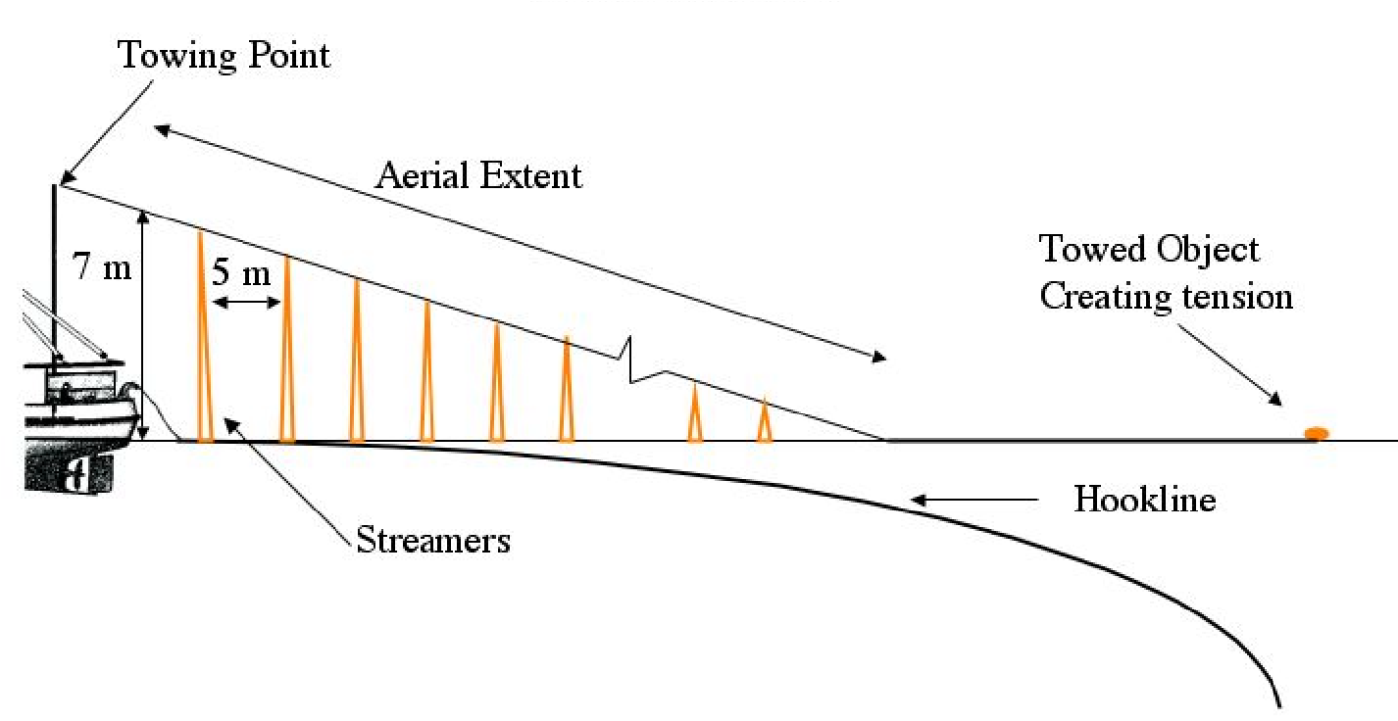
Figure A1-1: Specifications of the longline bird scaring lines.

- The aerial extent of the bird scaring line, being that part of the line supporting the streamers, is the effective seabird deterrent component of a bird scaring line. Vessels are encouraged to optimise the aerial extent of the bird scaring line and ensure that it protects the hookline as far astern of the vessel as possible, even in crosswinds.
- The bird scaring line shall be attached to either the port or starboard sides of the vessel.
- The bird scaring line shall be a minimum of 150 m in length and include an object towed at the seaward end to create tension to maximise aerial coverage. The object towed should be maintained directly behind the attachment point to the vessel such that in crosswinds the aerial extent of the bird scaring line is over the hookline.
- Branched streamers, each comprising two strands of a minimum of 3 mm diameter brightly coloured plastic tubing (or cord, shall be attached no more than 5 m apart commencing 5 m from the point of attachment of the bird scaring line to the vessel and thereafter along the aerial extent of the bird scaring line. Where tubing is used for the branched streamers, the tubing should be of a type that is manufactured to be protected from ultraviolet radiation.
- Streamer length shall range between minimums of 6.5 m from the stern to 1 m for the seaward end. When a bird scaring line is fully deployed, the branched streamers shall be of sufficient length to reach the sea surface in the absence of wind and swell. Swivels or a similar device should be placed in the bird scaring line in such a way as to prevent streamers being twisted around the bird scaring line. Each branched streamer may also have a swivel or other device at its attachment point to the bird scaring line to prevent fouling of individual streamers.
- A spare bird scaring line shall be carried and deployed in the event of loss or damage of a bird scaring line.
Longline Vessels ≥ 25m in length
- Each bird scaring line shall be suspended from a point a minimum of 7 m above the water at the stern of the point where the hookline enters the water.

Longline Vessels < 25 m in length
- The bird scaring line shall be suspended from a point a minimum of 6 m above the water at the stern of the point where the hookline enters the water.
- Streamers may be modified over the first 15 m to prevent tangling.
- The bird scaring line should achieve an aerial extent of at least 75 m when setting at ≥ 4 knots or 50 m is setting at speeds < 4 knots.

ANNEX 2: Specification of Bird Exclusion Devices (BEDs) for demersal longliners

BEDs shall have the following operational characteristics:

- deterrence of birds from flying directly into the area where the line is being hauled; and
- prevention of birds that are sitting on the surface from swimming into the hauling bay area.

ANNEX 3 : Mitigation measures for pelagic longliners

Mitigation | Description | Specification
Night setting with minimum deck  lighting | No setting between nautical dawn and before nautical dusk.  Deck lighting to be kept to a minimum. | Nautical dusk and nautical dawn are defined as set out in the  Nautical Almanac tables for relevant latitude, local time and date.  Minimum deck lighting should not breach minimum standards for safety and navigation.
Bird-scaring lines (Tori lines), in accordance with the specifications provided in Annex 1 | Bird-scaring lines shall be deployed during the entire longline setting to deter birds from approaching the branch line. | For vessels greater than or equal to 35 m:  - Deploy at least 1 bird-scaring line. Where practical, vessels are encouraged to use a second tori pole and bird scaring line at times of high bird abundance or activity; both tori lines should be deployed simultaneously, one on each side of the line being set.  - Aerial extent of bird-scaring lines must be greater than or equal to 100 m.  - Long streamers of sufficient length to reach the sea surface in calm conditions must be used.  - Long streamers must be at intervals of no more than 5m.  For vessels less than 35 m:  - Deploy at least 1 bird-scaring line.  - Aerial extent must be greater than or equal to 75m.  - Long and/or short (but greater than 1 m in length) streamers must be used and placed at intervals as follows: o Short: intervals of no more than 2 m.  o Long: intervals of no more than 5 m for the first 55 m of bird scaring line.  Additional design and deployment guidelines for bird-scaring lines are provided in Annex I of this CMM.
Line weighting | Line weights to be deployed on the snood prior to setting. | Greater than a total of 45 g attached within 1 m of the hook or;  Greater than a total of 60 g attached within 3.5 m of the hook or;  Greater than a total of 98 g weight attached within 4 m of the hook.

Annex 4: Guidelines for trawl vessel seabird mitigation

- In addition to the provisions in paragraph 2 of CMM13(2025), CCPs should encourage any fishing trawler flying their flag and operating in the SIOFA area south of 25°S to apply the following mitigation measures:

- Vessels should if feasible adopt shooting and hauling procedures that minimise the time that the net is lying on the surface of the water with the meshes slack. Net maintenance should, to the extent possible, not be carried out with the net in the water;

- Nets should be cleaned prior to shooting to remove residue of fish or other items that may attract seabirds;

- Offal or discards should not be discharged immediately prior to or during deployment or retrieval of fishing gear. The period of deployment is defined as the period from shooting the net until the doors are released, retrieval is the time between attachment of the doors at the stern till the net is on deck;

- Seabird mitigation, should if feasible be deployed during fishing operations to prevent seabird from flying around the stern of the vessel or prevent seabirds from interacting with the fishing gear;

    - If ‘Bird Bafflers’, are used they should be deployed prior to the fishing gear being deployed, and should remain in place until all fishing gear is removed from the water (see example specifications in Annex 4 Figure A4-1);
    - If bird scaring lines are used (see example specifications in Annex 4 Figure A4-2) they should be deployed immediately after shooting and retrieved before hauling

- Vessels should carry materials for construction, replacement, and repair of bird scaring lines in the event of changes to seabird abundance or behaviour (par 1. b).

- In the event that a vessel causes 3 or more threatened seabird mortalities in the same calendar year. In addition to the provisions in paragraphs 2, 3 and 8, the following additional seabird mitigation measures should be added for this vessel. The following additional measures should remain in place until the incidences have been reviewed by the CCP and appropriate mitigation actions have been implemented:

- There should be no discharging of offal or discards immediately prior to and during the deployment or retrieval of fishing. The period of deployment is defined as the period from shooting the net until the doors are released, retrieval is the time between attachment of the doors at the stern till the net is on deck;

- In the event that the seabird mortalities are from warp strikes, bird scaring streamer lines should be deployed immediately after shooting and retrieved before hauling, unless their deployment is in conflict with vessel safety priorities in poor sea conditions (see example specifications in Annex 4 Figure A4-2);

- Net monitor cables should not be used. Where this is impracticable:

  - a snatch block should be installed at the stern of a vessel to draw the net monitoring cable close to the water and thus reduce its aerial extent; and
  - bird scaring lines should be deployed and specifically positioned to deter birds away from net monitoring cables while fishing.
After this review process has been completed the provisions of paragraph 1 should be reapplied.

Bird Bafflers

- Exact design and placement will be contingent on vessel shape.
- Each boom should extend outwards not less than four metres from the side or stern of the vessel (Figure A4-1).
- Dropper lines should be attached to the booms and be no more than 2 metres apart.
- Plastic cones, rods or other brightly coloured and durable material should be attached to the ends of the dropper lines, so that the bottom of the cone, rod or material is not more than 50 centimetres above the water, in the absence of wind and swell.
- Lines or webbing should be attached between the dropper lines to prevent tangling.

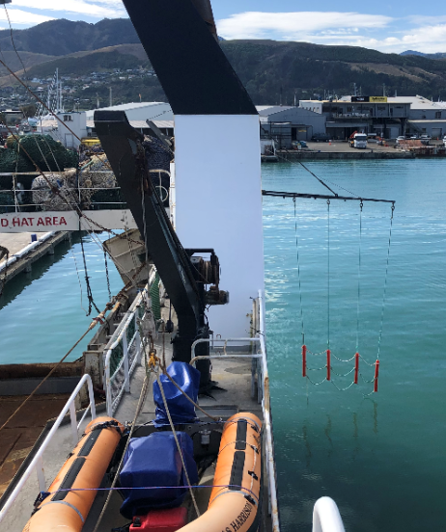
Figure A4-1: Bird baffler deployed. Seabirds are impeded from flying round the stern of the vessel.

Bird Scaring Lines for Demersal and Mid-water Trawlers
- The main line should be at least 50 metres in length.
- Streamers should be attached no more than 5 metres apart and be long enough to extend beyond the point at which warp and net monitoring cables reach the water’s surface. It is recommended that for every metre of block height 5 metres of bird scaring line be deployed.
- It is essential that streamers are made from semi-flexible tubing of high visibility. The recommended material is UV-protected fluorescent red polythene tubing. Alternative streamer materials such as fire hose; old waterproofs and dark coloured tubing are not acceptable.
- To avoid deflection of bird scaring lines away from cables in strong cross winds, the bird scaring lines must tow an object attached to the seaward end of line to create tension and keep the line straight. It is recommended that for every metre of block height, 1.2 kg of terminal object drag weight be used. The towed object can be linked to the warp with a vertical line using a shackle (Figure A4-2) for better coverage of the warp area.
- The lines should be mounted outboard of the trawl blocks on both the port and starboard sides.
- Streamer lines should be deployed once the trawl doors are submerged during setting and should be retrieved as net hauling commences. It is important to retrieve the streamer lines before hauling as vessels often go astern during this process. This can suck the buoys underwater and lead to entanglement problems.
- A spare streamer line should be carried and deployed in the event of loss or damage of a line.

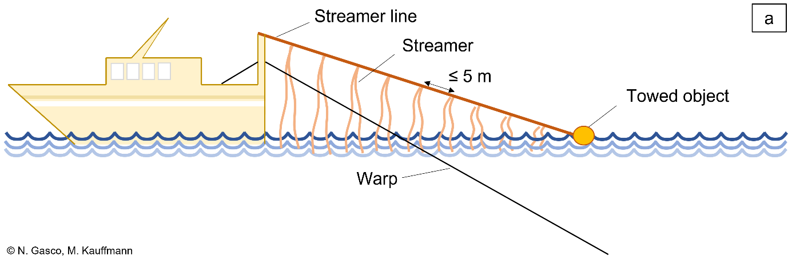
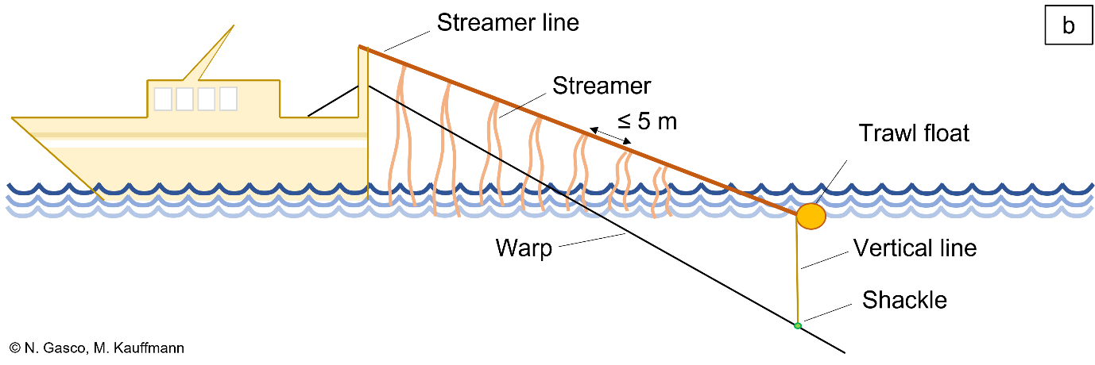
Figure A4-2: Examples of bird scaring lines either free from the warp (a) or linked to the warp with a shackle (b).

Restricted documents may contain confidential information. Please do not distribute restricted documents in any form without the explicit permission of the SIOFA Secretariat and the data owner(s)/provider(s).
Documents available only to members invited to closed sessions.
CMM 13(2025) (Mitigation of seabird bycatch) supersedes CMM13(2022) (Mitigation of seabirds bycatch).
Or any subsequent replacements.
A net monitoring cable (i.e. net-sonde cable or third wire) is defined as “a wire commonly suspended from the trawl gantry running to net monitoring equipment attached directly to the net” (CCAMLR).

