**9th Meeting of the Compliance Committee (CC9) and 12th Meeting of the Parties (MoP12)**

*Ebene, Mauritius, 25–27 June 2025 and 30 June – 04 July 2025*

**MoP-12-38-Rev3**

Proposal

New CMM for Benthic Protection

Proposed by the delegations of Australia, Cook Islands, and Japan

|  |  |
| --- | --- |
| **Meeting** | Compliance Committee  Meeting of the Parties |
| **Document type** | working paper  information paper |
| **Distribution** | Public  Restricted [1]  Closed session document [2] |
| **Abstract** | |
| Given the global concerns about sensitive marine benthic species and habitats, and the complexities around their management, benthic closures represent a practical and effective means for their protection. Following on from the workshop to progress future protected area designation (WS2024-PAD), which evaluated a number of areas for benthic protection. The workshop and the subsequent recommendations from the SC10 in paragraphs 443, 445, 447, 449, 451, 453, 455, 457, 459, 461 ,463 and 465 of the SC10 Report recommended that nine areas be designated as Benthic Protected Areas (BPAs) and closed to bottom fishing. In addition, three areas were recommended for BPA designation and closure to bottom fishing but with allowances for bottom longlining.  This proposal is to enact these recommendations and formulate a Conservation and Management Measure for the establishment, management and maintenance of 12 BPAs within the SIOFA Area.  Please note if MoP12 adopts this CMM for benthic protection, paragraphs 42, 43 and 44 of CMM-01(2024) would be redundant, and therefore MoP12 will need to agree that the Secretariat be tasked with revising CMM-01(2024) deleting these paragraphs, and revising Annex 3 by replacing it **with Tables 1 and 2 from this benthic protection CMM.**  **Included in this revision**:   * A number of editorial amendments; * Clarifications of demersal and bottom fishing; and * Two alternative proposals to reflect the continental shelf claim by Mauritius. These include either a clarifying footnote on table 1 (footnote 4) or a revision of the South-Indian Ridge BPA boundaries which requires an amendment to the coordinates in Table 1 and a replacement Figure 1 (Figure 1 alt). * Proposed name change from benthic protected area (BPA) to benthic fishery closure (BFC). | |

**CMM XX (2025)**

**Conservation and Management Measure for [~~Benthic Protected Areas]~~ [Benthic Fishery Closures]**

**The Meeting of the Parties to the Southern Indian Ocean Fisheries Agreement;**

*RECALLING* Article 4(a) of the *Southern Indian Ocean Fisheries Agreement* (the Agreement) which calls on the Contracting Parties, in giving effect to the duty to cooperate, to adopt measures on the basis of the best scientific evidence available to ensure the long-term conservation of fishery resources, taking into account the sustainable use of such resources and implementing an ecosystem approach to their management;

*FURTHER RECOGNISING* Articles 4(c), (d), (e) and (f) of the Agreement which call on the Contracting Parties to apply the precautionary approach and the principles that measures shall be taken to ensure that the level of fishing activity is commensurate with the sustainable use of the fishery resources, that fishing practices and management measures shall take due account of the need to minimise the harmful impact that fishing activities may have on the marine environment, and that biodiversity in the marine environment shall be protected;

*FURTHER* *RECOGNISING* Articles 6(1)(d) and (e) of the Agreement which provide that the Meeting of the Parties shall adopt conservation and management measures (CMMs) necessary for ensuring the long-term sustainability of fishery resources, taking into account the need to protect marine biodiversity, based on the best scientific evidence available and adopt generally recommended international minimum standards for the responsible conduct of fishing operations;

*MINDFUL* of Article 16 of the Agreement that calls on Contracting Parties, acting jointly under the Agreement, to cooperate closely with other international fisheries and related organisations in matters of mutual interest;

*COMMITTED* to ensuring that bottom fishing undertaken in the SIOFA Area of Application (the Agreement Area) is consistent with the long-term sustainability of deep-sea fish stocks and the protection of the marine environment;

*NOTING* that the SC10 recommended the establishment of benthic protected areas in areas with sensitive physical and/or biological properties, and the SC has agreed on a set of criteria to evaluate protected area designation;

*NOTING* that since 2006, SIODFA members have voluntarily refrained from engaging in bottom fishing within the areas outlined in this CMM and now agree to formally designate these areas as [] [Benthic Fishery Closures (BFCs)] under SIOFA CMMs;

*NOTING* the requirements in CMM 01(2024) on the Management of Bottom Fishing in the Agreement Area which place a number of obligations on Contracting Parties, cooperating non-Contracting Parties and participating fishing entities who intend to authorise their flagged vessels to engage in any bottom fishing in the Agreement Area.

***ADOPTS* the following CMM in accordance with Articles 4 and 6 of the Agreement:**

**Objective**

1. The objective of this CMM is to provide benthic protection to sensitive areas through the implementation of [] [Benthic Fishery Closures (BFCs)] in the Agreement Area.

**General provisions**

1. This CMM applies to all bottom fishing vessels flying the flag of Contracting Parties, cooperating non-Contracting Parties, participating fishing entities or cooperating non-participating fishing entities (collectively CCPs) to the Agreement currently engaging in, or intending to engage in, any existing, new or exploratory bottom fishing activities in the Agreement Area.
2. CCPs shall ensure that their flagged vessels do not engage in bottom fishing within the [] [BFCs] outlined in Table 1.
3. CCPs shall ensure that their flagged vessels do not engage in bottom fishing within the [] [BFCs] outlined in Table 2 unless the CCP has existing bottom longline footprint within those areas.

**Definitions**

1. For the purpose of this CMM,
   1. ‘bottom fishing’ means fishing using any gear type likely to come in contact with the seafloor or benthic organisms during the normal course of operations. This includes trawling; bottom longlining; drop lining and trap fishing or any method listed as bottom gear in CMM 01 or CMM 17 or bottom fisheries listed in any future amendments, or replacements, to these CMMs.
   2. [] [‘BFC’] means [] Benthic Fishery Closure] where bottom fishing is not permitted, unless specifically provided for in Table 2. The latitude and longitude coordinates of the [] [BFCs] are specified in Tables 1 and 2 and a map of the [] [BFCs] are included at Figure 1.

**Reporting requirements**

1. For any vessel allowed to fish, and engaging in fishing within the [] [BFCs] listed in Tables 1 and 2, CCPs shall record all catch and effort occurring within these BPAs and shall report these data annually, for each [] [BFC] separately, to the SC in the CCP’s country report.
2. The secretariat shall annually undertake an assessment of the VMS data for all vessels entering these [] [BFCs] noting the time spent and potential activity (fishing and transiting) by vessel type and flag in each [] [BFC]. In addition, the secretariat shall provide a summary of VMS reporting under paragraph 30 of CMM 16(2023)[3].
3. Until such time that CCPs' flagged vessels automatically report VMS position reports in accordance with CMM 16, the Master of any CCP's flagged vessel transiting through a [] [BFC] shall report to the Secretariat and its flag CCP 4 hours prior to entering and exiting a [] [BFC].
4. All reports under paragraph 8 shall contain the following information:
5. Report type (ZENT for entry and ZEXT for exit)
6. Vessel name
7. Flag CCP
8. IMO Number
9. Trip start date i.e. date of departure from port
10. Date and time on entry or exit (GMT)
11. International Radio Call Sign (IRCS)
12. Position of entry to, or exit from, the [][BFC] by latitude/longitude (to one tenth of a minute of arc)
13. Intended or completed activity while inside the [] [BFC]
14. On exit from a [] [BFC], catch on board by weight (kilograms) and species for all catch caught within the BPA.

**Research and Monitoring**

1. By 2028, the SC shall develop a research and monitoring plan for the [] [BFCs] listed in Tables 1 and 2 and provide advice to the Meeting of the Parties on the maintenance, modification or termination of these [] [BFCs]. The research and monitoring plan may include fisheries independent surveys, benthic monitoring data, remote sensing analyses or other relevant research.

**Review**

1. This CMM shall be reviewed no later than at the 17th ordinary Meeting of the Parties in 2030 and periodically thereafter (e.g. every 5 years). The review shall take into account, *inter alia*, the most recent advice from the Scientific Committee including the results of the research and monitoring plan, international best practices and analyses of fisheries impacts on benthic areas.

**Table 1: SIOFA [] [Benthic Fishery Closures,] closed to all bottom fishing with the coordinates and closure type. Note these can be downloaded as shapefiles from the SIOFA website at** [**https://siofa.org/science**](https://siofa.org/science)**.**

|  |  |  |  |  |  |  |
| --- | --- | --- | --- | --- | --- | --- |
| **Area Name** | **Coordinates** | | | | | **Closure type** |
| **Position 1** | **Position 2** | **Position 3** | | **Position 4** |
| *Gulden Draak* | 28° 00'S  98o 00E | 29o 00’S  98o00’E | 28° 00'S  99o00’E | | 29° 00'S  99o00’E | Closed to all bottom fishing activities |
| *Rusky* | 31° 20'S  94° 55'E | 31 ° 30'S  94° 55'E | 31 ° 20'S  95° 00'E | | 31 ° 30'S  95° 00'E |
| *Fools-Flat* | 31° 30'S  94° 40'E | 31 ° 40'S  94° 40'E | 31 ° 30'S  95° 00'E | | 31 ° 40'S  95° 00'E |
| *East Broken Ridge* | 32° 50'S  100° 50'E | 33 ° 25'S  100° 50'E | 32° 50'S  101° 40'E | | 33 ° 25'S  101° 40'E |
| *Mid-Indian Ridge[4]* | 13° 00'S  64° 00'E | 15° 50'S  64° 00'E | 15° 50'S  66° 48'E | 15° 02'S  68°00'E | 15° 50'S  68° 00'E |
|  | |
| *Atlantis Bank* | 32° 00'S  57° 00'E | 32° 50'S  57° 00'E | 32° 00'S  58° 00'E | | 32° 50'S  58° 00'E |
| *Bridle* | 38° 03'S  49° 00'E | 38° 45 'S  49° 00'E | 38° 03'S  50° 00'E | | 38° 45'S  50° 00'E |
| *Banana* | 30° 20'S  45° 40'E | 30° 30'S  45° 40'E | 30° 20'S  46° 00'E | | 30° 30'S  46° 00'E |
| *Middle of What* | 37° 54'S  50° 23'E | 37° 56’5S  50° 23'E | 37° 54'S  50° 27'E | | 37° 56’5S  50° 27'E |

**Table 2: SIOFA [] [Benthic Fishery Closures,] closed to all bottom fishing, but where bottom longlining is permitted, with the coordinates and closure type. Note these can be downloaded as shapefiles from the SIOFA website at** [**https://siofa.org/science**](https://siofa.org/science)**.**

|  |  |  |  |  |  |
| --- | --- | --- | --- | --- | --- |
| **Area Name** | **Coordinates** | | | | **Closure type** |
| **Position 1** | **Position 2** | **Position 3** | **Position 4** |
| *Walters Shoal* | 33 ° 00'S  43° 10'E | 33° 20'S  43° 10'E | 33 ° 00'S  44° 10'E | 33° 20'S  44° 10'E | Closed to bottom fishing, with bottom longlining permitted |
| *Coral* | 41 ° 00'S  42° 00'E | 41° 40'S  42° 00'E | 41 ° 00'S  44° 00'E | 41° 40'S  44° 00'E |
| *Magneto (formally South Indian Ridge)* | 44° 00'S  40o52’40.8E | 45 ° 00'S  42o07’26.4E | 44° 00'S  46o32’38.4E | 45 ° 00'S  45o42’39.6E |

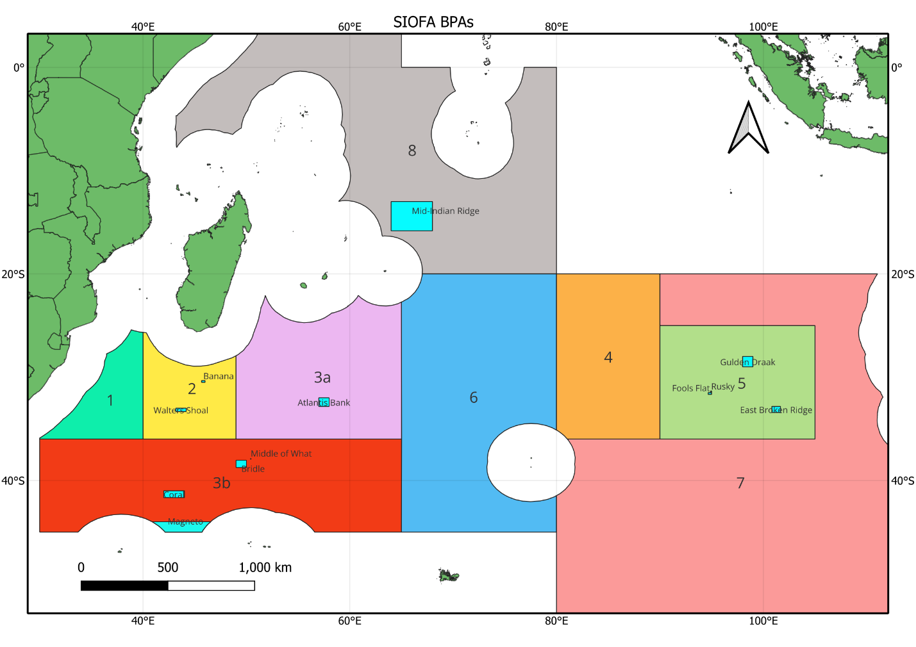**Figure 1: Map showing the location of all the SIOFA [] [BFCs].**

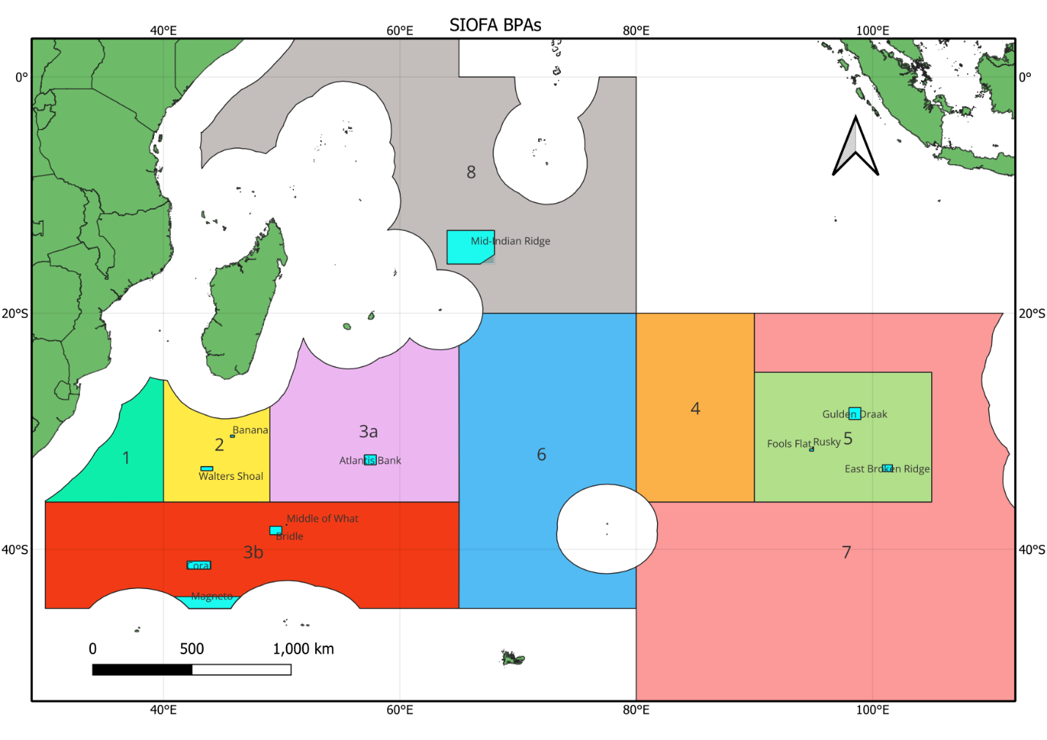

**[Figure 1_alt: Map showing the location of all the SIOFA [~~BPAs~~] [BFCs].]**

1. Restricted documents may contain confidential information. Please do not distribute restricted documents in any form without the explicit permission of the SIOFA Secretariat and the data owner(s)/provider(s).
2. Documents available only to members invited to closed sessions.
3. Or its replacement.
4. [The Mid-Indian Ridge [~~BPA~~] [BFC] established under this CMM shall not prejudice any CCP's rights in respect to territorial claims submitted in accordance with international law.]