Workshop on Harmonisation of Scientific Observers’ Programmes of the Southern Indian Ocean Fisheries Agreement (SIOFA)

Proposed tasks for the harmonisation of SIOFA observer data

Cook Islands Delegation
October 2021

Introduction
Currently the Southern Indian Ocean Fisheries Agreement (SIOFA) has ten Contracting Parties, one Participating fishing entity and one cooperating non-Contracting Party (collectively CCPs) and four additional signatories. SIOFA has scheduled a meeting to discuss the harmonisation of observer data. These CCPs participate in a number of different fisheries, each has their own observer programs and collect data independently of each other.
At the 2021 SIOFA Meeting of the Parties the CCPs amended the Conservation and Management Measure (CMM) for the Collection, Reporting, Verification and Exchange of Data relating to fishing activities in the Agreement Area (Data Standards CMM 2021/02). An important part of this CMM is Annex B that specifies data that are to be collected by observers in each fishery.
In 2021 the SIOFA CCPs agreed to hold an online meeting to discuss the harmonisation of these scientific observer programs. The objective of the workshop is to make recommendations on how to harmonise the scientific observation programmes of the CCPs, to recommend a process for evaluating scientific observation programmes in order to improve data quality and to explore the prospect of an electronic monitoring system to support scientific observation. This meeting will be held once a week for three weeks in October and November 2021.

Discussion
The first session of this meeting was largely dedicated to reviewing what is currently being done and focused largely on how each CCP was collecting data and what data and training of observers was being undertaken.
Following on from this, we propose a workplan and schedule of tasks that would need to be undertaken to focus the work at hand on the data requirements in the Data Standards CMM and develop a system that can be used by independent observer programs while ensuring compatibility of data with consistent coding and data collection protocols.
Noting that some CCPs may want to collect additional data that are not specified in the Data Standards CMM, we consider these data can still be collected on that CCPs own forms and stored alongside the required data in country. While the data specified in the Data Standards CMM would need to be provided to SIOFA, these additional data could be supplied to SIOFA at the discretion of that CCP. In addition, some CCPs may want to use their own data collections forms, which would still be possible provided the data fields, codes used, metrics and units of measure are consistent with the final agreed forms.
The intent being that this proposed schedule of work can be performed by an individual from a volunteer CCP, the secretariat Science Officer or contracted out to a data specialist as a specific project.

The following tasks are proposed along with a chronology (Figure 1) of the work plan:
- Using the Data Standards CMM Annex B develop a series of fishery specific data collection forms.
- Circulate those for comment.
- Amend the forms as needed and get agreement on the finalised forms.
- Create electronic forms that reflect the agreed forms with all fields linked to the specific fishing set that is being observed.
- Develop standard reporting formats and codes to populate the forms and hard wire these into the e-forms to ensure the data quality and consistency in reporting across observer programs.
- Circulate for comment.
- Amend standard reporting formats as needed.
- Develop a manual that describes how to collect these data and complete each data field.
- Circulate those for comment.
- Amend them as needed.
- Develop a database that each CCP can use to capture and store the data in country. These data can be submitted annually to the secretariat and housed at the secretariat on a single database.

While most of these tasks would need to be undertaken sequentially, tasks 8 and 11 could happen simultaneously once the reporting formats are all agreed. At each stage there would be a review period and chance for reporting back. It is estimated that this project would take 12 months to complete (Figure 1).

We propose this as a way forward for members consideration at the SIOFA workshop on the harmonisation of scientific observer programs.

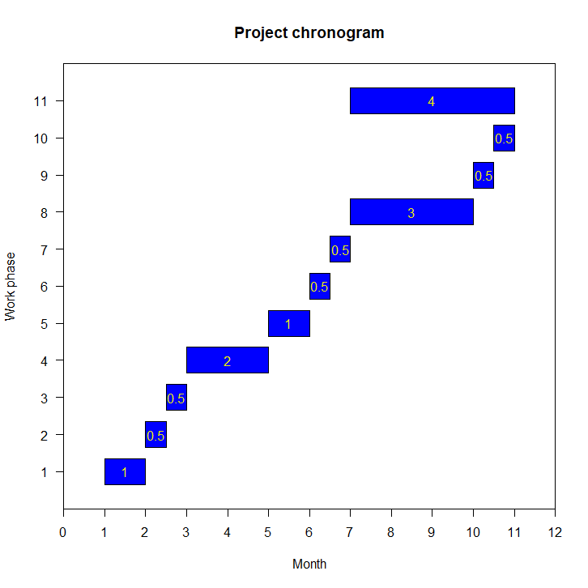
Figure 1: Chronogram of the schedule of tasks for the harmonisation of observer data within SIOFA. The work phase numbers correspond to the list of tasks in the document. The months are numbers from the start of the project onwards. Numbers in yellow is the time in months that each task is estimated to take.

