SC-07-07

7th Meeting of the Scientific Committee (SC7)
21-25 March 2022 (online)

Update on the ecological risk assessment of teleost species in SIOFA waters
Relate to agenda item: 7

Working paper Info paper Restricted

Delegation of Australia
Abstract
This paper updates the SIOFA SERAWG and SC on an ecological risk assessment (ERA) for SIOFA teleosts. This assessment updates previous results of Productivity-Susceptibility Analysis (PSA) and Sustainability Assessment for Fishing Effects (SAFE) tools to assess the vulnerability of teleosts to demersal trawl, midwater trawl, ‘shallow trawl’ (Saya de Malha bank fishery), demersal line and pelagic line gears in the SIOFA area. The species list was developed using catch and observer records in the SIOFA database and information from annual reports submitted by SIOFA Contracting Parties. Fishing effort data are updated to 2019. Species distribution data was sourced from AquaMaps.org and various probability of occurrence layers were assessed as sensitivities. Life history attribute data was sourced from the CSIRO database that underpins the CSIRO ERA online tool and was available for most species. Results indicated less species were found to be at high or extreme risk compared to the preliminary analysis presented in 2020 and most species found to be at high or extreme risk had missing productivity attributes.
Recommendations

It is recommended that the SERAWG and SC:
Notes: that Australia has updated the teleost ERA following the provision of new catch and effort data for the period 2015-2019.
Notes: revisions have been made to the species list and methodology, but continued taxa identification issues prevent a comprehensive species list being developed.
Notes: the results of the SAFE assessment indicate only a few species at high or extreme risk across all fishing gears and most of these species are data deficient.
Notes: the reduction in risk ratings for some species is due to the use of updated data at a finer spatial scale.
Notes: additional work could be undertaken to further refine the species list and reduce underlying uncertainties. However, this work may be of limited utility unless species reporting issues are rectified in some fisheries and/or the level of fishing effort and its spatial extent increases from that assessed (i.e., 2015-2019).
Recommends: that assessment efforts continue to be focussed on targeted stock that are taken in high volumes.
Recommends: that catches of Nemadactylus spp and Polyprions spp be closely monitored and consideration of developing catch triggers for further assessment in future.
Recommends: that any future ERA concentrates on other taxa rather than teleosts.

Ecological risk assessment for teleost species caught by demersal fishing gears in the Southern Indian Ocean Fisheries Agreement area
ABARES:  CSIRO Oceans and Atmosphere | T. Emery, T. Timmiss and L. Georgeson  J. R. Hartog, M Fuller

Introduction
The Southern Indian Ocean Fisheries Agreement (SIOFA) Meeting of the Parties have requested the SIOFA Scientific Committee to provide advice on the status of target, non-target (i.e., by-product) and bycatch (i.e., discarded, including endangered, threatened, and protected) species with which their fisheries interact. Australia has been leading ecological risk assessments (ERAs) to support these objectives.
This paper updates the SIOFA Stock and Ecological Risk Assessment Working Group (SERAWG) and Scientific Committee (SC) on ERAs undertaken for teleost species for which records of interaction with fishing gears (demersal trawl, midwater trawl, shallow demersal trawl, demersal longline and pelagic longline) exist in the SIOFA area. ERA methods and assumptions have been previously outlined (in SC04-27 and SERAWG-02-10) and are not detailed herein. Additional information on the ERA tools can also be found in Zhou et al. (2007, 2011, 2016) and Hobday et al. (2011).
Background
This paper provides an overview of the results of the most recent ERA conducted to assess the relative vulnerability of teleosts to demersal trawl, midwater trawl, shallow demersal trawl, demersal longline and pelagic longline gears in the SIOFA area. The two ERA tools that were applied in this assessment are the same that have been detailed in previous Australian papers to SIOFA (e.g., SERAWG-02-10, SC04-27), that is the Productivity-Susceptibility Analysis (PSA) and Sustainability Assessment for Fishing Effects (SAFE). Updates made to the previous teleost ERA include: (i) a revised species list; (ii) use of more recent fishing effort data (2015-2019); (iii) running sensitivities on the Aquamaps distribution data to explore broader probability of occurrence layers; and (iv) comparison of Aquamaps distribution data with other sources (e.g., FAO Geonetwork).
Methods
PSA and SAFE methods used in this assessment and underlying assumptions are fully described in SC04-27 with minor updates to the PSA susceptibility scoring described in SERAWG-02-10. They are not repeated herein.
Australia received updated catch and effort data for the period 2015 to 2019 from seven Contracting Parties and Participating Fishing Entities (CCPs) via the SIOFA Secretariat. A new species list of 70 species was created using this data. Any species caught in SIOFA by any fishing method was assessed under all methods. It is important to note that the species list represents only a subset of the species for which interaction records exist in SIOFA due to poor resolution of catch data (e.g., catches reported at a genus or higher taxonomic level). Species reported at a genus level (See Table 1) in the SIOFA dataset were not included in the ERA because there is no ‘species-specific’ biological and life history information (including distribution) to inform their assessment.
Table 1: Taxa groups not identified to a species level in the SIOFA database and notes on possible species.
FAO Species Code | Scientific Name | English Name | Notes
AXQ | Acanthurus spp. |  | Could be several species such as Acanthurus auranticavus, Acanthurus blochii, Acanthurus dussumieri
CVY | Coryphaenoides spp. | Grenadiers, whiptails nei | Could be several species such as Coryphaenoides armatus
ROK | Helicolenus spp. | Rosefishes nei | Could be several species such as Helicolenus mouchezi, Helicolenus percoides, Helicolenus dactylopterus
HAX | Hemiramphus spp |  | Could be Hemiramphus archipelagicus, Hemiramphus far, Hemiramphus lutkei or Hemiramphus marginatus
LAP | Lampris spp | Opahs nei | Likely to be Lampris guttatus
LEV | Lepidion spp | Lepidion codlings nei | Could be Lepidion inosimae or Lepidion microcephalus
THB | Nemipterus spp | Threadfin breams nei | Could be Nemipterus bipunctatus, Nemipterus japanonicus, Nemipterus peronii, Nemipterus randalli or Nemipterus zysron
RPX | Parupeneus spp |  | Could be several species such as Parupeneus barberinus, Parupeneus ciliatus, Parupeneus heptacanthus
BAT | Platax spp | Batfishes | Could be Platax batavianus, Platax orbicularis or Platax teira
PBX | Plectorhinchus spp | Sweetlips, rubberlips nei | Could be several different species such as Plectorhinchus pictus, Plectorhinchus cinctus or Plectorhinchus flavomaculatus
BIG | Priacanthus spp | Bigeyes nei | Could be Priacanthus hamrur, Priacanthus prolixus or Priacanthus tayenus
TZX | Pterocaesio spp |  | Could be several species such as Pterocaesio chrysozona, Pterocaesio marri or Pterocaesio pisang
RAX | Rastrelliger spp | Indian mackerels nei | Could be Rastrelliger kanagurta (Indian mackerel)
KGX | Scomberomorus spp | Seerfishes nei | Could be Scomberomorus commerson
SPI | Siganus spp | Spinefeet(=Rabbitfishes) nei | Could be several species such as Siganus luridus, Siganus argenteus, Sigan us canaliculatus
POX | Trachinotus spp | Pompanos nei | Could be Trachinotus botla or Trachinotus baillonii
GOX | Upeneus spp | Goatfishes | Could be several different species such as Upeneus asymmetricus, Upeneus margarethae or Upeneus mascareinsis
SDX | Decapterus spp | Scads nei | Possible Decapterus russelli
SZX | Saurida spp |  | Possible Saurida undosquamis
NGX | Carangoides spp |  | Possible Carangoides fulvoguttatus
GRV | Macrourus spp | Grenadiers nei | Possible Macruronus novaezelandiae (Blue Grenadier)
SNA | Lutjanus spp | Snappers nei | Likely covered by species already in list
GPX | Epinephelus spp | Groupers nei | Likely covered by species already in list
BAR | Sphyraena spp | Barracudas nei | Likely covered by species already in list
LZX | Lethrinus spp |  | Likely covered by species already in list
HAU | Polyprion spp | Hapuka | Likely covered by species already in list
ALF | Beryx spp | Alfonsinos nei | Likely covered by species already in list
AMX | Seriola spp | Amberjacks nei | Likely covered by species already in list

Depth ranges for individual fishing gears were also updated based on the new effort data for 2015 to 2019 (Table 2). The middle 90 percent (i.e., from the 5th to 95th percentiles) of fishing depth records for each gear was defined as the core depth range.
Table 2: Revised depth ranges for each gear (i.e., middle 90% - core depth range) informing vertical overlap (encounterability) for the PSA and SAFE assessments.
Gear | Depth Min (m) | Depth Max (m)
Shallow Trawl (Thai) | 50 | 96
Pelagic Longline | 100 | 150
Demersal Trawl | 500 | 1381
Midwater Trawl | 133 | 888
Demersal Longline | 397 | 2062

Previously, species distribution data was sourced from www.aquamaps.org using the 80-100% probability layer of occurrence. Australia attempted to run sensitivities using different sources of distribution data (from the FAO Geonetwork and IUCN Red List), however there was a lack of distribution maps for teleost species, which meant this work was not pursued further.
A key benefit of using AquaMaps for this assessment was the excellent coverage of species included in the analysis (i.e., very few species were missing distribution data). Consequently, Australia was able to run sensitivities on the AquaMaps distribution data to explore the broader probability of occurrence layers (e.g., 60-100%, 40-100%), in addition to the existing 80-100% probability of occurrence layer that was used in the preliminary teleost ERA.
Results and Discussion
Unless specified, the following results are based on the existing 80-100% probability of occurrence layer from the AquaMaps distribution data.
The PSA assessed 10, 13, 12, 7 and 8 species to be at high relative vulnerability for demersal trawl, midwater trawl, demersal longline, pelagic longline and shallow trawl gears, respectively (Table 2). Of these species, 8 were assessed to be ‘data deficient’ across all methods, meaning that they were missing information for three or more productivity and/or susceptibility attributes (Table 2).
The SAFE assessed 4, 5, 6, 5 and 4 species to be at high or extreme vulnerability for demersal trawl, midwater trawl, demersal longline, pelagic longline and shallow trawl gears, respectively (Table 2). Of the extreme risk species, 3 species were assessed to be ‘data deficient’ across all gears and 2 species across some of the gear methods, meaning that F-based reference points were unable to be calculated from the available biological data. The only species found to be at extreme risk that was not data deficient was Nemadactylus macropterus (grey morwong) in midwater trawl. Catches of this species, however, are low across the period assessed. Two species that were found to be at high risk in demersal longline, which were not data deficient, including, Polyprion americanus (Atlantic wreckfish) and Polyprion oxygeneios (hapuku wreckfish).
Consistent with the previous results presented in 2020, the PSA resulted in many more species being assessed at medium and high relative vulnerability than the SAFE across all gears. This is an expected result driven by the more precautionary nature of the PSA, in which species can still be assessed to be ‘at risk’ (based on a combination of their productivity and susceptibility attributes) even if they have no overlap with fishing effort or are only rarely encountered by the gears. In contrast, the SAFE gives a true zero for risk (expressed as an F-estimate of zero) if there is zero overlap between the species range and the fishing effort. In this vein, SAFE is a much more powerful tool for situations where good quality and coverage of effort data are available and there is a high level of confidence around the species distribution data used in the assessment. However, SAFE may fail to accurately represent risk if there are problems with the species distribution and/or effort data. Furthermore, and similarly to the PSA, SAFE can also result in species assessed as being ‘at risk’ if there is overlap between the fishery and the species distribution, even if those species are rarely or never encountered by the fishing gears.
For the PSA, Figures 1a and 1b show a broad distribution of scores across the productivity axes for each gear. This is to be expected given the varied biology and life history of species included in the ERA, ranging from very high productivity to very low productivity species. Despite this, most species are categorised as moderately productive (i.e., clustered around the 1.5-2 scores on this axis). Distribution in scores across the susceptibility axes for each gear are more variable, with susceptibility for some gears (e.g., shallow demersal trawl) having a narrower distribution than others (e.g., demersal longline). Figures 1a and 1b also show that the remaining ‘data deficient’ species, defined as those missing three or more productivity and/or susceptibility attributes (and represented by circles as opposed to triangles), are generally assessed to be at higher relative vulnerability. This accords with the precautionary nature of the PSA in which attributes for which there is no information are automatically assigned a high-risk score.
The PSA vs. SAFE results (Figures 2a and 2b), in which PSA scores (low, medium and high) are compared against the SAFE estimates (low, medium, high and extreme, expressed as the ratio of the F-estimate to the F_{LIM} threshold) generally show a high level of potential false positives in the PSA, which are species assessed to be at high relative vulnerability in the PSA that are probably not vulnerable to fishing activities during the period assessed.
Australia also investigated running different sensitivities using various probability of occurrence layers from Aquamaps. Results presented in this paper are for 80-100% probability of occurrence layer from Aquamaps. Results were also analysed for the 60-100%, 40-100% and >0-100% probability of occurrence. Generally, the lower probabilities result in the range of species within the SIOFA area increasing in size. This resulted in a reduction in the overall risk score (Table 3) of some species as they are assumed to be distributed over a larger area and this usually reduces the overlap between the fishery and the species distribution.
Table 3: List of species that changed SAFE estimates across various probability of occurrence layers from Aquamaps, which informs horizontal overlap (availability) for the PSA and SAFE assessments.
Species | Gear type | Overlap
 |  | >0-100 | 40-100 | 60-100 | 80-100
Hoplostethus atlanticus | Demersal longline | Low | Low | Low | Medium
Pseudocyttus maculatus | Demersal longline | Low | Low | Extreme | Low
Polyprion americanus | Demersal longline | Low | Low | High | High
Polyprion oxygeneios | Demersal longline | Low | Low | Medium | High
Polyprion americanus | Demersal trawl | Low | Low | Low | Medium
Polyprion oxygeneios | Demersal trawl | Low | Low | Low | Medium
Nemadactylus macropterus | Midwater trawl | Low | Low | Medium | Extreme
Polyprion americanus | Midwater trawl | Low | Low | Medium | Medium
Polyprion oxygeneios | Midwater trawl | Low | Low | Low | Medium

However, for one species, Pseudocyttus maculatus (smooth oreo-dory) this increased the risk at the 60-100% probability of occurrence layer, as the assumed increase in species range led it to overlapping with a fishery where no such overlap occurred in the 80-100% layer. Australia did not pursue this analysis further as there was a limited number of species that changed SAFE estimates. This analysis does highlight that the SAFE method appears robust to assumptions about species distribution and how they subsequentially overlap with fishing effort for teleosts in SIOFA.
Species identification issues reduce confidence that all species of interest are included in the ERA. An example of a significant limitation of this assessment is that it does not include any Nemipterus spp. (i.e., threadfin breams), of which several thousand tonnes were recorded as caught in SIOFA fisheries between 2015 and 2019. This genus is listed under the group code ‘THB’ in the SIOFA databases but are not included in our assessment because there is no ‘species-specific’ biological and life history information (including distribution) to inform their assessment. To properly resolve these problems, catches should ideally be recorded and reported at the species level, but we recognise that there may be several practical constraints to this and that these sorts of changes take time to implement.
In conclusion, the results indicate that there are fewer species considered to be at extreme or high risk compared to the previous assessment presented in 2020. One of the main factors driving this change is the provision of more comprehensive and updated fishing effort data from 2015 to 2019, by CCPs, which reduced the spatial overlap with some species. The results of the SAFE analysis indicate that a lack of productivity data for five species is responsible for most of the extreme risk ratings. The SAFE methodology is designed to be precautionary and the lack of data results in assuming the species have the lowest possible productivity score for the missing attributes. It is possible that some of these species could be genuinely high risk, but experience elsewhere has shown that most of these species will be found to be at lower risk once the productivity attributes of these species are known. Further work on the productivity attributes of these species could reduce the uncertainty in the assessment. The three species with all productivity attributes known, which were found to be at extreme or high risk with the SAFE methodology were Nemadactylus macropterus in the midwater trawl fishery and Polyprion americanus and Polyprion oxygeneios in the demersal longline fishery. While the reported catch of these species is not high, the level of discards is not known, and it is recommended that the CCPs who operate in this fishery consider further analysis or management action to ensure the catch of this species is sustainable within the SIOFA area.
Figure 1a. PSA results for 70 teleost species thought to occur and have the potential to interact with demersal trawl, midwater trawl and shallow trawl gears in the Southern Indian Ocean. Size of symbol represents number (n) of species with the same vulnerability score, while the shape equates to whether the species is ‘data deficient’ (circle) or ‘data robust’ (triangle). Data deficient species are defined as those missing three or more productivity and/or susceptibility attributes. Based on the existing 80-100% probability of occurrence layer from the AquaMaps distribution data.
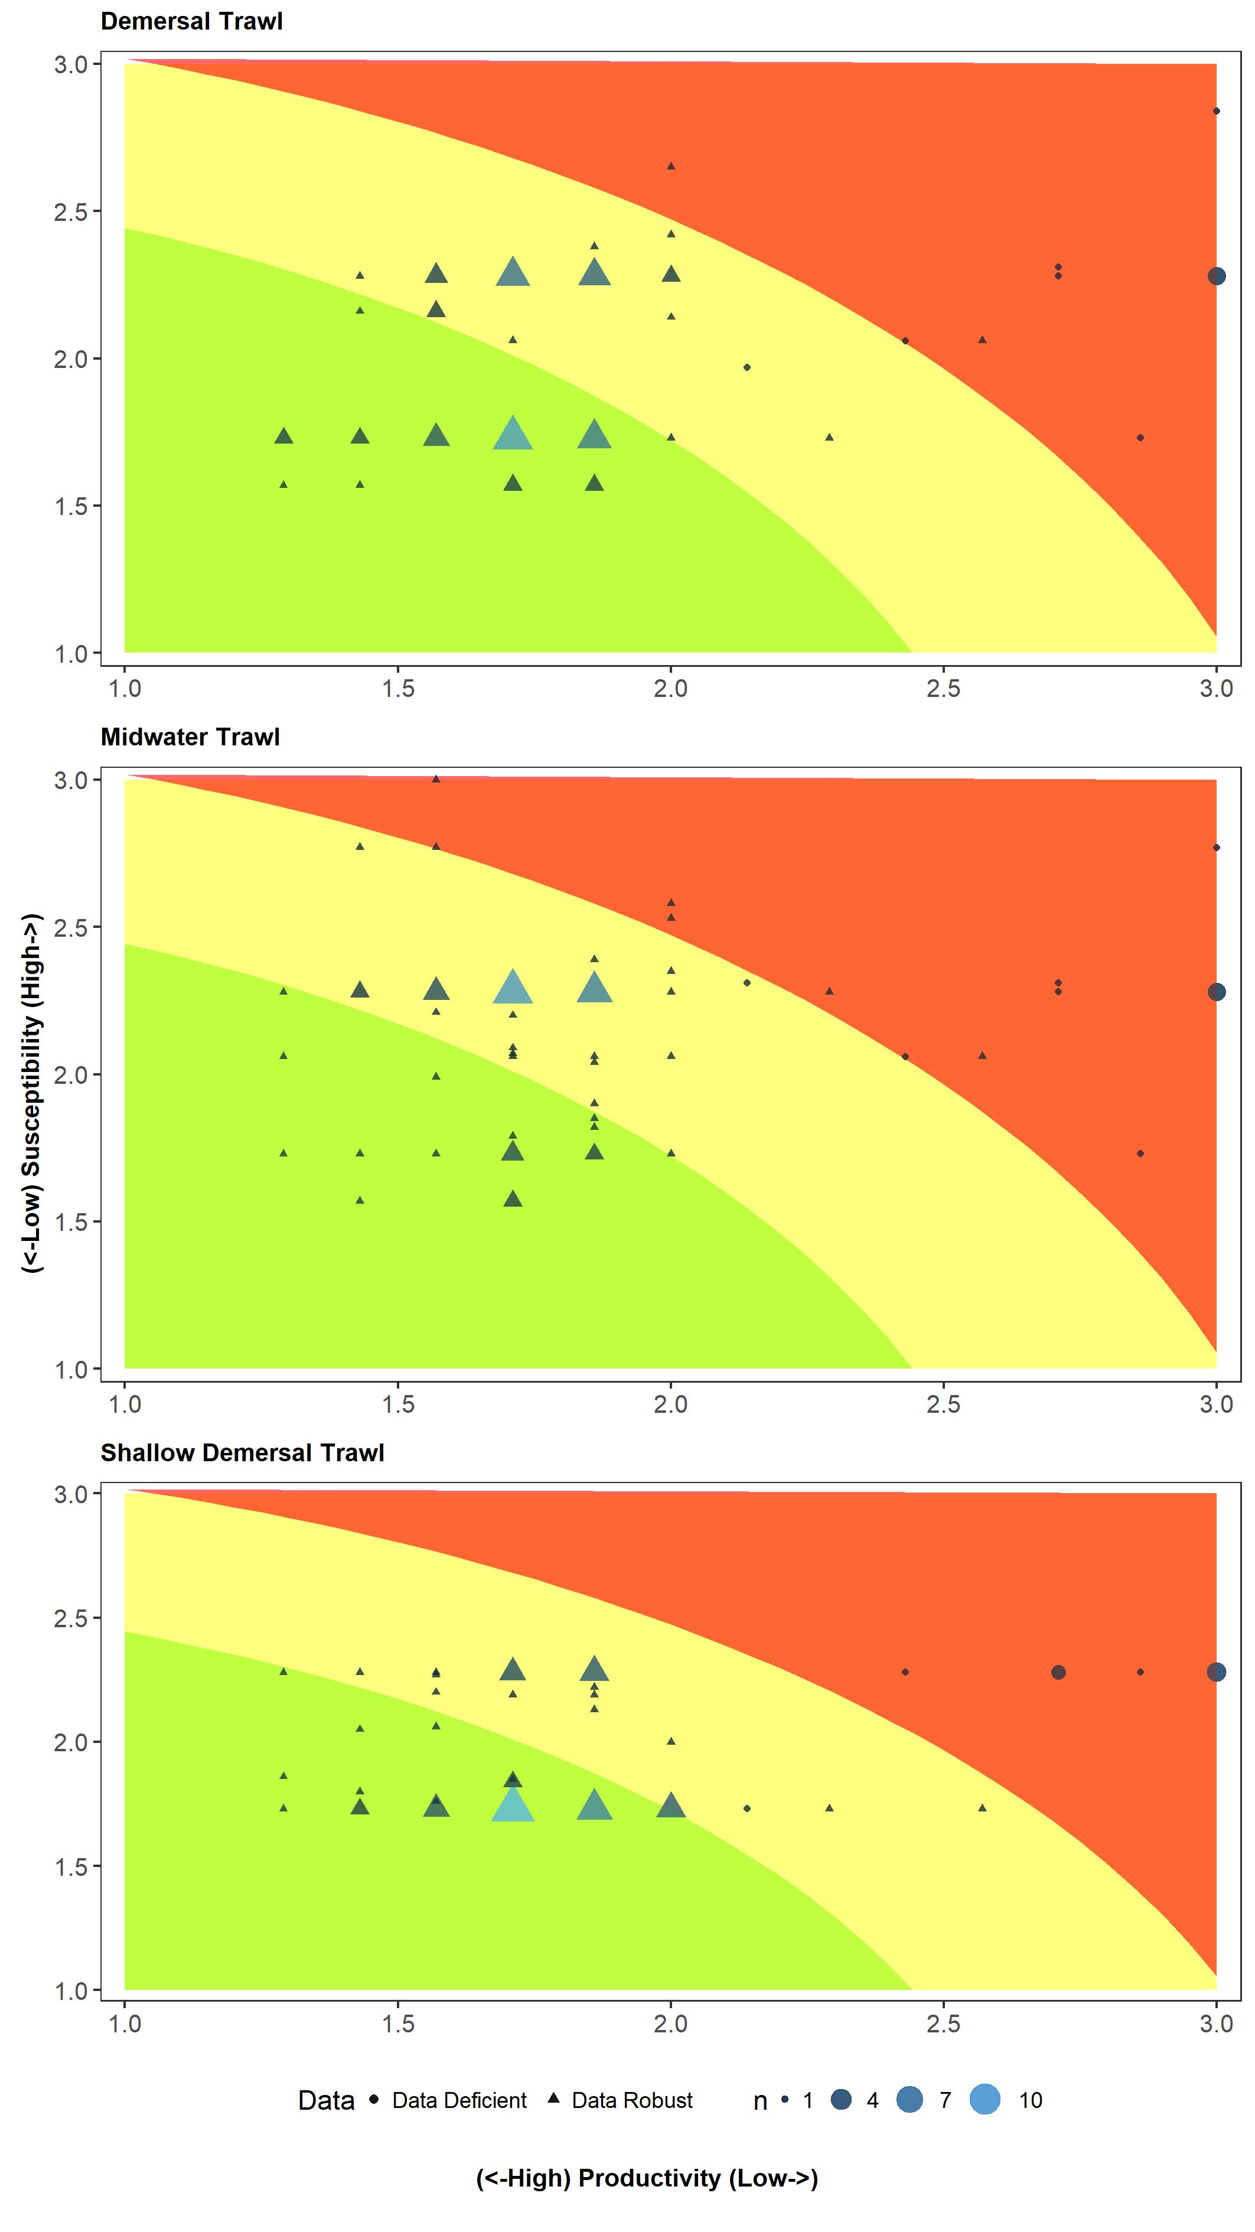

Figure 1b. PSA results for 70 teleost species thought to occur and have the potential to interact with demersal longline and pelagic longline gears in the Southern Indian Ocean. Size of symbol represents number (n) of species with the same vulnerability score, while the shape equates to whether the species is ‘data deficient’ (circle) or ‘data robust’ (triangle). Data deficient species are defined as those missing three or more productivity and/or susceptibility attributes. Based on the existing 80-100% probability of occurrence layer from the AquaMaps distribution data.
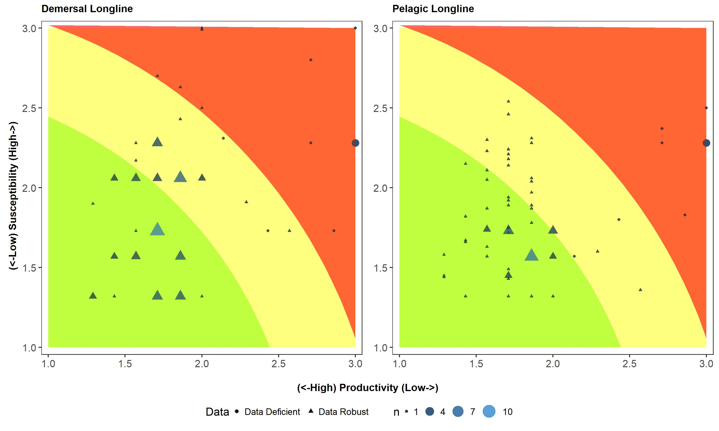

Figure 2a: Relationship between SAFE and PSA results for 70 teleost species thought to occur and have the potential to interact with demersal trawl, midwater trawl and shallow demersal trawl in the Southern Indian Ocean. Points are coloured yellow and green to signify species classified as medium and low vulnerability, respectively, in the SAFE. Dashed red and orange lines represent PSA risk high and medium score boundaries. Six species are not shown on the panels as F-based reference points were unable to be calculated. Based on the existing 80-100% probability of occurrence layer from the AquaMaps distribution data.
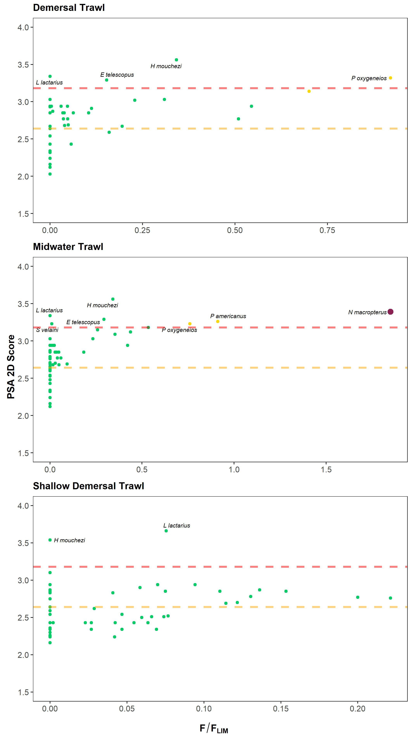
Figure 2b: Relationship between SAFE and PSA results for 70 teleost species thought to occur and have the potential to interact with demersal longline and pelagic longline gears in the Southern Indian Ocean. Points are coloured dark red, light red, yellow and green to signify species classified as extreme, high, medium and low vulnerability, respectively, in the SAFE. Dashed red and orange lines represent PSA risk high and medium score boundaries. Six species are not shown on the panels as F-based reference points were unable to be calculated. Based on the existing 80-100% probability of occurrence layer from the AquaMaps distribution data.
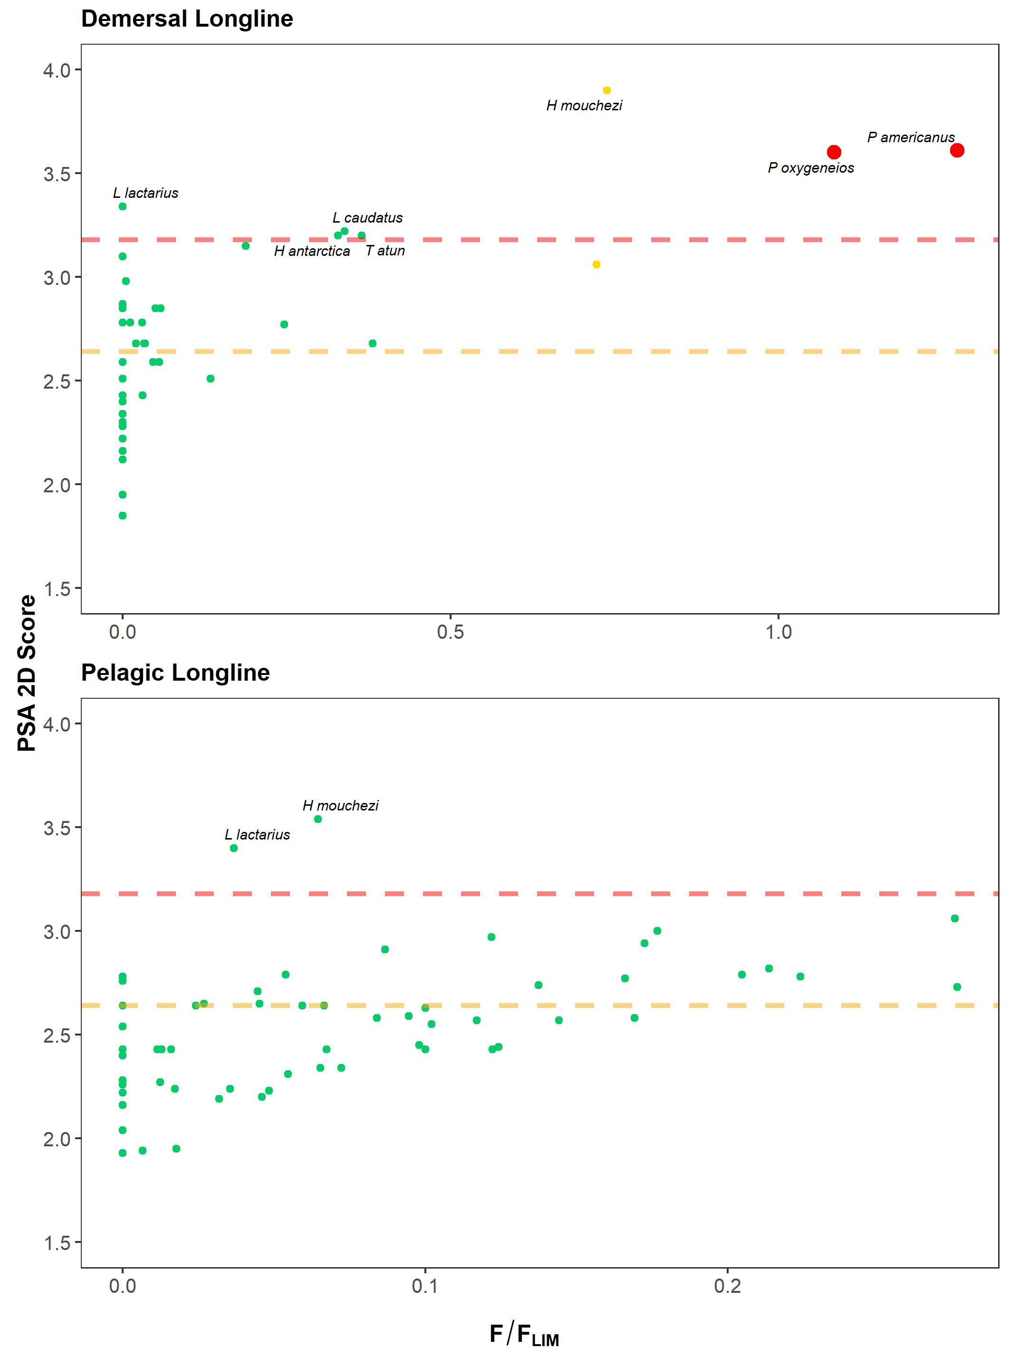
Table 3. Overview of PSA and SAFE vulnerability categories for each species and each gear type included in the assessment. Note that PSA DD (‘Data Deficient’) denotes species included in the PSA that were missing three or more productivity and/or susceptibility attributes. SAFE DD denotes species included in the SAFE for which F-based reference points (F_{msm}, F_{lim} and F_{crash}) were unable to be estimated. Based on the existing 80-100% probability of occurrence layer from the AquaMaps distribution data.
Species | Demersal Trawl |  | Midwater Trawl |  | Demersal Longline |  | Pelagic Longline |  | Shallow Demersal Trawl |  | PSA DD | SAFE DD
 | PSA | SAFE | PSA | SAFE | PSA | SAFE | PSA | SAFE | PSA | SAFE
Allocyttus niger | Medium | Low | Medium | Low | Medium | Low | Low | Low | Low | Low
Allocyttus verrucosus | Medium | Low | Medium | Low | Medium | Low | Low | Low | Low | Low
Aluterus monoceros | Low | Low | Low | Low | Low | Low | Low | Low | Low | Low
Antimora rostrata | Medium | Low | Medium | Low | Medium | Low | Low | Low | Low | Low
Aprion virescens | Low | Low | Medium | Low | Low | Low | Medium | Low | Medium | Low
Barbourisia rufa | High | Extreme | High | Extreme | High | Extreme | High | Extreme | High | Extreme | DD | DD
Beryx decadactylus | Medium | Low | Medium | Low | Low | Low | Low | Low | Low | Low
Beryx splendens | Medium | Low | Medium | Low | Low | Low | Low | Low | Low | Low
Borostomias antarcticus | High | Extreme | High | Extreme | Medium | Extreme | Medium | Extreme | High | Extreme | DD | DD
Caesio cuning | Medium | Low | Medium | Low | Low | Low | Low | Low | Medium | Low
Carangoides fulvoguttatus | Low | Low | Low | Low | Low | Low | Low | Low | Medium | Low
Cephalopholis sonnerati | Low | Low | Low | Low | Low | Low | Medium | Low | Medium | Low
Cyttus traversi | Medium | Low | Medium | Low | Low | Low | Low | Low | Low | Low
Decapterus russelli | Low | Low | Medium | Low | Low | Low | Low | Low | Low | Low
Dissostichus eleginoides | Medium | Low | Medium | Low | Medium | Low | Low | Low | Medium | Low
Elagatis bipinnulata | Low | Low | Low | Low | Low | Low | Medium | Low | Medium | Low
Epigonus telescopus | High | Low | High | Low | Medium | Low | Medium | Low | Medium | Low
Epinephelus fasciatus | Low | Low | Low | Low | Low | Low | Medium | Low | Medium | Low
Epinephelus marginatus | High | Extreme | High | Extreme | High | Extreme | High | Extreme | High | Low | DD | DD
Epinephelus morrhua | Low | Low | Medium | Low | Low | Low | Low | Low | Low | Low
Epinephelus multinotatus | Low | Low | Low | Low | Low | Low | Low | Low | Medium | Low
Etelis carbunculus | Low | Low | Medium | Low | Low | Low | Medium | Low | Low | Low
Etelis coruscans | Low | Low | Medium | Low | Low | Low | Medium | Low | Low | Low
Gnathanodon speciosus | Low | Low | Low | Low | Low | Low | Low | Low | Medium | Low
Helicolenus dactylopterus | High | Extreme | High | Extreme | High | Extreme | High | Extreme | High | Extreme | DD | DD
Helicolenus mouchezi | High | Low | High | Low | High | Medium | High | Low | High | Low | DD
Helicolenus percoides | Medium | Low | Medium | Low | Medium | Low | Low | Low | Low | Low
Hoplostethus atlanticus | Medium | Low | Medium | Low | Medium | Medium | Low | Low | Low | Low
Hoplostethus intermedius | Medium | Low | Medium | Low | Low | Low | Low | Low | Low | Low
Hyperoglyphe antarctica | Medium | Low | Medium | Low | High | Low | Medium | Low | Medium | Low
Lactarius lactarius | High | Low | High | Low | High | Low | High | Low | High | Low | DD
Latridopsis forsteri | Low | Low | Medium | Low | Low | Low | Medium | Low | Medium | Low
Lepidocybium flavobrunneum | Medium | Low | Medium | Low | Medium | Low | Low | Low | Low | Low
Lepidopus caudatus | Medium | Low | Medium | Low | High | Low | Low | Low | Low | Low
Lethrinus mahsena | High | Low | High | Low | High | Low | High | Extreme | High | Extreme | DD | DD
Lethrinus nebulosus | Low | Low | Low | Low | Low | Low | Low | Low | Medium | Low
Lutjanus bohar | Low | Low | Medium | Low | Low | Low | Medium | Low | Medium | Low
Lutjanus lutjanus | Low | Low | Low | Low | Low | Low | Low | Low | Medium | Low
Macruronus novaezelandiae | Medium | Low | Medium | Low | Medium | Low | Low | Low | Low | Low
Microcanthus strigatus | Low | Low | Low | Low | Low | Low | Medium | Low | Medium | Low
Mora moro | Medium | Low | Medium | Low | Medium | Low | Low | Low | Low | Low
Nemadactylus macropterus | Medium | Low | High | Extreme | Medium | Low | Low | Low | Low | Low
Neocyttus rhomboidalis | Medium | Low | Medium | Low | Medium | Low | Low | Low | Low | Low
Pagellus affinis | High | Low | High | Low | High | Low | High | Low | High | Low | DD | DD
Pentaprion longimanus | Low | Low | Medium | Low | Low | Low | Medium | Low | Medium | Low
Plagiogeneion rubiginosum | Low | Low | Medium | Low | Medium | Low | Low | Low | Low | Low
Platycephalus australis | Low | Low | Medium | Low | Low | Low | Medium | Low | Medium | Low
Plectropomus laevis | Low | Low | Low | Low | Low | Low | Low | Low | Medium | Low
Polyprion americanus | Medium | Medium | High | Medium | High | High | Medium | Low | Medium | Low
Polyprion oxygeneios | High | Medium | High | Medium | High | High | Medium | Low | Medium | Low
Pristipomoides filamentosus | Low | Low | Medium | Low | Low | Low | Medium | Low | Low | Low
Promethichthys prometheus | Medium | Low | Medium | Low | Medium | Low | Low | Low | Low | Low
Pseudocaranx georgianus | Medium | Low | Medium | Low | Medium | Low | Low | Low | Low | Low
Pseudocyttus maculatus | Medium | Low | Medium | Low | Medium | Low | Low | Low | Medium | Low
Pseudopentaceros richardsoni | Medium | Low | Medium | Low | Medium | Low | Medium | Low | Medium | Low | DD
Rexea solandri | Medium | Low | Medium | Low | Medium | Low | Low | Low | Low | Low
Ruvettus pretiosus | Medium | Low | Medium | Low | Medium | Low | Low | Low | Low | Low
Sargocentron rubrum | Low | Low | Low | Low | Low | Low | Low | Low | Low | Low
Saurida undosquamis | Low | Low | Low | Low | Low | Low | Low | Low | Low | Low
Schedophilus velaini | Medium | Low | High | Low | Medium | Low | Medium | Low | Medium | Low
Selar crumenophthalmus | Low | Low | Medium | Low | Low | Low | Medium | Low | Medium | Low
Selaroides leptolepis | Low | Low | Low | Low | Low | Low | Low | Low | Low | Low
Seriola dumerilli | Low | Low | Medium | Low | Low | Low | Medium | Low | Low | Low
Seriola lalandi | Medium | Low | Medium | Low | Medium | Low | Low | Low | Low | Low
Seriolella punctata | Medium | Low | Medium | Low | Low | Low | Low | Low | Low | Low
Seriolina nigrofasciata | Low | Low | Low | Low | Low | Low | Medium | Low | Medium | Low
Sphyraena obtusata | Low | Low | Low | Low | Low | Low | Low | Low | Low | Low
Thyrsites atun | Low | Low | Medium | Low | High | Low | Low | Low | Low | Low
Trachurus novaezelandiae | Low | Low | Low | Low | Low | Low | Low | Low | Low | Low
Zeus faber | Low | Low | Medium | Low | Low | Low | Low | Low | Low | Low

Table 4. Overview of SAFE vulnerability categories, susceptibility (F-estimate) scores and F-based reference points (F_{msm}, F_{lim} and F_{crash}). Based on the existing 80-100% probability of occurrence layer from the AquaMaps distribution data.
Species | Pelagic longline |  | Demersal longline |  | Demersal trawl |  | Midwater trawl |  | Shallow demersal trawl |  | F_{msm} | F_{lim} | F_{crash}
 | Vulnerability | F estimate | Vulnerability | F estimate | Vulnerability | F estimate | Vulnerability | F estimate | Vulnerability | F estimate
Allocyttus niger | Low | 0 | Low | 0 | Low | 0 | Low | 0 | Low | 0 | 0.12 | 0.19 | 0.25
Allocyttus verrucosus | Low | 0.017 | Low | 0.002 | Low | 0.008 | Low | 0.003 | Low | 0 | 0.11 | 0.17 | 0.23
Aluterus monoceros | Low | 0.011 | Low | 0 | Low | 0 | Low | 0 | Low | 0.026 | 0.42 | 0.62 | 0.83
Antimora rostrata | Low | 0.033 | Low | 0.01 | Low | 0.031 | Low | 0.008 | Low | 0.001 | 0.33 | 0.49 | 0.65
Aprion virescens | Low | 0.154 | Low | 0 | Low | 0 | Low | 0 | Low | 0.073 | 0.37 | 0.56 | 0.75
Barbourisia rufa | Extreme | 0.117 | Extreme | 0.097 | Extreme | 0.055 | Extreme | 0.043 | Extreme | 0.017
Beryx decadactylus | Low | 0.034 | Low | 0.022 | Low | 0.017 | Low | 0.019 | Low | 0.022 | 0.31 | 0.47 | 0.63
Beryx splendens | Low | 0.034 | Low | 0.029 | Low | 0.025 | Low | 0.031 | Low | 0.014 | 0.34 | 0.52 | 0.69
Borostomias antarcticus | Extreme | 0.039 | Extreme | 0.014 | Extreme | 0.035 | Extreme | 0.022 | Extreme | 0.003
Caesio cuning | Low | 0 | Low | 0 | Low | 0 | Low | 0 | Low | 0 | 0.81 | 1.22 | 1.63
Carangoides fulvoguttatus | Low | 0.016 | Low | 0 | Low | 0 | Low | 0 | Low | 0.069 | 0.62 | 0.92 | 1.23
Cephalopholis sonnerati | Low | 0.055 | Low | 0 | Low | 0 | Low | 0 | Low | 0.086 | 0.82 | 1.23 | 1.64
Cyttus traversi | Low | 0.041 | Low | 0 | Low | 0.037 | Low | 0.07 | Low | 0 | 0.5 | 0.75 | 1
Decapterus russelli | Low | 0.079 | Low | 0 | Low | 0 | Low | 0 | Low | 0.056 | 0.62 | 0.94 | 1.25
Dissostichus eleginoides | Low | 0 | Low | 0 | Low | 0 | Low | 0 | Low | 0 | 0.12 | 0.18 | 0.24
Elagatis bipinnulata | Low | 0.136 | Low | 0 | Low | 0 | Low | 0 | Low | 0.085 | 0.51 | 0.77 | 1.02
Epigonus telescopus | Low | 0.013 | Low | 0 | Low | 0.023 | Low | 0.044 | Low | 0 | 0.1 | 0.15 | 0.2
Epinephelus fasciatus | Low | 0.091 | Low | 0 | Low | 0 | Low | 0 | Low | 0.073 | 0.22 | 0.33 | 0.44
Epinephelus marginatus | Extreme | 0.056 | Extreme | 0.303 | Extreme | 0.241 | Extreme | 0.219 | Low | 0
Epinephelus morrhua | Low | 0.066 | Low | 0 | Low | 0 | Low | 0 | Low | 0.027 | 0.26 | 0.39 | 0.52
Epinephelus multinotatus | Low | 0.046 | Low | 0 | Low | 0 | Low | 0 | Low | 0.074 | 0.25 | 0.37 | 0.49
Etelis carbunculus | Low | 0.094 | Low | 0 | Low | 0 | Low | 0 | Low | 0.028 | 0.29 | 0.44 | 0.59
Etelis coruscans | Low | 0.088 | Low | 0 | Low | 0 | Low | 0 | Low | 0.033 | 0.29 | 0.43 | 0.57
Gnathanodon speciosus | Low | 0 | Low | 0 | Low | 0 | Low | 0 | Low | 0 | 0.51 | 0.77 | 1.03
Helicolenus dactylopterus | Extreme | 0.099 | Extreme | 0.067 | Extreme | 0.027 | Extreme | 0.028 | Extreme | 0.042
Helicolenus mouchezi | Low | 0.02 | Medium | 0.229 | Low | 0.106 | Low | 0.106 | Low | 0 | 0.21 | 0.31 | 0.41
Helicolenus percoides | Low | 0 | Low | 0 | Low | 0 | Low | 0 | Low | 0 | 0.23 | 0.35 | 0.46
Hoplostethus atlanticus | Low | 0.022 | Medium | 0.13 | Low | 0.098 | Low | 0.076 | Low | 0 | 0.12 | 0.18 | 0.24
Hoplostethus intermedius | Low | 0.016 | Low | 0.01 | Low | 0.013 | Low | 0.016 | Low | 0.018 | 0.22 | 0.33 | 0.44
Hyperoglyphe antarctica | Low | 0.019 | Low | 0.105 | Low | 0.099 | Low | 0.113 | Low | 0 | 0.21 | 0.32 | 0.42
Lactarius lactarius | Low | 0.042 | Low | 0 | Low | 0 | Low | 0 | Low | 0.086 | 0.76 | 1.14 | 1.52
Latridopsis forsteri | Low | 0 | Low | 0 | Low | 0 | Low | 0 | Low | 0 | 0.21 | 0.31 | 0.41
Lepidocybium flavobrunneum | Low | 0.075 | Low | 0.026 | Low | 0.019 | Low | 0.025 | Low | 0.014 | 0.35 | 0.52 | 0.7
Lepidopus caudatus | Low | 0.006 | Low | 0.176 | Low | 0.119 | Low | 0.121 | Low | 0 | 0.35 | 0.52 | 0.7
Lethrinus mahsena | Extreme | 0.144 | Low | 0 | Low | 0 | Low | 0 | Extreme | 0.065
Lethrinus nebulosus | Low | 0.016 | Low | 0 | Low | 0 | Low | 0 | Low | 0.069 | 0.3 | 0.45 | 0.6
Lutjanus bohar | Low | 0.103 | Low | 0 | Low | 0 | Low | 0 | Low | 0.056 | 0.31 | 0.46 | 0.62
Lutjanus lutjanus | Low | 0.029 | Low | 0 | Low | 0 | Low | 0 | Low | 0.072 | 0.42 | 0.63 | 0.84
Macruronus novaezelandiae | Low | 0 | Low | 0 | Low | 0 | Low | 0 | Low | 0 | 0.24 | 0.36 | 0.48
Microcanthus strigatus | Low | 0 | Low | 0 | Low | 0 | Low | 0 | Low | 0 | 0.28 | 0.42 | 0.55
Mora moro | Low | 0.047 | Low | 0.015 | Low | 0.048 | Low | 0.013 | Low | 0 | 0.31 | 0.46 | 0.61
Nemadactylus macropterus | Low | 0 | Low | 0.122 | Low | 0.163 | Extreme | 0.592 | Low | 0 | 0.22 | 0.32 | 0.43
Neocyttus rhomboidalis | Low | 0.004 | Low | 0 | Low | 0.001 | Low | 0.002 | Low | 0 | 0.16 | 0.25 | 0.33
Pagellus affinis | Low | 0 | Low | 0 | Low | 0 | Low | 0 | Low | 0
Pentaprion longimanus | Low | 0.045 | Low | 0 | Low | 0 | Low | 0 | Low | 0.076 | 1.24 | 1.86 | 2.48
Plagiogeneion rubiginosum | Low | 0 | Low | 0 | Low | 0 | Low | 0 | Low | 0 | 0.36 | 0.54 | 0.72
Platycephalus australis | Low | 0.1 | Low | 0 | Low | 0 | Low | 0 | Low | 0.079 | 0.39 | 0.58 | 0.78
Plectropomus laevis | Low | 0 | Low | 0 | Low | 0 | Low | 0 | Low | 0 | 0.31 | 0.47 | 0.62
Polyprion americanus | Low | 0.012 | High | 0.229 | Medium | 0.126 | Medium | 0.164 | Low | 0 | 0.12 | 0.18 | 0.24
Polyprion oxygeneios | Low | 0 | High | 0.217 | Medium | 0.184 | Medium | 0.152 | Low | 0 | 0.13 | 0.2 | 0.26
Pristipomoides filamentosus | Low | 0.083 | Low | 0 | Low | 0 | Low | 0 | Low | 0.037 | 0.33 | 0.5 | 0.66
Promethichthys prometheus | Low | 0.055 | Low | 0.014 | Low | 0.014 | Low | 0.011 | Low | 0.022 | 0.31 | 0.47 | 0.63
Pseudocaranx georgianus | Low | 0.041 | Low | 0.101 | Low | 0.08 | Low | 0.219 | Low | 0 | 0.27 | 0.41 | 0.54
Pseudocyttus maculatus | Low | 0 | Low | 0 | Low | 0 | Low | 0 | Low | 0 | 0.16 | 0.23 | 0.31
Pseudopentaceros richardsoni | Low | 0.011 | Low | 0.077 | Low | 0.046 | Low | 0.106 | Low | 0 | 0.27 | 0.41 | 0.54
Rexea solandri | Low | 0 | Low | 0 | Low | 0 | Low | 0 | Low | 0 | 0.28 | 0.41 | 0.55
Ruvettus pretiosus | Low | 0.051 | Low | 0.018 | Low | 0.018 | Low | 0.019 | Low | 0.022 | 0.35 | 0.52 | 0.7
Sargocentron rubrum | Low | 0.016 | Low | 0 | Low | 0 | Low | 0 | Low | 0.069 | 1.6 | 2.4 | 3.2
Saurida undosquamis | Low | 0 | Low | 0 | Low | 0 | Low | 0 | Low | 0 | 0.56 | 0.85 | 1.13
Schedophilus velaini | Low | 0.021 | Low | 0.002 | Low | 0.003 | Low | 0.004 | Low | 0 | 0.26 | 0.39 | 0.52
Selar crumenophthalmus | Low | 0.048 | Low | 0 | Low | 0 | Low | 0 | Low | 0.062 | 0.71 | 1.06 | 1.41
Selaroides leptolepis | Low | 0.018 | Low | 0 | Low | 0 | Low | 0 | Low | 0.033 | 0.96 | 1.44 | 1.92
Seriola dumerilli | Low | 0.077 | Low | 0 | Low | 0 | Low | 0 | Low | 0.037 | 0.38 | 0.56 | 0.75
Seriola lalandi | Low | 0.052 | Low | 0.032 | Low | 0.021 | Low | 0.015 | Low | 0.03 | 0.37 | 0.55 | 0.73
Seriolella punctata | Low | 0 | Low | 0 | Low | 0 | Low | 0 | Low | 0 | 0.33 | 0.5 | 0.66
Seriolina nigrofasciata | Low | 0.106 | Low | 0 | Low | 0 | Low | 0 | Low | 0.082 | 0.58 | 0.87 | 1.17
Sphyraena obtusata | Low | 0 | Low | 0 | Low | 0 | Low | 0 | Low | 0 | 0.42 | 0.63 | 0.84
Thyrsites atun | Low | 0.007 | Low | 0.197 | Low | 0.031 | Low | 0.099 | Low | 0 | 0.36 | 0.54 | 0.71
Trachurus novaezelandiae | Low | 0 | Low | 0 | Low | 0 | Low | 0 | Low | 0 | 0.46 | 0.69 | 0.93
Zeus faber | Low | 0.016 | Low | 0.067 | Low | 0.08 | Low | 0.219 | Low | 0 | 0.33 | 0.5 | 0.66

Formerly ABARES, now Office of the Science Convenor
See Zhou et al. (2011) https://www.sciencedirect.com/science/article/pii/S0165783610002481 for a full description of the reference points and ecological consequence.

