9th Meeting of the Parties (MoP9)
Reunion Island, 4–8 July 2022
MOP-09-16-rev1
Proposed SIOFA standard operating procedure for data use and data requests

Consultant Ross Analytics
Submitted 09.06-2022

Document type | administrative paper ☐  working paper ✔  information paper ☐
Distribution | Public ✔  Restricted ☐  Confidential ☐
Abstract
CMM 2016/03 on Data Confidentiality in paragraph 2€ states that “Finer-scale data including catch and effort, length-frequency and observer data will be made available to the Scientific Committee and any of its working groups, on a confidential basis, to undertake its work.” Regarding the different views of the CCPs on the modalities by which such data should be ‘made available’ (ref SC 07 paragraphs 54 - 56), the Scientific Committee recommended the MoP to provide documentation and guidelines on how CMM 2016/03 should be operationalised. This document proposes a draft standard operating procedure for data use and data requests for the MoP attention.

Recommendations
- The MoP to review the proposed procedure
- The MoP to endorse a standard operating procedure for data use and data requests
- The procedure to be annexed to CMM 2016/03

Proposed SIOFA standard operating procedure for data use and data requests.
Prepared as part of Project Code: SEC2021-05
  - Dr Keith Reid, Ross Analytics PTY LTD, Australia. keith.reid@rossanalytics.com.au

Introduction
CMM 2016/03 paragraph 2. (e) states that “Finer-scale data including catch and effort, length-frequency and observer data will be made available to the Scientific Committee and any of its working groups, on a confidential basis, to undertake its work.”.

However, there are differences in the views of CCPs on the modalities by which such data should be ‘made available’ (SC 07 paragraphs 54 - 56).

The Scientific Committee recommended the MoP consider providing documentation and guidelines on how CMM 2016/03 should be operationalised, including the implementation of standard operating procedures for data use and data requests provided in SC-07-08 (SC 07 paragraphs 54 - 56). The proposed standard operating procedure is also included as Section 6.2 of MoP-09-08.

Proposed standard operating procedure for data use and data requests
The standard operating procedure for data use and data requests presented in SC-07-08 seeks to provide a standard operating procedure to formalise the process by which SIOFA data are made available, to ensure that all relevant CCPs are consulted, to increase awareness of the process, facilitate greater consultation and increase the scope for making data available.

The following, which is based on the procedures currently used in WCPFC and CCAMLR, provides a procedure to be implemented in SIOFA to manage all data releases from the Secretariat (where these ‘data releases’ includes database extracts and/or data analysis/summary products including meeting papers).

Upon the adoption of a standard operating procedure for data use and data requests for use in SIOFA, CMM 2016/03 paragraph 2 (f) could be simplified as follows (with strike through text deleted and red text inserted):
f) Catch and effort and length-frequency data grouped at a finer level of time-area stratification will only be released following the SIOFA standard operating procedure for data use and data requests.

The MoP is invited to consider and adopt the standard operating procedure for data use and data requests for use in SIOFA and to make the consequential change in CMM 2016/03 paragraph 2 (f).
SIOFA standard operating procedure for data use and data requests

Data Requests

Data requests should be received via secretariat@siofa.org in the first instance.

Public Domain data, that is currently in the public domain, may be provided directly from the Secretariat to the data requestor.

Requests for all other data should be dealt with as follows:

- Request for access

A request for access to data that is not in the public domain should be accompanied by a standardised data request form (this should be sent to the data requestors for completion if not supplied with the request). This form, an example of which is given in Figure 3, specifies the type of data being requested, the spatial and temporal resolution and extent and the resolution and the proposed use of the data including any references to specific paragraphs that contain the requests for the analysis from the MoP, the SC and its working groups or the Compliance Committee.

Requester | Dr A Scientist (Employer, CCP, non-CCP, other)
Data | Data type: Haul by Haul toothfish catch and effort data, including  - Setting dates  - Setting coordinates  - Number of hooks set and lost for each haul  - Mass of all individual species caught  - Vessels should be identified as being distinct but anonymised with respect to name and flag  Level of aggregation: Haul by haul  Spatial and Temporal extent: All SIOFA Area 2011-2021
Proposed use | Research question: Are CPUE measurements for toothfish catches biased by gear loss when fishing in exploratory areas where the sea floor topography is not well studied?  Planned analysis: We will examine CPUE and gear loss rates spatially and temporally.  Anticipated format to be used in presenting results: We will present a paper on variation of CPUE of target and non-target catch in the longline fishery for toothfish in the SIOFA Area to SERWG
SIOFA SC reference | SC 5 para xx-yy  MoP3 para xx-yy

Figure 3. Example SIOFA request for access to data

- Request for permission to release data

Unless otherwise advised by a CCP, the SC Representative will be the CCP’s data owner(s)/originator(s) primary contact (CCP data primary contact) for all requests for permission to release data.

When the SIOFA data request form has been completed by the Requester the Secretariat will send it to all CCP data primary contacts for those CCPs that are originator(s)/owner(s) of data that form part of the request. The following explanation will accompany each permission request:

In accordance with CMM 2016/03 Conservation and Management Measure for Data Confidentiality and Procedures for access and use of data (Data Confidentiality) the Secretariat is seeking your permission to release some of the data held at the SIOFA Secretariat of which you are the owner and/or originator. The details of the requester, the requested data, the proposed use and any references to specific requests for the analysis from the relevant SIOFA body are included in the table below.

Please email your permission or refusal to release these data, including any conditions and/or recommendations relating the proposed use of the data before [insert date]. If you have any questions or clarifications for the data requester, please email these to the Secretariat for forwarding.

Release of data for the analysis outlined above does not constitute permission to publish or release these data into the public domain. Such permission remains a matter to be determined between the requester and the data originator(s)/owner(s).

This request for permission to release data has been sent to the data contacts for the following CCPs [list the data contacts of all data originators] e.g.
Australia Dr A. Scientist France Dr B. Scientist

- Secretariat correspondence

Following the request for permission to release data the Secretariat will follow the procedure outlined below:
  - Request a response from the CCP data primary contact within 3 weeks.
  - Follow up after 2 weeks to CCP data primary contact who have not yet responded.
  - Request a response within 1 more week, notifying CCP data primary contact that, no data will be released without the expressed consent of the data owner.The Secretariat would continue engaging with the CCP in the absence of answer. .
  - Where a CCP data primary contact raises any questions or concerns, the Secretariat will facilitate consultation between data requester(s) and data owner(s) to address these concerns,
  - Any subset of the data not approved for release will be excluded from the data extract.
  - Prior to releasing the data, the requester(s) should be contacted to let them know the outcome of the data request process and provide details of the format and content of the data that will be released.

Release of data:
When agreement has been reached on what data can be released, the Secretariat will provide the data, metadata and associated documentation and will inform all data owners of the data release.
The Secretariat will provide all data releases by email as an attached zip file that is password protected.
Each data release from the SIOFA Secretariat will be given a reference number, and the data, query used to extract the data and the date(s) of extraction will be recorded in a data release registry. The reference number should be added to the Data Request form and this should be stored within a data release registry.

Use of data by the Secretariat

The Secretariat has access to all SIOFA data in order to carry out its functions on a day-to-day basis. Furthermore, the Secretariat is expected to present data products to the MoP, the SC and other subsidiary bodies for which the requirement (and in some cases the method including the data to be used and the format for presentation) will have been agreed by these bodies in advance. In those cases, the Secretariat should produce these papers as part of its normal work. Where additional data analyses (i.e. not those specifically requested by MoP, the SC and other subsidiary bodies) are undertaken and are prepared for inclusion in a paper to the Scientific Committee or its Working Groups, the Secretariat should follow the same procedures to seek permission to use the data as for any other data release.
Data Corrections
Each data release should be accompanied by a reporting form to allow users to identify any data errors that they encounter while using the data. The Secretariat will then review the information provided and implement a data verification and change process as required. Users should be advised of any data change that would potentially impact on the data included in an extract provided in a data extract from the past 12 months.

Annex 1: Flowchart of process data use and data requests.
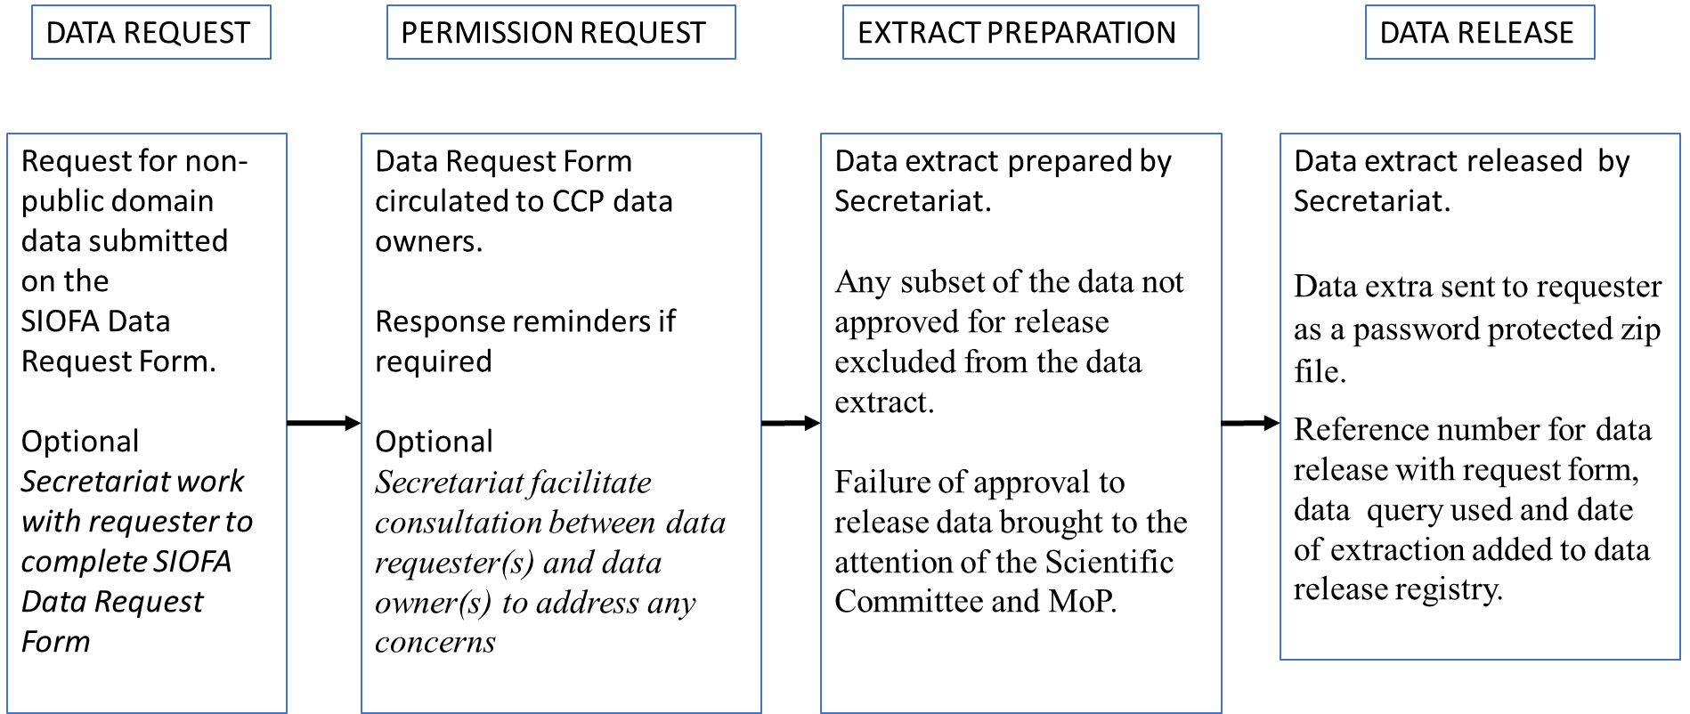

Restricted documents may contain confidential information. Please do not distribute restricted documents in any form without the explicit permission of the SIOFA Secretariat and the data owner(s)/provider(s).
Documents available only to members invited to closed sessions as per SIOFA RoP 20.

