CC-05-09 rev1

5th Compliance Committee of the Southern Indian Ocean Fisheries Agreement
(CC5)
01-03 July 2021 (online)

Proposal to amend Conservation and Management Measure 2020/15 for the Management of Demersal Stocks in the Agreement Area (Management of Demersal Stocks)

Relates to agenda item: 4.1 Working paper Info paper

Delegations of Australia and the European Union
Abstract

During the 2020/21 toothfish fishing season, Australia and the European Union with input from the Secretariat, established informal working arrangements and templates to ensure that the Williams Ridge fishery could be implemented smoothly, in particular as regards the treatment of fishing notifications, while respecting the effort limitation agreed for that fishery.

The proposed amendments to CMM 2020/15 aim to incorporate these informal arrangements and templates into the CMM to render them obligatory, thereby enhancing legal certainty, and to enable them to be compliance assessed. It is proposed to use this opportunity to replace reference to ‘D. eleginoides’ by ‘Dissostichus spp.’ throughout the CMM, as recommended by the Scientific Committee (SC6 report, para 114) and also to include the existing reporting templates that are currently available on the SIOFA website: https://www.apsoi.org/sites/default/files/files/CMM%202020-15%20Guidelines%20and%20Reporting%20Templates.pdf.
Recommendations

1. CC5 is invited to review and discuss the proposed amendments to CMM 2020/15, and to recommend their adoption to MoP8.

CMM 2020/15

Conservation and Management Measure for the Management of Demersal Stocks in the Agreement Area (Management of Demersal Stocks)

The Meeting of the Parties to the Southern Indian Ocean Fisheries Agreement;
RECOGNISING that Article 4(a) of the Southern Indian Ocean Fisheries Agreement (the Agreement) calls on the Contracting Parties, in giving effect to the duty to cooperate, to adopt measures on the basis of the best scientific evidence available to ensure the long-term conservation of fishery resources, taking into account the sustainable use of such resources and implementing an ecosystem approach to their management;

FURTHER RECOGNISING Articles 4(c), (e) and (f) of the Agreement which call on the Contracting Parties to apply the precautionary approach and the principles that fishing practices and management measures shall take due account of the need to minimise the harmful impact that fishing activities may have on the marine environment and that biodiversity in the marine environment shall be protected;

FURTHER RECOGNISING Articles 6(1)(d) and (e) of the Agreement which provide that the Meeting of the Parties shall adopt conservation and management measures (CMMs) necessary for ensuring the long-term sustainability of fishery resources, taking into account the need to protect marine biodiversity, based on the best scientific evidence available and adopt generally recommended international minimum standards for the responsible conduct of fishing operations;

MINDFUL of Article 16 of the Agreement that calls on Contracting Parties, acting jointly under the Agreement, to cooperate closely with other international fisheries and related organisations in matters of mutual interest;

COMMITTED to ensuring that bottom fishing undertaken in the Agreement Area is consistent with the long-term sustainability of deep-sea fish stocks and the protection of the marine environment;

ADOPTS the following CMM in accordance with Article 6 of the Agreement: Objective
- The objective of this CMM is to promote the sustainable management of deep-sea fisheries resources in the Agreement Area, including target fish stocks and non-target species.
General provisions
- This CMM applies to all fishing vessels flying the flag of a Contracting Party, cooperating non-Contracting Party, participating fishing entity or cooperating non-participating fishing entity (collectively CCPs) to the Agreement engaging or intending to engage in bottom fishing in the Agreement Area.
Status of Stocks
- The Scientific Committee shall provide annual reports, based on the best available science, on the status of the demersal fisheries resources targeted in the Agreement Area, relative to available and/or relevant reference points. The reports shall include, where possible, projections of stock status over a period no less than 20 years, with 5 years steps, relative to a range of fishing mortality. In addition to the annual report on stock status, the Scientific Committee will provide management advice relative to available and/or relevant reference points.
Orange Roughy
Fishing season
- For the purposes of this CMM, the fishing season for Hoplostethus atlanticus in the Agreement area shall be defined as the period from 1st January to 31 December both dates inclusive.

Stock assessment
- The orange roughy stocks shall be the subject of a full stock assessment to be assessed every three to five years. In the interim period available information on ORY stocks shall be presented annually.
- The SC shall provide a summary of future data needs to improve assessment accuracy, as well as provide a summary to MoP-7 on progress against the ORY workplan.
Toothfish
- For the purpose of this fishery, the target species are Dissostichus mawsoni and Dissostichus eleginoides, defined as Dissostichus spp.
- The objectives of this section are to:
  - ensure collaborative and complementary arrangements are in place for Dissostichus spp. between SIOFA and the Commission for the Conservation of the Antarctic Marine Living Resources (CCAMLR); and
  - ensure that fishing mortality of Dissostichus spp. on William’s Ridge in the Agreement Area and Del Cano Rise do not cause biologically sustainable catch levels to be exceeded, taking into account population links.

- The catch limit for Dissostichus spp. on Del Cano Rise, and research catch limit for Dissostichus spp. on William’s Ridge as specified in paragraphs 16 and 37 shall apply until:
a. the Meeting of the Parties has adopted a biologically appropriate catch limit for the populations of Dissostichus spp. occurring in the SIOFA portion of Williams Ridge and Del Cano Rise and other appropriate management measures which are comparable in effectiveness to those in force in CCAMLR taking into account the advice and recommendations of the SIOFA Scientific Committee and
b. the Meeting of the Parties has adopted appropriate bycatch mitigation measures, including measures to minimize the incidental catch of seabirds which are comparable in effectiveness to those in force in CCAMLR consistent with the advice provided by the Scientific Committee.

- The Scientific Committee shall, by no later than the close of its 7th ordinary meeting in 2022, provide advice and recommendations on:
a. a biologically appropriate catch limit for the populations of Dissostichus spp. occurring in the SIOFA portion of Williams Ridge and Del Cano Rise;
b. appropriate bycatch mitigation measures, including for benthic bycatch and seabirds; and
c. any other matter that the Scientific Committee determines as relevant or necessary for the sustainable management of the Dissostichus spp. populations.
- In formulating its advice and recommendations to the Meeting of the Parties in respect of this CMM, the SIOFA Scientific Committee shall take full account of relevant CCAMLR Scientific Committee material.
- CCPs with an interest in this stock shall cooperate to ensure scientific collaboration between CCAMLR and SIOFA to ensure long-term sustainable management for Dissostichus spp. stocks which takes due account of relevant rights and responsibilities under international law, and which does not undermine the conservation status of the stock.
General Provisions

- Fishing with demersal longlines shall be prohibited in depths shallower than 500m. in order to protect benthic communities and juvenile Dissostichus spp.

Management measures for toothfish in the Del Cano Area [FAO Subarea 51.7]
Area

- For the purpose of this fishery, the Del Cano Rise area is defined as the area set out in Figure A.
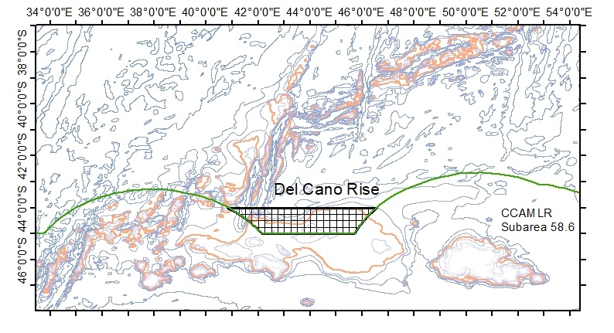
Figure A: Extent of the proposed Del Cano Rise area. The area is bounded between -44S and -45S latitude, and the adjacent EEZ to the east and west. The red bathymetry line denotes depth at -2000 m.
Season
- For the purpose of the longline fishery for Dissostichus spp in [FAO Subarea 51.7], the season is defined as the period from 1 December to 30 November both dates inclusive.
Effort/catch and operational limits
- CCPs shall ensure that the total annual catches of Dissostichus spp in the Del Cano Rise area do not exceed 55 tonnes. Without prejudice to any future sharing arrangement of the catch opportunities, this catch shall be equally shared between those CCPs which have historical catches declared to SIOFA up to 2016 in the Del Cano Rise area. Any excess by a given CCP in a given year shall be deducted from its following year catch share.
- CCPs shall send monthly reports of their Dissostichus spp catches to the Secretariat, using the template at Annex I. As soon as 90% of the catch limit is reached, the Secretariat shall notify the CCPs of the closure of the fishery.
- CCPs shall ensure that their fishing vessels inform the Secretariat daily on start and end points of set longlines, using the template at Annex II.
- Longlines shall not exceed 3000 hooks per line and shall be set at minimum 3 nautical miles from each other.
By-catch limits
- Toothfish caught by vessels not targeting Dissostichus spp may not exceed 0.5 t per season of Dissostichus spp.
- Should a vessel fishing for species other than Dissostichus spp reach the Dissostichus spp limit of 0.5 tonnes, the Del Cano area shall be closed for this vessel for that season.
Mitigation of depredation
- To reduce likelihood of depredation, vessels are encouraged to not haul longlines in the presence of killer whales (Orcinus orca) and are discouraged from hauling longlines in presence of any odontocete (toothed) whales.
- Should killer whales arrive during hauling operations, the vessels are encouraged to cease hauling, tie off the longline with a buoy, and move on. The vessel may only retrieve the tied-off line once the killer whales are no longer near the line.
- To further reduce potential for depredation, vessels are encouraged to set lines at depths exceeding 1000 m.
VMS polling
- CCPs shall require their flagged vessels fishing for Dissostichus spp in this area to report VMS data automatically to their FMC at least every hour when they are present in the Del Cano area.
Observers
- Each vessel participating in the fishery shall have at least one scientific observer on board throughout all fishing activities within the fishing period. The observer shall have a target of observing 25% of hooks hauled per line over the duration of the fishing deployment.
Tagging and release
- CCPs shall require their flagged vessels to tag and release Dissostichus spp specimens at a rate of at least 5 fish per tonne green weight caught. A minimum overlap statistic of at least 60% shall apply for tag release, once 30 or more Dissostichus spp specimens have been caught.
Scientific committee
- In 2020 the SC shall make recommendations in order to build an area wide habitat model, a spatial and temporal CPUE analysis, an estimate and map of local abundancies and a local population assessment. It shall further advise on any necessary improvements to data collection in order to reduce future assessment uncertainty.
- The SC shall also address the issues related to depredation
- At its ordinary meeting in 2020 the Scientific Committee will advise on the appropriate limits for relevant species caught as bycatch in Dissostichus spp. fisheries.
Review
- The provisions above shall be reviewed annually until a collaborative approach involving SIOFA and CCAMLR is established. This shall include sharing of relevant data, undertaking collaboratively the stock assessments and agreeing in coherent, fair and scientifically sound conservation and management measures for the Dissostichus spp that are shared by the two organisations.

Management & research measures for toothfish in Williams Ridge [FAO Subarea 57.4]

Area and purpose
- For the purpose of this fishery, Williams Ridge is defined as the area set out in Figure B and Table 2, and divided into a 15’x15’ grid for spatial management. This grid is in place to address the risk of localised depletion and ensure representative data collection throughout the SIOFA part of Williams Ridge.
Season
- For the purpose of the new longline fishery for Dissostichus spp. in Williams Ridge, the season is defined as the period from 1 December to 30 November (both dates inclusive).
Data collection for fisheries research
- CCPs shall require their flagged vessels to tag and release Dissostichus spp at a rate of at least 5 fish per tonne green weight caught. A minimum overlap statistic of at least 60% shall apply for tag release, once 30 or more Dissostichus spp have been caught.
- Representative data and samples of length, weight, sex, maturity stage, gonad weight and otoliths shall be collected to contribute to the work of the 5th meeting of the Scientific Committee, and in particular to contribute to assessing the risk to localised depletion.
Effort/catch and operational limits
- Total annual research catches in this area shall not exceed 140 tonnes. Any excess in a given year shall be deducted from that CCP from the following year.
- CCPs shall ensure their vessels send daily reports of their Dissostichus spp. catches to the Secretariat using the template at Annex III and inform the Secretariat daily on start and end points of set longlines, using the template at Annex IV. As soon as 90% of the catch limit is reached, the Secretariat shall notify all CCPs and CCPs shall ensure there is no further fishing effort by their fishing vessels for the remainder of the season.
- Only one fishing vessel at a time can fish for Dissostichus spp. in a given grid cell. A grid cell shall be closed to fishing by other vessels while a line is being set or hauled by a vessel, and while a line has been set by a vessel and has not been hauled.
- CCPs shall ensure that their fishing vessels inform the Secretariat as soon as they enter a grid cell to fish for Dissostichus spp., using the entry notification template at Annex V. Outside Secretariat business hours, an advance notification process will apply. The Secretariat shall inform the vessel as soon as possible of the number of lines that have been set in that grid cell during that season and whether it is currently being fished by another vessel, using the template at Annex VI. Where the Secretariat receives notifications from multiple fishing vessels for a given grid cell, the Secretariat will respond to the notifications in the order that they were received.
- CCPs shall ensure that their fishing vessels shall not fish in a grid cell before having received confirmation from the Secretariat that two lines have not already been set in that grid cell during that season and that it is not currently being fished by another fishing vessel, however a fishing vessel entering a grid cell to haul a line and to set a second line may haul the first line (but not set the second line) before receiving the confirmation.
- CCPs shall ensure that their fishing vessels inform the Secretariat as soon as they exit the grid cell specified in paragraph 39 and that they inform the Secretariat of the number of lines they have set and/or hauled in that grid cell, if any, using the exit notification template at Annex VII.
- Longlines shall not exceed 6250 hooks per line and shall not be set across grid cells.

- CCPs shall ensure that no more than two lines in total are set per grid for the duration of the fishing season of Dissostichus spp.
- Once two lines have been set in a given grid cell, it shall be closed to fishing for the remainder of that fishing season.

- CCPs shall require their flagged vessels fishing for Dissostichus spp. in Williams Ridge to apply a break of a minimum of 30 days between consecutive fishing trips to Williams Ridge.

By-catch limits
- Toothfish caught by vessels not targeting Dissostichus spp. may not exceed 0.5 tonnes per season.
- Should a vessel fishing for species other than Dissostichus spp reach the Dissostichus spp limit of 0.5 tonnes, the Williams Ridge area shall be closed for this vessel for that season.
Mitigation of depredation
- To reduce likelihood of depredation, vessels are encouraged not to haul longlines in the presence of sperm whales (Physetes catodon) and are discouraged from hauling longlines in presence of any odontocete (toothed) whales.
- Should sperm whales arrive during hauling operations, the vessels are encouraged to cease hauling, tie off the longline with a buoy, and move on. The vessel may only retrieve the tied-off line once the sperm whales are no longer near the line.
Observers
- Each vessel participating in the fishery shall have at least one scientific observer on board throughout all fishing activities within the fishing period. The observer shall have a target of observing 25% of hooks hauled per line over the duration of the fishing deployment.
Review
- The level of fishing on Williams Ridge shall be reviewed annually. This CMM may be reviewed annually until a collaborative approach involving SIOFA and CCAMLR is established. This shall include sharing of relevant data, undertaking collaboratively the stock assessments and agreeing in coherent, fair and scientifically sound conservation and management measures for the Dissostichus spp that are shared by the two organisations.
Table 2: Williams Ridge Fishing Area Coordinates
Point | Latitude | Longitude
1 | -52.5 | 80.0
2 | -55 | 80.0
3 | -55 | 85.0
4 | -52.5 | 85.0
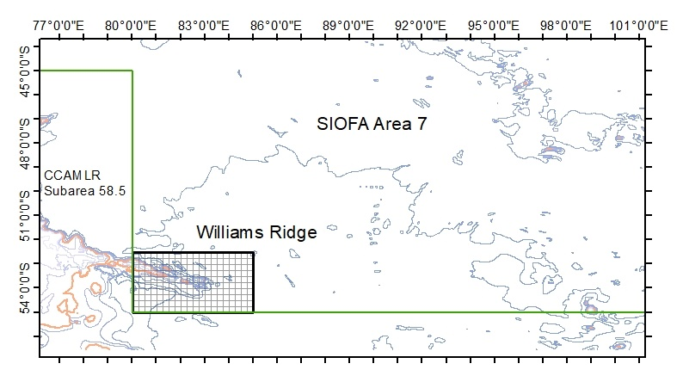
Figure B Extent of Williams Ridge. The area boundaries are given in Table 1. The red bathymetry line denotes depth at -2000 m.
Management plan for Alfonsino
Season
- For the purpose of fishery for Beryx splendens in SIOFA area the season is defined as the period from 1 January to 31 December both dates inclusive.
Stock assessment
- The MoP requests that the SC assess the Beryx splendens stocks in 2022 at the ordinary meeting of the Scientific Committee (if the SC, in 2021, determines that suitable data exist to undertake that assessment). In addition, the SC is requested to provide advice on a regular assessment schedule for future years
- The Scientific Committee shall provide clear advice and guidance on any necessary changes to data collection in order to reduce future assessment uncertainty.

Application
- This CMM shall apply from 1 December 2021.

Annex I - Template for CCPs to use for monthly catch reports to the Secretariat when fishing on the Del Cano Rise area (paragraph 17)

CCPs shall send monthly reports of their Dissostichus spp catches to the Secretariat [at 06:00 UTC the first day of the next month]. This report shall be sent to SIOFA Secretariat (mcs@siofa.org).

Vessel name |  | Vessel Flag
Area  (circle or underline correct area) | DEL CANO RISE | WILLIAMS RIDGE | OTHER
Year |  | Month
Catch live weight (Kg) |  | Catch Pieces

Annex II - Template for CCPs to use for daily longline reporting to the Secretariat when fishing on the Del Cano Rise area (paragraph 18)

CCPs shall ensure that their fishing vessels inform the Secretariat (mcs@siofa.org) daily on start and end point of set longlines, and shall use the following template:

Vessel name |  | Vessel Flag
Set Start Date |  | Set Start Time
Set Start Longitude |  | Set Start Latitude
Set Start Depth
Set End Date |  | Set End Time
Set End Longitude |  | Set End Latitude
Set End Depth
Number of hooks set

Annex III - Template for CCPs to use for daily catch reports to the Secretariat when fishing on the Williams Ridge area (paragraph 37)

CCPs shall send daily catch reports of their Dissostichus spp catches to the Secretariat (mcs@siofa.org).

Vessel name |  | Vessel Flag
Area  (circle or underline correct area) | DEL CANO RISE | WILLIAMS RIDGE | OTHER
Month |  | Day
Catch live weight (Kg) |  | Catch Pieces

Annex IV - Template for CCPs to use for daily longline reporting to the Secretariat when fishing on the Williams Ridge area (paragraph 37).

CCPs shall ensure that their fishing vessels inform the Secretariat (mcs@siofa.org) daily on start and end point of set longlines, and shall use the following template:
Vessel name |  | Vessel Flag
Set Start Date |  | Set Start Time
Set Start Longitude |  | Set Start Latitude
Set Start Depth
Set End Date |  | Set End Time
Set End Longitude |  | Set End Latitude
Set End Depth
Grid Cell* (e.g. C8)
Number of hooks set

*Williams Ridge Area grid cells:
 | A | B | C | D | E | F | G | H | I | J | K | L | M | N | O | P | Q | R | S | T |  | lat.
1
2
3 |  |  |  |  |  |  |  |  |  |  |  |  |  |  |  |  |  |  |  |  |  | 53 S
4
5
6
7 |  |  |  |  |  |  |  |  |  |  |  |  |  |  |  |  |  |  |  |  |  | 54 S
8
9
10
 |  |  |  |  |  |  |  |  |  |  |  |  |  |  |  |  |  |  |  |  |  | 55 S
long. | 80 E |  |  |  | 81 E |  |  |  | 82 E |  |  |  | 83 E |  |  |  | 84 E |  |  |  | 85 E

Annex V – Template for vessel entry notification when fishing on the Williams Ridge area (paragraph 39)

[Vessel name] hereby notifies its entry into grid cell [Number] at [Date:Time (UTC)] to fish for toothfish.
I [Name of Captain] confirm that the [vessel name] will not commence fishing until receipt of confirmation from the Secretariat that two lines have not already been set in this cell during this fishing season and that the cell is not currently being fished by another vessel.

Annex VI – Template for Secretariat confirmation in response to vessel entry notifications when fishing on the Williams Ridge area (paragraph 39)

The Secretariat acknowledges receipt of your notification of entry into [grid cell number] to fish for toothfish and advises that:
- [number of lines] have been set in this cell during this fishing season, and
- this cell [is/is not] currently being fished by another vessel.

Annex VII – Template for vessel exit notification when fishing on the Williams Ridge area (paragraph 41)

[Vessel name] hereby notifies its exit from grid cell [Number] at [Date:Time (UTC)]. I [Name of Captain] inform you that the [vessel name] has (choose 1 option from the list below):
- set 1 line
- set 2 lines
- hauled 1 line
- hauled 2 lines
- hauled 1 line and set 1 line

CMM 2020/15 (Management of Demersal Stocks) supersedes CMM 2019/15 (Management of Demersal Stocks).
The portion of Williams Ridge in the Agreement Area is bounded by the area 80E to 85E and 52S to 55S.
For the avoidance of doubt, a vessel that ceases hauling a line in a grid cell in order to mitigate depredation in accordance with paragraphs 48 and 49 is still fishing in that grid cell until it hauls the line.
In accordance with any arrangements agreed ahead of each fishing season between the CCPs with fishing vessels fishing for Dissostichus spp. in Williams Ridge and the Chair of the MoP in consultation with the Secretariat. The arrangements could include procedures and expected timeframes for the Secretariat’s response to prevent unreasonable operational disruption to fishing outside Secretariat business hours. Once agreed, the Secretariat should circulate the arrangements to all CCPs before the beginning of the season.

