Guideline for the submission of Annual National Reports to the SIOFA Scientific Committee

Purpose of annual national reports
Contracting Parties, Cooperating non-Contracting Parties and participating fishing entities shall submit national reports to the Scientific Committee (SC) on an annual basis at least 30 days before its annual meeting in order to keep the SC informed, in a concise format, of their fishing, research and management activities over the previous year. (Ref CMM 2021/02 paragraph 9)
Such annual reports do not replace data submissions under any CMM developed for the collection, reporting, verification and exchange of data; nor do they replace submission of detailed scientific papers.
- Catch and effort data should still be submitted to the SIOFA Secretariat in accordance with data submission standards and procedures.
- Detailed information or scientific analyses on aspects of fisheries should continue to be presented in specific scientific papers to SC meetings.
The SC may review these guidelines periodically and update them as required to take into account new reporting requirements established under CMMs or other best practice standards.
It is proposed that national reports submitted to the SIOFA SC be made publicly available on the SIOFA website once available.

Template for the submission of National Reports
Annual national reports should include the following sections of specific relevance to the work of the Scientific Committee. Table templates are provided in Annex 2, and can be used for reporting in each section. Examples have been added to this version of the document following the recommendations of SC7 (see SC7 Report, para 63).

Description of fisheries
A general overview description of the fisheries of the flag state concerned over the previous five years, providing summarised information on:
- Fleet composition (number of vessels by gear type and size and how this has changed by year).
- Summary tables of effort (trawl fisheries - hours trawled, longline fisheries - number of hooks set, other gears-units appropriate to the gear) and total catches by year, gear-type, season and area. With respect to area, data should be provided, at a minimum, by the sub-areas at annex 1 of these guidelines.
- Brief description of significant changes and new developments in fisheries over the past year.
Example:
In the SIOFA convention area (CA), two different fishery types of Japanese vessels have operated discontinuously for 45 years (1977-2021) (Fig. 1). i.e. trawl fisheries and bottom longline fisheries. Fig. 1 shows that the number of vessels (trawl and bottom longline fisheries) operated in the SIOFA CA during 1977-2021 (3 vessels maximum). Table 1 shows [that] the number of vessels and their total tonnages (trawl and bottom longline fisheries) that operated in the SIOFA CA in recent 7 years (2015-2021).
From National Report of Japan (2022), SC-07-13

Catch, effort and CPUE summaries
Overall summary figures of trends in nominal effort, retained catch (tonnes or kilograms as appropriate) and discards (tonnes or kilograms as appropriate) and CPUE in the SIOFA Area over the history of the fishery, including:
- Trends in nominal fishing effort by gear type over time.
- Trends in catch by species for the main target, bycatch, associated and depended species.
- Trends in nominal CPUE by gear type for the main species contributing to catches.
Example:
Since 2012, Australian vessels in the SIOFA Area have been restricted to fishing within the 1999–2009 Australian fishing footprint (Figure 1), and to the average annual level of catch (1100 t) within that same period. Three Australian flagged vessels fished using demersal longlines in the SIOFA Area in 2021. The vessels recorded 109,769 demersal longline hooks (100 sets) (Table 2). One Australian-flagged vessel used both midwater otter trawl and crustacean pots in 2021. The vessel recorded 1.5 hours of trawling and 51 crustacean pots. The trend in trawl effort and the number of active vessels between 2005 and 2021 is presented in Figure 2. Potting gears were permitted in 2021 following an update to Australia’s bottom fishing impact assessment and the number of pots set in 2021 is presented in Figure 2.
From Australia’s Annual Report (2022), SC-07-14

Fisheries data collection and research activities
Brief description of the fisheries data collection systems implemented, and the research and assessment activities conducted, including:
- Description of the statistical data collection systems in use, and how these have changed or been improved over the past year.
- Description of fisheries sampling programs or surveys conducted, scientific analyses and stock assessments undertaken, or other relevant research activities conducted.
- Information on other SIOFA-related research activities over the past year and future research plans.
Example:
EU data are obtained from different sources: Logbook data (provided to SIOFA in accordance with SIOFA CMM 2021/02), declaration system, records from the master and scientific observation, when available.
C2 and observer logbook data are collected in an Excel spreadsheet and processed at the IEO (Spanish Institute of Oceanography) for storage in a linked Access database. Analysis of the data are made using R.
From National Report of the European Union (2022), SC-07-16

VME Thresholds
(for bottom fishing activity only)
- Describe threshold levels for encounters with VMEs and any move-on protocols
- For operations that exceeded the pre-determined VME threshold, provided details of the VME taxa observed including (wet) weight, number of taxa, the corresponding effort information and total weight of catch of the operation; and any action taken in respect of the relevant site.
Example:
In 2021, flagged vessels adhered to the VME encounter threshold established in CMM 20/01 Interim Bottom Fishing Measures section 12(b).
Table 3: Threshold levels for VME encounters and move-on protocols in areas other than BPAs for Cook Islands vessels
Gear/fishery | Thresholds | Move-on protocols
Trawl (CMM 20/01-12b) | More than  60 kg of live corals and/or 300 Kg of sponges in any tow. | For bottom or mid-water trawling, or fishing with any other net – two miles either side of a trawl track extended by two (2) nautical miles at each end;
In 2021 a total of 336 bottom trawl shots were carried out by Cook Islands vessels, and based on provisional data from limited observer reports, no shots breached the VME threshold.
From National Report – Cook Islands (2022), SC-07-17

Biological sampling and length/age composition of catches
- Overview summary of the coverage of biological and size-frequency sampling conducted.
- Simple summary table or figure showing length and/or age-frequency distribution of the target species by gear, and how this has changed over the past five years.
Example:
Since 2017 biological and size composition sampling by species are conducted by scientific observers on board the EU-Spanish vessels.
Table 12 below shows the biological sampling information of the species in 2021 when more than 100 specimens have been sampled. Information about sex and maturity is also available. Macrourid length measures are made to the Total length and additionally Anal length.
From National Report of the European Union (2022), SC-07-16

Description of data verification mechanisms
- Brief description of data verification mechanisms used. For example:
  - Position verification through VMS
  - Scientific observer programs to collect verification data on catch, effort, catch composition (target and non-target) discards and other details of fishing operations.
  - Vessel trip, landing and transhipment reports; and
  - Port sampling.
Example:
Commercial fisheries data (logbook) are verified by Japan Overseas Fishing Association (JOFA) and Fishery Agency of Japan. Fisheries Agency of Japan also verifies locations of vessels through Vessel Monitoring System (VMS). Scientific observer data started in 2017 are verified by Fisheries Agency of Japan and FRI (formally NRIFSF) in Japan Fisheries Research and Education Agency. Exploratory fishing data are verified by Japan Marine Fishery Resources Research Centre (JAMARC), whose current name is Marine Fisheries Research and Development Centre (also JAMARC) in FRA.
From National Report of Japan (2022), SC-07-13

Summary of observer and port sampling programs
- Brief description of observer and port sampling programs conducted, and how these have changed or been improved over the past year and any problems encountered during the previous year.
- Information on observer programme design and coverage rates achieved and the type of data collected.

- Information on the level of observer coverage focused on recording bycatch of seabirds, marine mammals, reptiles and other species of concern.
- Reporting of observed bycatch by species and fishery for all seabirds, marine mammals, reptiles and other species of concern.
- Sampling coverage achieved by port sampling programs, over the past year.
Example:
Scientific observers have been deployed on board the EU-Spain fishing vessels operating in the region since 2017. Reports on the scientific observations and information on toothfish recaptures were prepared and provided to SIOFA Secretariat. Three fishing trips have taken place in 2021, one straddling the year 2020 and another straddling the year 2022 (the latter is still unfinished).
In 2021 a total of two trips out of three have been covered by an on-board observer corresponding 100% of the TOP targeted fishing days and 43% of the fishing days targeting other species from a total of 307 fishing days.
The scientific observers (Biologist or Marine Science degree) are trained at the Instituto Español de Oceanografía, specific training is also adapted for all fleets that are monitored.
No accidental catch data have been collected for birds or marine mammals in 2021.
Bird scare (tori) lines are deployed in most of the setting/hauling (if weather permits).
The EU has no port sampling program for vessels fishing within the SIOFA CA.
From National Report of the European Union (2022), SC-07-16

Relevant social and economic information (optional)
- Brief description of relevant social or economic information related to the fisheries.
- Future prospects of the fishery
- Onshore development
Example:
No information is prepared for this time.
From National Report of Japan (2022), SC-07-13

2023 Version, to be revised at the 8th meeting of the SIOFA Scientific Committee
Annex 1 - Sub-areas for reporting catch and effort data
Table 1
 | Area | Lats  NS |  | Longs  E
1 | Mozambique Ridge | S 20° | S 36° | - | 40°
2 | Madagascar Ridge | S 20° | S 36° | 40° | 49°
3a | Northern SW Indian Ridge | S 20° | S 36° | 49° | 65°
3b | Southern SW Indian Ridge | S 36° | S 45° | 30° | 65°
6 | Mid-Indian Ridge | S 20° | S 45° | 65° | 80°
4 | Ninety Degree East Ridge | S 20° | S 36° | 80° | 90°
5 | Broken Ridge | S 25° | S 36° | 90° | 105°
7 | SE Indian Ocean | S 20° | S 55° | 80° | 120°
8 | North of 20° | N 10° | S 20° | - | 80°

Figure 1
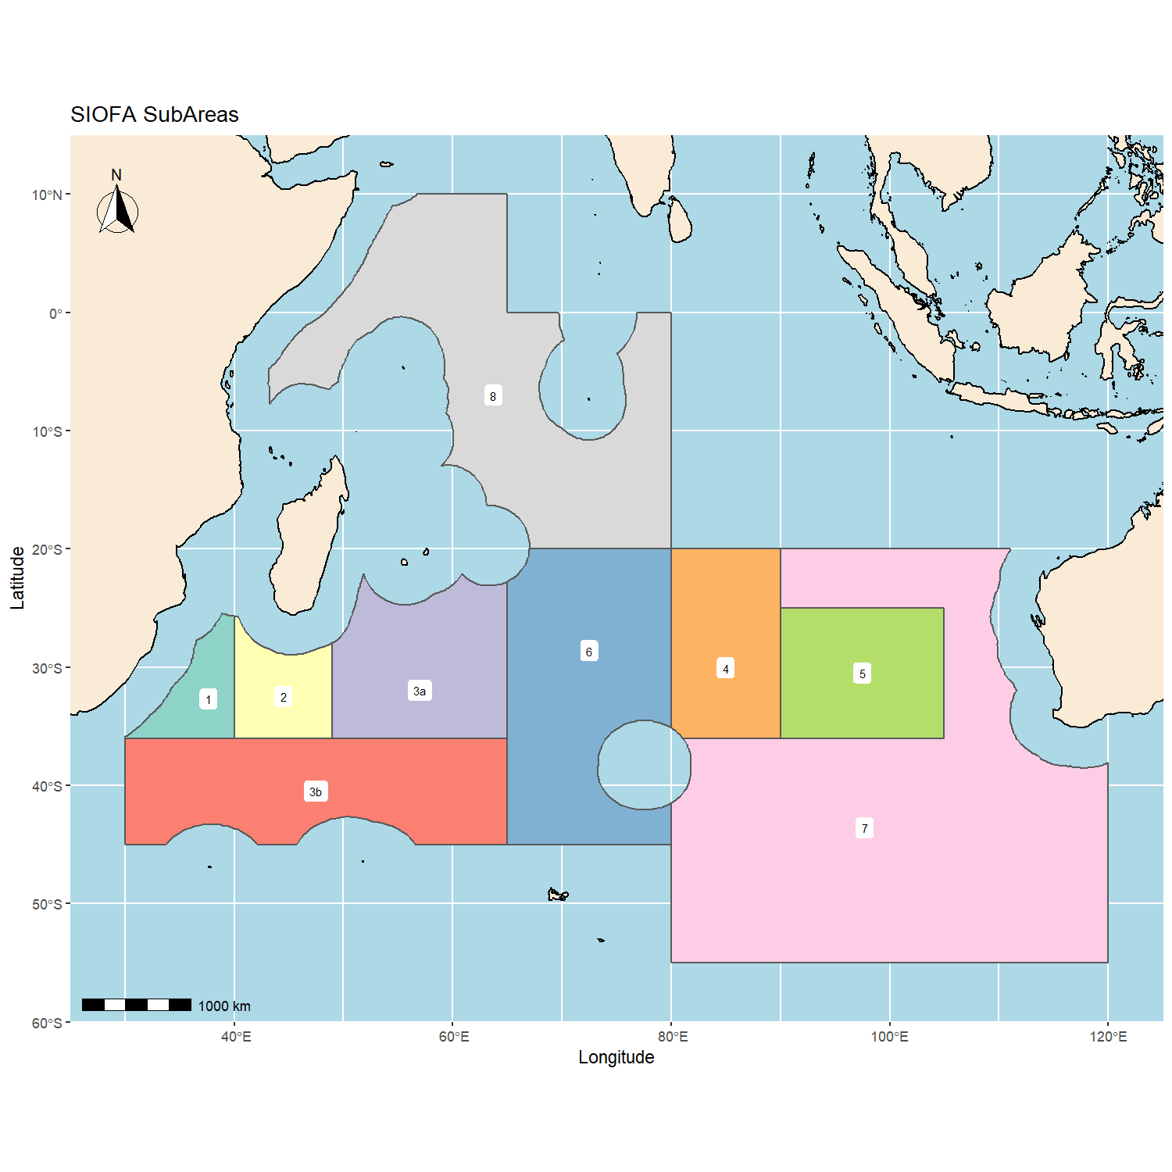
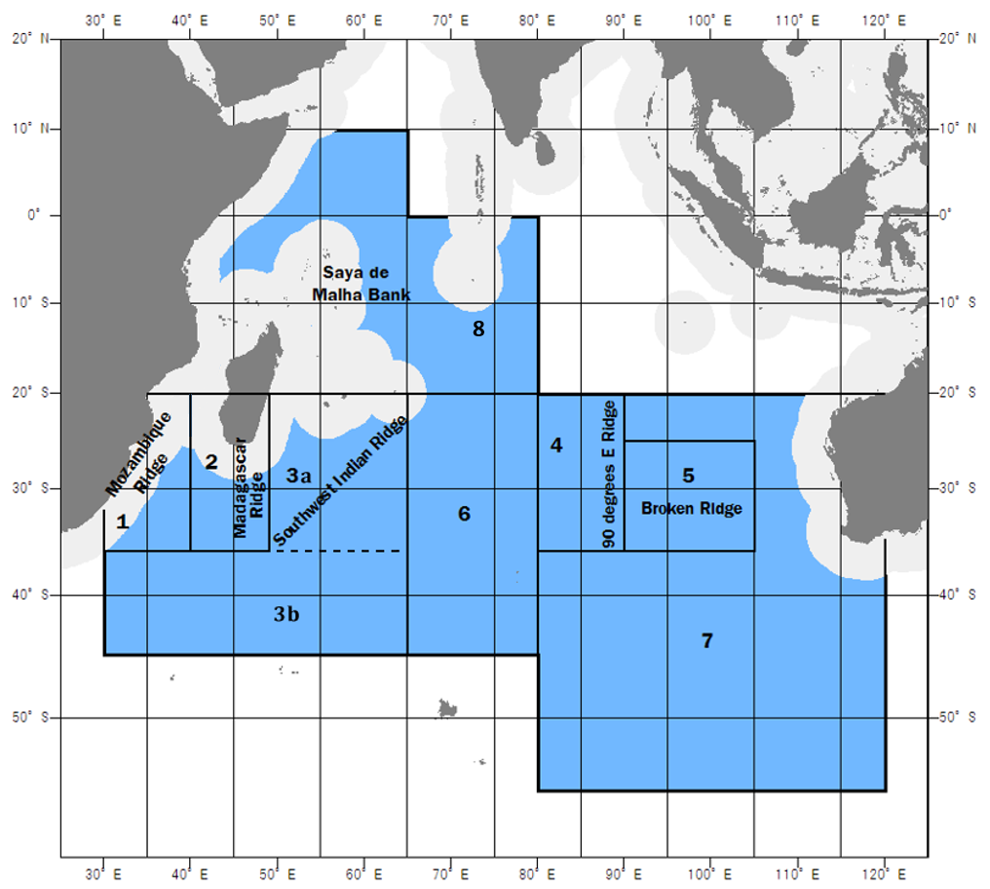

Annex 2 - Table templates for National Report sections
The tables below provide guidance on the format to be used for CP to report information in their National Report. Text in Yellow must be updated by CCP.

Description of fisheries

Table 1: Fleet composition (number of vessels by gear type and size and how this has changed by year).
Year | Vessels that actively fished
 | Gear 1 | Gear 2 | Gear 3 | Gear 4
year | No of vessels (total tonnage) | No of vessels (total tonnage) | No of vessels (total tonnage) | No of vessels (total tonnage)
year | No of vessels (total tonnage) | No of vessels (total tonnage) | No of vessels (total tonnage) | No of vessels (total tonnage)

Table 2: Summary table of gear effort (unit).
Year | Sub-areas for reporting catch and effort data
 | 1 | 2 | 3.a | 3.b | 4 | 5 | 6 | 7 | 8
year
year
Note: please provide one table for each gear/fishery and specify the unit used (e.g. Mid
water trawl, hours trawled)

Table 3: Summary table of gear catches (unit)
Year | Sub-areas for reporting catch and effort data
 | 1 | 2 | 3.a | 3.b | 4 | 5 | 6 | 7 | 8
year
year
Note: please provide one table for each gear/fishery and specify the unit used (e.g. Mid
water trawl, tons)

Catch, effort and CPUE summaries

Table 4: Catch (Kg) by species for main target, bycatch, associated and depended species (R-retained and D-discarded)
Year | Species 1 |  | Species 2 |  | Species 3 |  | Species 4 |  | Species 5 |  | Others |  | Total
 | R | D | R | D | R | D | R | D | R | D | R | D | R | D
year 1
year 2

Fisheries data collection and research activities
Brief description of the fisheries data collection systems implemented, and the research and assessment activities conducted, including:
- Description of the statistical data collection systems in use, and how these have changed or been improved over the past year. If fisheries need to be separated, please provide a table for each fishery.
Table 5: Details on the scales and resolutions of the fishery data collection for one fishery
 | fishery/gear data collection items
Year | tow / set  (individual or some aggregation) | time scale  (set-tow hauling time, daily, etc.) | spatial scale  (tow/set exact position or grid, please provide grid resolution) | species details  (any aggregation or species grouping)
Year
Year
Year
Year
Note: please provide one table for each gear/fishery if data collection modes differ.

VME Thresholds
(for bottom fishing activity only)
- Describe threshold levels for encounters with VMEs and any move-on protocols
Table 6: Threshold levels for encounters with VMEs and move-on protocols
Gear/fishery | Thresholds (kgs) | Move-on protocols description
Gear1
Gear2
…

- For operations that exceeded the pre-determined VME threshold, provided details of the VME taxa observed including (wet) weight, number of taxa, the corresponding effort information and total weight of catch of the operation; and any action taken in respect of the relevant site.
Table 7: Summary VME Taxa (wet) weight (kg), operations exceeding thresholds and effort: gear type identified, 1 table per gear
Year | VME  taxa | Unit | Sub-areas for reporting catch and effort data
 |  |  | 1 | 2 | 3.a | 3.b | 4 | 5 | 6 | 7 | 8
year | taxon name | Weight (kg)
 |  | Nb of Operations
 |  | Effort (Tables 2.1..)
year | taxon name | Weight (kg)
 |  | Nb of Operations
 |  | Effort (Tables 2.1..)
year | taxon name | Weight (kg)
 |  | Nb of Operations
 |  | Effort (Tables 2.1..)

- It is desirable for the SC to report any VME taxa caught during fishing operations as recorded in the logbooks
Table 8: VME taxa bycatch quantities per gear from logbooks data (specify taxa and units)
 |  | gear1/fishery1 | gear2/fishery2 | …
 | total set/tow number | number | number
taxa | taxon 1 (unit) | quantity | quantity
 | taxon 2 (unit) | quantity | quantity
 | taxon 3 (unit) | quantity | quantity
 | …

Summary of observer and port sampling programs

- Information on observer programme design and coverage rates achieved and the type of data collected. (table 9)
- Information on the level of observer coverage and focus on recording bycatch of seabirds, marine mammals, reptiles and other species of concern. (table 9)
Table 9: Observer program design and coverage summary table
 | trips  coverage  (%) | total no of  sets/hauls | no of  sets/hauls  covered | within set/haul  coverage  (%) | incidental bycatch (bird, mammal) observation coverage (% set/haul)
gear1/fishery1
gear2/fishery2
gear3/fishery3

- Reporting of observed bycatch by species and fishery for all seabirds, marine mammals, reptiles and other species of concern. (table 10)
Table 10: Reporting of observed bycatch
bycatch | gear1/fishery1 | gear2/ fishery2 | gear3/ fishery3
seabirds | occurrence number | occurrence number | occurrence number
mammals | occurrence number | occurrence number | occurrence number
sharks | occurrence number | occurrence number | occurrence number
VME taxon 1 (unit) | quantity | quantity | quantity
VME taxon 2 (unit) | quantity | quantity | quantity
other

- Summary of Biological samplings performed (past 5 years)
Table 11: Summary numbers of fish sampled* per species and year
 | Years
Species (FAO code) | 2017 | 2018 | 2019 | 2020 | 2021
BYS | L/F: 2000  BS: 350
ORY
EDR
* For length/frequency counts, just input the total number of fish measured (e.g. L/F: 2000), for complete individual biological sampling (BS), provide the number of fish sampled (e.g. BS: 350)

These guidelines recognise that, where appropriate, data confidentiality will be maintained as it relates to the application of relevant national legislation.
A table of relevant scientific names and associated common English name should be provided in an annex to report.
Source for Table 1 and Figure 1: FAO Fisheries Report No. 677: report of the “SECOND AD HOC MEETING ON MANAGEMENT OF DEEPWATER FISHERIES RESOURCES OF THE SOUTHERN INDIAN OCEAN” held in Fremantle 20 -22 May 2002

