2.II FLUX Vessel Position Implementation Document

Introduction

This document aims to describe the implementation of Vessel Position in the context of the SIOFA VMS. Submissions of reports will be done through the FLUX Transportation Layer.

References

UN/CEFACT P1000 FLUX Standard v1.0 ²:
- FLUX BRS: P1000 – 1; General principles (version 2.1).
- FLUX BRS: P1000 – 7; Vessel Position domain (version 2.0). UN/CEFACT FLUXVesselPositionMessage_4p0.xsd

Scope
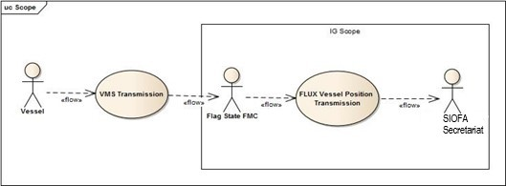
Figure 1: Implementing Guide Scope diagram
As shown on Figure 1, even if the message is provided by a Vessel, the scope of this document is limited to the transmission from a Flag CCP FMC, which has received the Vessel Position message, coming in most cases from aa ALC to the SIOFA Secretariat.

Procedures

General principles
The following activity diagram describes the normal procedure defined for the submission of every Vessel Position Messages sent between the FMC of a Flag CCP to the SIOFA Secretariat:
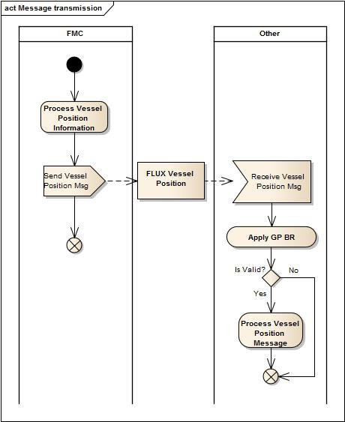

Figure 2: Message Transmission activity diagram
As shown in the diagram, Apply General Principles (GP) Business Rules (BR) is a validation process which does:
- XML Validation level: Based on the definition in the XSD, the parser validates the structure and cardinality as well as compliance for mandatory elements of the XML provided.
Note: Comparing XML vs. XSD defined by the namespace can make the parser generating error having technical information when the basic information requested by General Principles is not correct.
- Business Rules Validation level: a Business Rules Engine validates the content of XML according to the General Principles Business Rules definition.

Data Model (XSD) Implementation

The implementation of the Vessel Position Data Model applies the following general constraints at the level of XSD Element attributes:
- For Code & Identifier DataType: listID or schemeID attribute must be provided if it is not specifically defined in the definition of the element;
- For DateTime DataType: only udt:DateTime (of type xsd:dateTime) choice is used. The date and time must be in line with ISO8601 and expressed in UTC, unless explicitly mentioned otherwise. The format shall be YYYY-MM- DDThh:mm:ss[.000000]Z;
The following diagram describes the Vessel Position Data Model used for the implementation of transmission of VesselPositionMessage:
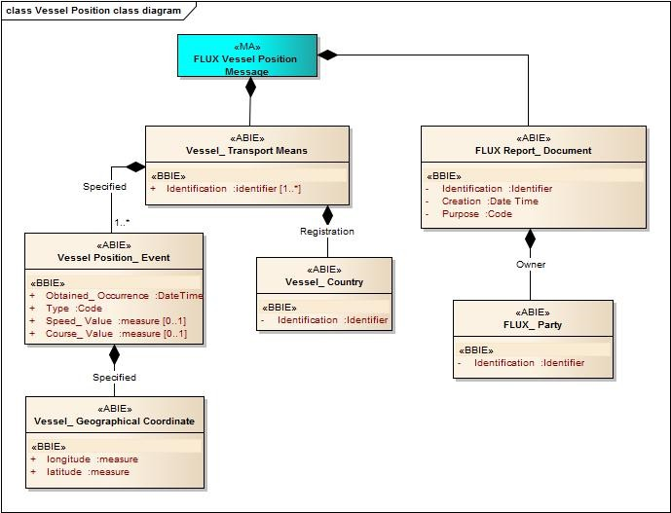

Figure 3: Vessel Position Message Data Model

The table below describes for each fields defined in the Data Model (XSD) the values that can be used:

Entity/Field Name | DataType | Cardinality |  | Description | Remarks
 |  | Min | Max
FLUX  Report_ Document |  | 1 | 1 | The document details for this FLUX vessel position message. | FLUX General Principles Entity
Identification | Identifier | 1 | 1 | The unique identification of the FLUX vessel position message | A UUID as defined in the RFC 4122
Creation | DateTime | 1 | 1 | The date, time, date time of the creation of the FLUX vessel position message. | A UTC date time.  Must be according to the definition provided in 6(2)
Purpose | Code | 1 | 1 | The code specifying the purpose of this FLUX report document, such as original, cancellation or replace. | Attribute listID=  FLUX_GP_PURPOSE  Reference: EDIFACT Code List 1225 (qDT UN02000125 - Message Function_ Code).
 |  |  |  |  | Restriction: only value 9 is used in this context.
Owner. | Assoc. | 1 | 1 | Entity used to provide | FLUX General Principles
FLUX_ Party |  |  |  | information on an | Entity
 |  |  |  | individual, a group, or a
 |  |  |  | body having a role in a
 |  |  |  | Fisheries Language for
 |  |  |  | Universal eXchange
 |  |  |  | (FLUX) business
 |  |  |  | function. Party has a
 |  |  |  | legal connotation in a
 |  |  |  | business transaction.
Identification | Identifier | 1 | 1 | An identifier of this FLUX party. | Attribute listID=  TERITTORY
 |  |  |  |  | ISO 3166-1 alpha-3 code of the country owning this report.
 |  |  |  |  | e.g.: SWE

Entity/Field Name | DataType | Cardinality |  | Description | Remarks
 |  | Min | Max
Vessel_ Transport Means |  | 1 | 1 | Entity used to provide the identification and characteristic information of a ship or boat.
Identification | Identifier | 1 | * | An identifier for this transport means vessel UVI, as defined by the SIOFA VMS SSPs, | Attribute schemeID must be provided with a value from list = FLUX_VESSEL_ID_TY PE
Registration. Vessel_ Country | Assoc. | 1 | 1 | The country of registration of this transport means vessel.
Identification | Identifier | 1 | 1 | The identifier for this vessel country. | Use Code Countries code list in MDR.
 |  |  |  |  | listID = TERRITORY
 |  |  |  |  | ISO 3166-1 alpha-3 code of the country where the vessel is registered (flag state).
Specified. Vessel | Assoc. | 1 | * | The general information of the VMS message. | More than one position can be provided.

Entity/Field Name | DataType | Cardinality |  | Description | Remarks
 |  | Min | Max
Position_ Event
Obtained_ Occurrence | DateTime | 1 | 1 | The date and time when the position of the vessel was taken by the vessel's navigation equipment. | The UTC date time when the position was obtained by the vessel navigation equipment, transmitted by the VMS system on-board of the vessel.
 |  |  |  |  | Must be according to the definition provided in 6(2)
Type | Code | 1 | 1 | The code specifying the type of vessel position event. | Attribute listID must be provided with a value from list = FLUX_VESSEL_POSITION_TY PE
 |  |  |  |  | Example of values are: "ENTRY,"EXIT","POS",” MANUAL”.
Speed_ Value | Measure | 0 | 1 | The measure of speed of the vessel for this vessel position event. | Mandatory.  In knots. Maximum 2 significant decimals.
 |  |  |  |  | Optional in case the following conditions are all met:
 |  |  |  |  | - TypeCode= EXIT
 |  |  |  |  | - Message addressed to Third party or RFMO
 |  |  |  |  | - The element is defined as optional in the agreement with the Third Party or RFMO
Course_ Value | Measure | 0 | 1 | The measure of course of the vessel for this vessel position event. | Mandatory.  In degrees and decimal degrees. Maximum 2 significant decimals.
 |  |  |  |  | Optional in case the following conditions are all met:
 |  |  |  |  | - TypeCode= EXIT
 |  |  |  |  | - Message addressed to

Entity/Field Name | DataType | Cardinality |  | Description | Remarks
 |  | Min | Max
Third party or RFMO
- The element is defined as optional in the agreement with the Third Party or RFMO
Specified. Vessel_ Geographical Coordinate | Assoc. | 1 | 1 | The latitude and longitude of a specified place, by which a vessel's relative situation on the globe is known. The height above the sea level constitutes a third coordinate. | Geographical Coordinates Position of the vessel transmitted by the VMS system at Obtained DateTime.  Altitude and System information are not used in context of this implementation.
Latitude | Measure | 1 | 1 | The measure of the latitude as an angular distance north or south from the Equator meridian to the meridian of a specific place for this vessel geographical coordinate. | Reference ISO 6709.  Coordinate expressed in WGS84, decimal degree notation, using a precision of at least 3 and maximum 6 decimal positions.  Positive coordinate refers to North of equator.  Negative coordinate refers to South.
Longitude | Measure | 1 | 1 | The measure of the longitude as an angular distance east or west from the Greenwich meridian to the meridian of a specific place for this vessel geographical coordinate. | Reference ISO 6709.  Coordinate expressed in WGS84, decimal degree notation, using a precision of at least 3 and maximum 6 decimal positions.  Positive coordinate refers to East of Greenwich meridian. Negative coordinate refers to West.

- XML EXAMPLES

<rsm:FLUXVesselPositionMessage xsi:schemaLocation="urn:un:unece:uncefact:data:standard:FLUXVesselPositionMessage:4 FLUXVesselPositionMessage_4p0.xsd" xmlns:xsi="http://www.w3.org/2001/XMLSchema-instance" xmlns:rsm="urn:un:unece:uncefact:data:standard:FLUXVesselPositionMessage:4" xmlns:ram="urn:un:unece:uncefact:data:standard:ReusableAggregateBusinessInformationEntity:18" xmlns:udt="urn:un:unece:uncefact:data:standard:UnqualifiedDataType:18">
<rsm:FLUXReportDocument>
<ram:ID> c133b211-0b0e-4358-893c-7afb5437bd61</ram:ID>
<ram:CreationDateTime>
<udt:DateTime>2001-12-17T09:30:47.0Z</udt:DateTime>
</ram:CreationDateTime >
<ram:PurposeCode >9</ram:PurposeCode>
<ram:OwnerFLUXParty>
<ram:ID >SWE</ram:ID>
</ram:OwnerFLUXParty>
</rsm:FLUXReportDocument>

<rsm:VesselTransportMeans>
<ram:ID schemeID=" CFR ">SWE000007880</ram:ID>
<ram:ID schemeID=" EXT_MARKING">S-381</ram:ID>
<ram:ID schemeID=" IRCS ">EI6207</ram:ID>
<ram:RegistrationVesselCountry>
<ram:ID>SWE</ram:ID>
</ram:RegistrationVesselCountry>

<ram:SpecifiedVesselPositionEvent>
<ram:ObtainedOccurrenceDateTime>
<udt:DateTime>2001-12-17T09:30:47.0Z </udt:DateTime>
</ram:ObtainedOccurrenceDateTime>
<ram:TypeCode >POS</ram:TypeCode>
<ram:SpeedValueMeasure>8.3</ram:SpeedValueMeasure>
<ram:CourseValueMeasure>50</ram:CourseValueMeasure>
<ram:SpecifiedVesselGeographicalCoordinate>
<ram:LatitudeMeasure >50.563</ram:LatitudeMeasure>
<ram:LongitudeMeasure>009.252</ram:LongitudeMeasure>
</ram:SpecifiedVesselGeographicalCoordinate>
</ram:SpecifiedVesselPositionEvent>
</rsm:VesselTransportMeans>
</rsm:FLUXVesselPositionMessage>

<rsm:FLUXVesselPositionMessage xsi:schemaLocation="urn:un:unece:uncefact:data:standard:FLUXVesselPositionMessage:4 FLUXVesselPositionMessage_4p0.xsd" xmlns:xsi="http://www.w3.org/2001/XMLSchema-instance" xmlns:rsm="urn:un:unece:uncefact:data:standard:FLUXVesselPositionMessage:4" xmlns:ram="urn:un:unece:uncefact:data:standard:ReusableAggregateBusinessInformationEntity:18" xmlns:udt="urn:un:unece:uncefact:data:standard:UnqualifiedDataType:18">
<rsm:FLUXReportDocument>
<ram:ID> c133b211-0b0e-4358-893c-7afb5437bd61</ram:ID>
<ram:CreationDateTime>
<udt:DateTime>2018-12-17T11:31:47.0Z</udt:DateTime>
</ram:CreationDateTime >
<ram:PurposeCode >9</ram:PurposeCode>
<ram:OwnerFLUXParty>
<ram:ID >SWE</ram:ID>
</ram:OwnerFLUXParty>
</rsm:FLUXReportDocument>

<rsm:VesselTransportMeans>
<ram:ID schemeID=" CFR "> SWE000007880</ram:ID>
<ram:ID schemeID=" EXT_MARKING">S-381</ram:ID>
<ram:ID schemeID=" IRCS ">EI6207</ram:ID>
<ram:RegistrationVesselCountry>
<ram:ID>SWE</ram:ID>
</ram:RegistrationVesselCountry>

<ram:SpecifiedVesselPositionEvent>
<ram:ObtainedOccurrenceDateTime>
<udt:DateTime>2018-12-17T09:30:47.0Z </udt:DateTime>
</ram:ObtainedOccurrenceDateTime>
<ram:TypeCode >POS</ram:TypeCode>
<ram:SpeedValueMeasure>8.3</ram:SpeedValueMeasure>
<ram:CourseValueMeasure>50</ram:CourseValueMeasure>
<ram:SpecifiedVesselGeographicalCoordinate>
<ram:LatitudeMeasure >50.563</ram:LatitudeMeasure>
<ram:LongitudeMeasure>009.252</ram:LongitudeMeasure>
</ram:SpecifiedVesselGeographicalCoordinate>
</ram:SpecifiedVesselPositionEvent>

<ram:SpecifiedVesselPositionEvent>
<ram:ObtainedOccurrenceDateTime>
<udt:DateTime>2018-12-17T11:30:47.0Z </udt:DateTime>
</ram:ObtainedOccurrenceDateTime>
<ram:TypeCode >POS</ram:TypeCode>
<ram:SpeedValueMeasure>8.3</ram:SpeedValueMeasure>
<ram:CourseValueMeasure>50</ram:CourseValueMeasure>
<ram:SpecifiedVesselGeographicalCoordinate>
<ram:LatitudeMeasure >50.123456</ram:LatitudeMeasure>
<ram:LongitudeMeasure>009.132</ram:LongitudeMeasure>
</ram:SpecifiedVesselGeographicalCoordinate>
</ram:SpecifiedVesselPositionEvent>
</rsm:VesselTransportMeans>
</rsm:FLUXVesselPositionMessage>

Code lists

Vessel Transport Means²

Description: the entity containing the details of the identification and characteristic information of a ship or boat.

Mult. | Business term | Rel. | Type | Description
0..n | Identification | Att | Identifier | An identifier for this transport means vessel, such as an identifier defined by the Food and Agriculture Organisation (FAO), the radio call sign, or an external marking.
0..1 | Registration | Ass | Vessel_ Country Entity | The country of registration of this transport means vessel.
0..n | Specified | Ass | Vessel Position_ Event Entity | A position event specified for this vessel transport means.

Vessel_ Country

Description: the entity containing the details of a country associated to a vessel.

Mult. | Business term | Rel. | Type | Description
1 | Identification | Att | Identifier | The identifier for this vessel country.

Vessel Position_ Event

Description: The entity containing information obtained related to the position of a vessel.

Mult. | Business term | Rel. | Type | Description
1 | Obtained_ Occurrence | Att | DateTime | The date and time when the position of the vessel was taken by the vessel's navigation equipment.
1 | Type | Att | Code | The code specifying the type of vessel position event.
0..1 | Speed | Att | Measure | The measure of speed of the vessel for this vessel position event.

0..1 | Course | Att | Measure | The measure of course of the vessel for this vessel position event.
0..1 | Activity_ Type | Att | Code | The code specifying the type of activity, such as of the vessel or the crew, at this vessel position event.
1 | Specified | Ass | Vessel_ Geographical Coordinates Entity | The set of geographical coordinates specified for this vessel position event.

Vessel_ Geographical Coordinates

Description: The latitude and longitude of a specified place, by which its relative situation on the globe is known. The height above the sea level constitutes a third coordinate.

Mult. | Business term | Rel. | Type | Description
1 | Latitude | Att | Measure | The measure of the latitude as an angular distance north or south from the Equator meridian to the meridian of a specific place for this vessel geographical coordinate.
1 | Longitude | Att | Measure | The measure of the longitude as an angular distance east or west from the Greenwich meridian to the meridian of a specific place for this vessel geographical coordinate.
0..1 | Altitude | Att | Measure | The measure of the altitude that reflects the vertical elevation of an object above a surface for this vessel geographical coordinate.
0..1 | System | Att | Identifier | The identifier of the system used for measuring this specified geographical coordinate.

Flux TL envelope parameters

The following FLUX TL parameters must be used for transmission of Vessel Position Messages.

Common name | FLUX TL  Envelope Tag name | Value | Remark
Dataflow name | DF | urn:un:unece:uncefact:data:standard: FLUXVesselPositionMessage:4
Timeout DateTime | TODT | DateTime (in UTC) of creation of the envelope + 60 minutes. | Value expressed as XSD DateTime in UTC. Must be according to the definition provided in 6(2).
Acknowledge Receipt | AR | False | Note: a non-delivery message is always sent when the recipient cannot be reached and timeout (TODT) time has expired.

In general, only XSD element are defined as mandatory. Element attributes and facets remain optional.
Some specific business rules of this domain can withdraw or overwrite the definition of FLUX General Principles
YYYY= year; MM= month, including leading 0 where month number is less than 10; DD= day of the month including leading 0 where day number is less than 10; T= the letter T to indicate the part of the time section; H24= hours of the day expressed with 2 digits using the 24-hour notation; MI=minutes expressed as 2 digits; SS=seconds expressed as 2 digits; [.000000]= optionally fractions of seconds may be included up to 6 digits, not including the brackets; Z= time zone, which must be Z (ie. UTC)
For sake of clarity, the description of Vessel_ Transport Means; Vessel Country entities contains only the part that is necessary for this domain. The complete definition of such entities can be found in the Vessel document

