Guidelines for the submission of Annual National Reports to the SIOFA Scientific Committee

Purpose of annual national reports
Contracting Parties, Cooperating non-Contracting Parties and participating fishing entities shall submit national reports to the Scientific Committee (SC) on an annual basis at least 30 days before its annual meeting in order to keep the SC informed, in a concise format, of their fishing, research and management activities over the previous year.
Such annual reports do not replace data submissions under any CMM developed for the collection, reporting, verification and exchange of data; nor do they replace submission of detailed scientific papers.
- Catch and effort data should still be submitted to the SIOFA Secretariat in accordance with the any prescribed data submission standards and procedures.
- Detailed information or scientific analyses on aspects of fisheries should continue to be presented in specific scientific papers to SC meetings.
The SC may review these guidelines periodically and update them as required to take into account new reporting requirements established under CMMs or other best practice standards.
It is proposed that national reports submitted to the SIOFA SC be made publicly available on the SIOFA website once available.

Template for the submission of National Reports
Annual national reports should include the following sections of specific relevance to the work of the Scientific Committee:

Description of fisheries
A general overview description of the fisheries of the flag state concerned over the previous five years, providing summarised information on:
- Fleet composition (number of vessels by gear type and size and how this has changed by year).
- Summary tables of effort (trawl fisheries - hours trawled, longline fisheries - number of hooks set, other gears-units appropriate to the gear) and total catches by year, gear-type, season and area. With respect to area, data should be provided, at a minimum, by the sub-areas at annex 1 of these guidelines.
- Brief description of significant changes and new developments in fisheries over the past year.

Catch, effort and CPUE summaries
Overall summary figures of trends in nominal effort, retained catch (tonnes or kilograms as appropriate) and discards (tonnes or kilograms as appropriate) and CPUE in the SIOFA Area over the history of the fishery, including:
- Trends in nominal fishing effort by gear type over time.
- Trends in catch by species for the main target, bycatch, associated and depended species.
- Trends in nominal CPUE by gear type for the main species contributing to catches.

Fisheries data collection and research activities
Brief description of the fisheries data collection systems implemented, and the research and assessment activities conducted, including:
- Description of the statistical data collection systems in use, and how these have changed or been improved over the past year.
- Description of fisheries sampling programs or surveys conducted, scientific analyses and stock assessments undertaken, or other relevant research activities conducted.
- Information on other SIOFA-related research activities over the past year and future research plans.

VME Thresholds
(for bottom fishing activity only)
- Describe threshold levels for encounters with VMEs and any move-on protocols
- For operations that exceeded the pre-determined VME threshold, provided details of the VME taxa observed including (wet) weight, number of taxa, the corresponding effort information and total weight of catch of the operation; and any action taken in respect of the relevant site.

Biological sampling and length/age composition of catches
- Overview summary of the coverage of biological and size-frequency sampling conducted.
- Simple summary table or figure showing length and/or age-frequency distribution of the target species by gear, and how this has changed over the past five years.
Description of data verification mechanisms
- Brief description of data verification mechanisms used. For example:
  - Position verification through VMS
  - Scientific observer programs to collect verification data on catch, effort, catch composition (target and non-target) discards and other details of fishing operations.
  - Vessel trip, landing and transhipment reports; and
  - Port sampling.

Summary of observer and port sampling programs
- Brief description of observer and port sampling programs conducted, and how these have changed or been improved over the past year and any problems encountered during the previous year.
- Information on observer programme design and coverage rates achieved and the type of data collected.

- Information on the level of observer coverage focused on recording bycatch of seabirds, marine mammals, reptiles and other species of concern.
- Reporting of observed bycatch by species and fishery for all seabirds, marine mammals, reptiles and other species of concern.
- Sampling coverage achieved by port sampling programs, over the past year.

Relevant social and economic information (optional)
- Brief description of relevant social or economic information related to the fisheries.
- Future prospects of the fishery
- Onshore development

2017 Version, adopted at the 2nd meeting of the SIOFA Scientific Committee, reviewed in 2019 at the 4th meeting of the Scientific Committee (SC4 report annex D)

Annex 1
Sub-areas for reporting catch and effort data
Table 1
 | Area | Lats  NS |  | Longs  E
1 | Mozambique Ridge | S 20° | S 36° | - | 40°
2 | Madagascar Ridge | S 20° | S 36° | 40° | 49°
3a | Northern SW Indian Ridge | S 20° | S 36° | 49° | 65°
3b | Southern SW Indian Ridge | S 36° | S 45° | 30° | 65°
6 | Mid-Indian Ridge | S 20° | S 45° | 65° | 80°
4 | Ninety Degree East Ridge | S 20° | S 36° | 80° | 90°
5 | Broken Ridge | S 25° | S 36° | 90° | 105°
7 | SE Indian Ocean | S 20° | S 55° | 80° | 120°
8 | North of 20° | N 10° | S 20° | - | 80°

Figure 1

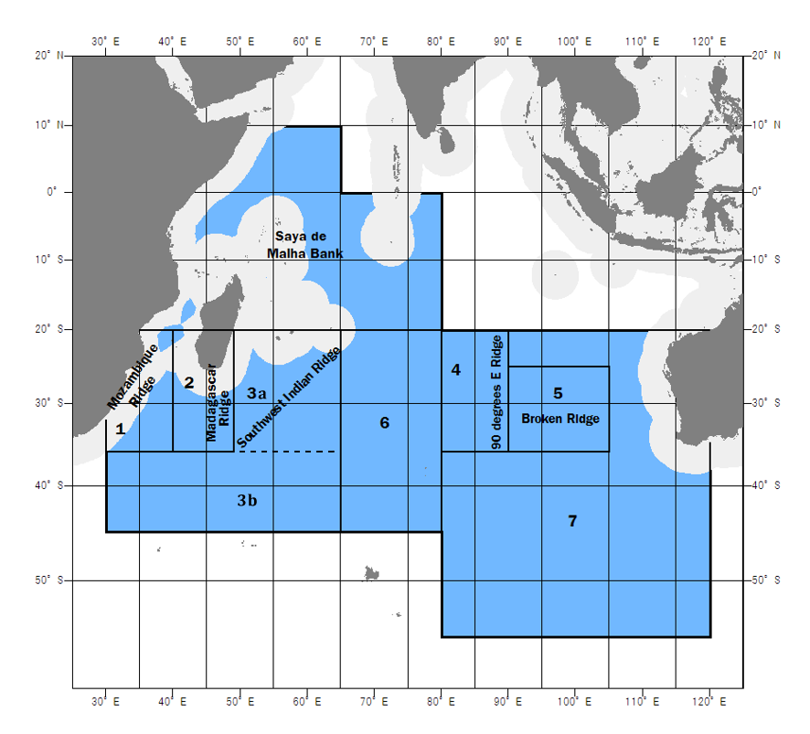
8

Annex 2
Tables templates for National Report sections
The tables below provide guidance on the format to be used for CP to report information in their National Report. Text in Yellow must be updated by CP.

Description of fisheries

Table 1: Fleet composition (number of vessels by gear type and size and how this has changed by year).
Year | Vessels that actively fished
 | Gear 1 | Gear 2 | Gear 3 | Gear 4
year | No of vessels (total tonnage) | No of vessels (total tonnage) | No of vessels (total tonnage) | No of vessels (total tonnage)
year | No of vessels (total tonnage) | No of vessels (total tonnage) | No of vessels (total tonnage) | No of vessels (total tonnage)

Table 2: Summary table of gear effort (unit).
Year | Sub-areas for reporting catch and effort data
 | 1 | 2 | 3.a | 3.b | 4 | 5 | 6 | 7 | 8
year
year
Note: please provide one table for each gear/fishery and specify the unit used (e.g. Mid
water trawl, hours trawled)

Table 3: Summary table of gear catches (unit)
Year | Sub-areas for reporting catch and effort data
 | 1 | 2 | 3.a | 3.b | 4 | 5 | 6 | 7 | 8
year
year
Note: please provide one table for each gear/fishery and specify the unit used (e.g. Mid
water trawl, tons)

Catch, effort and CPUE summaries

Table 4: Catch (Kg) by species for main target, bycatch, associated and depended species (R-retained and D-discarded)
Year | Species 1 |  | Species 2 |  | Species 3 |  | Species 4 |  | Species 5 |  | Others |  | Total
 | R | D | R | D | R | D | R | D | R | D | R | D | R | D
year 1
year 2

Fisheries data collection and research activities
Brief description of the fisheries data collection systems implemented, and the research and assessment activities conducted, including:
- Description of the statistical data collection systems in use, and how these have changed or been improved over the past year. If fisheries need to be separated, please provide a table for each fishery.
Table 5: Details on the scales and resolutions of the fishery data collection
 | fishery/gear data collection items
Year | tow / set  (individual or some aggregation) | time scale  (set-tow hauling time, daily, etc.) | spatial scale  (tow/set exact position or grid, please provide grid resolution) | species details  (any aggregation or species grouping)
Year
Year
Year
Year
Note: please provide one table for each gear/fishery if data collection modes differ.

VME Thresholds
(for bottom fishing activity only)
- Describe threshold levels for encounters with VMEs and any move-on protocols
Table 6: Threshold levels for encounters with VMEs and move-on protocols
Gear/fishery | Threshold (kgs) | Move-on protocols
Gear1
Gear2
…

- For operations that exceeded the pre-determined VME threshold, provided details of the VME taxa observed including (wet) weight, number of taxa, the corresponding effort information and total weight of catch of the operation; and any action taken in respect of the relevant site.
Table 7: Summary VME Taxa (wet) weight (kg), operations exceeding thresholds and effort: gear type identified, 1 table per gear
Year | Unit | Sub-areas for reporting catch and effort data
 |  | 1 | 2 | 3.a | 3.b | 4 | 5 | 6 | 7 | 8
year [Nº of taxa] | Weight (kg)
 | Nº Operations
 | Effort (Tables 2.1..)
year [Nº of taxa] | Weight (kg)
 | Nº Operations
 | Effort (Tables 2.1..)

- It is desirable for the SC to report any VME taxa caught during fishing operations as recorded in the logbooks
Table 8: VME taxa bycatch quantities per gear from logbooks data (specify taxa and units)
 |  | gear1/fishery1 | gear2/fishery2
 | total set/tow number
taxa | taxon 1 (unit)
 | taxon 2 (unit)
 | taxon 3 (unit)
 | …

Summary of observer and port sampling programs

- Information on observer programme design and coverage rates achieved and the type of data collected. (table 9)
- Information on the level of observer coverage and focus on recording bycatch of seabirds, marine mammals, reptiles and other species of concern. (table 9)
Table 9: Observer program design and coverage summary table
 | trips  coverage  (%) | total no of  sets/hauls | no of  sets/hauls  covered | within set/haul  coverage  (%) | incidental bycatch (bird, mammal) observation coverage (% set/haul)
gear1/fishery1
gear2/fishery2
gear3/fishery3

- Reporting of observed bycatch by species and fishery for all seabirds, marine mammals, reptiles and other species of concern. (table 10)
Table 10: Reporting of observed bycatch
bycatch | gear1/fishery1 | gear2/ fishery2 | gear3/ fishery3
seabird | occurrence number | occurrence number | occurrence number
mammal | occurrence number | occurrence number | occurrence number
sharks (not retained) | occurrence number | occurrence number | occurrence number
VME taxon 1 (unit) | quantity | quantity | quantity
VME taxon 2 (unit) | quantity | quantity | quantity
other

These guidelines recognise that, where appropriate, data confidentiality will be maintained as it relates to the application of relevant national legislation.
A table of relevant scientific names and associated common English name should be provided in an annex to report.
Source for Table 1 and Figure 1: FAO Fisheries Report No. 677: report of the “SECOND AD HOC MEETING ON MANAGEMENT OF DEEPWATER FISHERIES RESOURCES OF THE SOUTHERN INDIAN OCEAN” held in Fremantle 20 -22 May 2002

