6th Meeting of the Compliance Committee (CC6)
Reunion Island, 29 June – 1 July 2022
CC-06-06-rev3
Proposal to amend CMM 2019/13 on mitigation of seabird bycatch
(Amendments to the initial version have been highlighted in yellow)
France (Overseas Territories)
Submitted 30.05.2022
Document type | working paper ✔  information paper ☐
Distribution | Public ✔  Restricted ☐  Confidential ☐
Abstract
The consultant report submitted at SC7 (SC-07-28) noted the high risks of seabird bycatch in the pelagic longline fishery operating in the SIOFA area, in particular with regards to the critically endangered albatrosses. In line with that assessment, the Scientific Committee recommended (para.141) that “pelagic longliners operating in the SIOFA Area follow IOTC Resolution 12/06 on reducing the incidental bycatch of seabirds in longline fisheries”. The SC further requested that “the Secretariat prepare a paper, for submission to the MoP, on how the provisions of IOTC Resolution 12/06 might be incorporated in the SIOFA CMMs”.
Noting this proposal falls outside the remit of the Secretariat’s duties, France(OT) hereby submits a proposal amending CMM 2019/13 so that it applies to pelagic longliners and incorporates bycatch mitigation measures as outlined in IOTC resolution 12/06.
The following amendments are proposed :
- Broaden the scope of the CMM in the title, the recitals and paragraph 2 ;
- Add provisions applying to pelagic longliners in a new article 6, along the terms of IOTC resolution 12/06 (“use at least two of the three mitigation measures”) ;
- Add a new annex (Annex 3) that incorporates the mitigation measures outlined in IOTC resolution 12/06, table 1.
FR(OT) also notes that the holding of a workshop to consider how seabird bycatch mitigation measures may be progressed further, as recommended by SC7 (para.148), should not prevent the MoP from adopting the required precautionary mitigation measures in the meantime.

Recommendations (for proposals and working papers only)
- The Compliance Committee to review the proposal and recommend its adoption to MoP9.

CMM 2019/13
Conservation and Management Measure on mitigation of seabirds bycatch in demersal and pelagic longlines and other demersal fishing gears fisheries (Mitigation of Seabirds Bycatch)
The Meeting of the Parties to the Southern Indian Ocean Fisheries Agreement:
RECALLING the relevant provisions of the Southern Indian Ocean Fisheries Agreement, in particular Article 4 and 6;
CONSIDERING that the United Nations Food and Agriculture Organization (FAO) International Plan of Action for Seabirds calls on States to cooperate through regional fisheries organizations to mitigate incidental by-catch of seabirds;
RECOGNISING the need to strengthen mechanisms to protect seabirds in the Southern Indian Ocean;
FURTHER TAKING INTO ACCOUNT the FAO Technical Guidelines for Responsible Fisheries concerning best practices to reduce incidental catch of seabirds in capture fisheries;
NOTING the Agreement on the Conservation of Albatrosses and Petrels (ACAP) has established best practice seabird bycatch mitigation measures for trawl and demersal and pelagic longline fisheries;
ADOPTS the following CMM in accordance with Article 4 and 6 of the Agreement:

Application and geographic scope
1. This CMM applies to all fishing vessels of Contracting Parties, cooperating non-Contracting Parties and participating fishing entities to the Agreement (collectively CCPs), engaged in fishing operations in the SIOFA Area of Application (Agreement Area) for resources as defined in article 1(f) of the Agreement, south of 25°S.

General provisions for demersal and pelagic longliners and Other demersal fishing gears
2. Until such time that the SIOFA Scientific Committee has developed advice for the Meeting of Parties on the most appropriate response to mitigate and minimise incidental bycatch of seabirds by demersal and pelagic fishing gears deployed in the Agreement Area, CCPs shall require any vessel flying their flag using demersal or pelagic longlines or other demersal fishing gears and operating in the area south of 25°S to apply the following mitigation measures:
- the location and level of lighting shall be arranged so as to minimise illumination directed out from the vessel, consistent with the safe operation of the vessel and the safety of the crew;
- information about birds colliding with the vessel, or caught by its gears will be recorded in accordance with CMM 2021/02 (Data Standards); and
- every effort should be made to ensure that birds captured alive during fishing operations are released alive and, for longlining, that hooks are removed without jeopardising the life of the bird concerned wherever possible.

Provisions applying to demersal longliners
- Until such time that the SIOFA Scientific Committee has developed advice for the Meeting of the Parties on the most appropriate response to mitigate and minimise incidental bycatch of seabirds by demersal fishing gears deployed in the Agreement Area, CCPs shall require any demersal longliners flying their flag and operating in the area south of 25°S to apply the following mitigation measures:
  - any vessel catching a total of three (3) seabirds in a single season shall immediately change to night setting only (i.e. setting only during the hours of darkness between the times of nautical twilight);
  - vessels are encouraged to use white colour lines, to increase visibility which decreases the bycatches of birds;
  - at least one bird scaring line (in accordance with Annex 1) shall be deployed when setting longlines and at least one bird exclusion device (BED, in accordance with Annex 2) shall be used to prevent birds entering the hauling area, to the extent allowed by prevailing weather;
  - there shall be no discharging of offal or discards immediately prior to and during the deployment or retrieval of fishing gear;
  - fishing vessels using autoline systems shall add weights to the hookline or use integrated weight (IW) hooklines while deploying longlines. IW longlines of a minimum of 50 g/m or attachment to non-IW longlines of 5 kg weights at 50 to 60 m intervals are recommended;
  - fishing vessels using the Spanish method of longline fishing shall release weights before line tension occurs; traditional weights (made of rocks or concrete) of at least 8.5 kg mass shall be used, spaced at intervals of no more than 40 m, or traditional weights of at least 6 kg mass shall be used, spaced at intervals of no more than 20 m, or solid steel weights of at least 5 kg mass shall be used, spaced at intervals of no more than 40 m;
  - fishing vessels using the trotline system exclusively (not a mix of trotlines and the Spanish system within the same longline) shall deploy weights only at the distal end of the droppers in the trotline. Weights shall be traditional weights of at least 6 kg or solid steel weights of at least 5 kg; and
  - fishing vessels alternating between the use of the Spanish system and trotline method shall use: (i) for the Spanish system: line weighting shall conform to the provisions in paragraph 3 f; (ii) for the trotline method: line weighting shall be either 8.5 kg traditional weights or 5 kg steel weights attached on the hook-end of all droppers in the trotline at no more than 80 m intervals.
- For demersal longliners of less than 25 m, at least one of the following measures shall apply:
  - at least one bird scaring line (in accordance with Annex 1) shall be deployed when setting lines, and at least one bird exclusion device (BED, see specifications in Annex 2), shall be used to prevent birds entering the hauling area, to the extent allowed by prevailing weather;
  - fishing vessels using autoline systems shall add weights to the hookline or use integrated weight (IW) hooklines while deploying longlines. IW longlines shall have a minimum of 50 g/m or a weight of a minimum of 5 kg attached to non-IW longlines at 50 to 60 m intervals; and
  - lines shall be set only at night (i.e. during the hours of darkness between the times of nautical twilight). The exact times of nautical twilight are set forth in the Nautical almanac tables for the relevant latitude, local time and date.

Provisions applying to other demersal fishing gears
5. In addition to the provisions in paragraph 2, CCPs shall require any fishing vessel flying their flag and operating in the Agreement Area south of 25°S using demersal pots or traps to ensure the cleanliness of the traps and pots not to attract birds, and ensure that buoy lines shall not be left floating at the surface.

Provisions applying to pelagic longliners
6. Until such time that the SIOFA Scientific Committee has developed advice for the Meeting of the Parties on the most appropriate response to mitigate and minimise incidental bycatch of seabirds by pelagic fishing gears deployed in the Agreement Area, CCPs shall require any pelagic longliners flying their flag and engaged in fishing operations for resources as defined in article 1(f) of the Agreement in the area south of 25°S to use at least two of the three mitigation measures outlined in Annex 3.

Final provisions
7. The Scientific Committee and the Compliance Committee will review this CMM every four years, unless the Meeting of the Parties decides otherwise.

ANNEX 1: Specification of bird scaring line for longliners
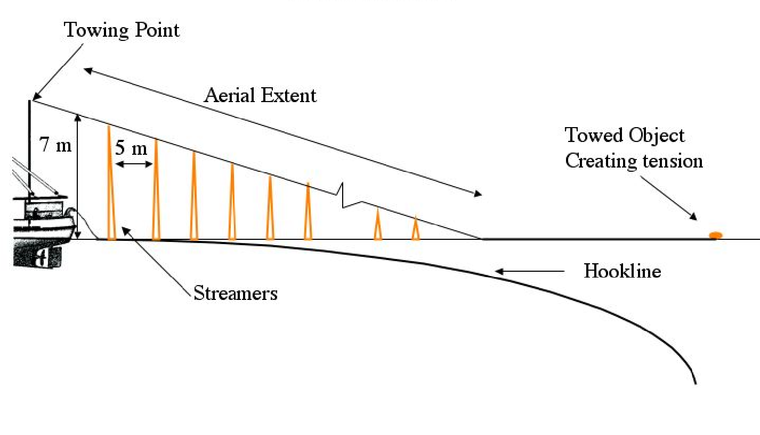
- The aerial extent of the bird scaring line, being that part of the line supporting the streamers, is the effective seabird deterrent component of a bird scaring line. Vessels are encouraged to optimise the aerial extent of the bird scaring line and ensure that it protects the hookline as far astern of the vessel as possible, even in crosswinds.
- The bird scaring line shall be attached to either the port or starboard sides of the vessel.
- The bird scaring line shall be a minimum of 150 m in length and include an object towed at the seaward end to create tension to maximise aerial coverage. The object towed should be maintained directly behind the attachment point to the vessel such that in crosswinds the aerial extent of the bird scaring line is over the hookline.
- Branched streamers, each comprising two strands of a minimum of 3 mm diameter brightly coloured plastic tubing (or cord, shall be attached no more than 5 m apart commencing 5 m from the point of attachment of the bird scaring line to the vessel and thereafter along the aerial extent of the bird scaring line. Where tubing is used for the branched streamers, the tubing should be of a type that is manufactured to be protected from ultraviolet radiation.
- Streamer length shall range between minimums of 6.5 m from the stern to 1 m for the seaward end. When a bird scaring line is fully deployed, the branched streamers shall be of sufficient length to reach the sea surface in the absence of wind and swell. Swivels or a similar device should be placed in the bird scaring line in such a way as to prevent streamers being twisted around the bird scaring line. Each branched streamer may also have a swivel or other device at its attachment point to the bird scaring line to prevent fouling of individual streamers.
- A spare bird scaring line shall be carried and deployed in the event of loss or damage of a bird scaring line.
Longline Vessels ≥ 25m in length
- Each bird scaring line shall be suspended from a point a minimum of 7 m above the water at the stern of the point where the hookline enters the water.

Longline Vessels < 25 m in length
- The bird scaring line shall be suspended from a point a minimum of 6 m above the water at the stern of the point where the hookline enters the water.
- Streamers may be modified over the first 15 m to prevent tangling.
- The bird scaring line should achieve an aerial extent of at least 75 m when setting at ≥ 4 knots or 50 m is setting at speeds < 4 knots.

ANNEX 2: Specification of BEDs for demersal longliners

BEDs shall have the following operational characteristics:

- deterrence of birds from flying directly into the area where the line is being hauled; and
- prevention of birds that are sitting on the surface from swimming into the hauling bay area.

ANNEX 3 : Mitigation measures for pelagic longliners

Mitigation | Description | Specification
Night setting with minimum deck  lighting | No setting between nautical dawn and before nautical dusk.  Deck lighting to be kept to a minimum. | Nautical dusk and nautical dawn are defined as set out in the  Nautical Almanac tables for relevant latitude, local time and date.  Minimum deck lighting should not breach minimum standards for safety and navigation.
Bird-scaring lines (Tori lines), in accordance with the specifications provided in Annex 1 | Bird-scaring lines shall be deployed during the entire longline setting to deter birds from approaching the branch line. | For vessels greater than or equal to 35 m:  - Deploy at least 1 bird-scaring line. Where practical, vessels are encouraged to use a second tori pole and bird scaring line at times of high bird abundance or activity; both tori lines should be deployed simultaneously, one on each side of the line being set.  - Aerial extent of bird-scaring lines must be greater than or equal to 100 m.  - Long streamers of sufficient length to reach the sea surface in calm conditions must be used.  - Long streamers must be at intervals of no more than 5m.  For vessels less than 35 m:  - Deploy at least 1 bird-scaring line.  - Aerial extent must be greater than or equal to 75m.  - Long and/or short (but greater than 1 m in length) streamers must be used and placed at intervals as follows: o Short: intervals of no more than 2 m.  o Long: intervals of no more than 5 m for the first 55 m of bird scaring line.  Additional design and deployment guidelines for bird-scaring lines are provided in Annex I of this CMM.
Line weighting | Line weights to be deployed on the snood prior to setting. | Greater than a total of 45 g attached within 1 m of the hook or;  Greater than a total of 60 g attached within 3.5 m of the hook or;  Greater than a total of 98 g weight attached within 4 m of the hook.

Restricted documents may contain confidential information. Please do not distribute restricted documents in any form without the explicit permission of the SIOFA Secretariat and the data owner(s)/provider(s).
Documents available only to members invited to closed sessions as per SIOFA RoP 20.

